

Capstone Project Report
Report 4 – Software Design Document

PickleVerse – Multiplayer Pickleball Skill-Training and Match Game with AI Coaching

Project code: PKV Group: GFA26SE111
Supervisor: Mr. Lại Đức Hùng
Team: Huỳnh Trung Kiên (Leader), Nguyễn Văn Thành Đạt,
Nguyễn Gia Huy, Trần Nguyễn Hiếu Thuận
– Ho Chi Minh City, November 2026 –
Table of Contents
I. Record of Changes 3
II. Software Design Document 4
1. System Design 4
1.1 System Architecture 4
1.2 Package Diagram 8
1.3 Technology Stack 12
1.4 Architecture Decisions 12
2. Database Design 13
2.1 Data Dictionary of the Core Tables 23
2.2 Design Notes 27
3. Detailed Design 27
3.1 Account and Authentication 27
3.2 Gameplay Core and Ball Physics 33
3.3 Training and Offline Synchronisation 36
3.4 Bot AI 41
3.5 Online Matchmaking and Netcode 44
3.6 AI Coaching 52
3.7 Progress, Economy, Social and Replays 57
3.8 Administration and Moderation 59
3.9 API Design 63
3.10 Security Design 66
4. Workflows and State Changes 67
4.1 Activity Diagrams 67
4.2 State Machine Diagrams 73

I. Record of Changes
Date | A*  M, D | In charge | Change Description
27/10/2026 | A | Nguyễn Gia Huy | v0.1 – Architecture, workflows W01–W04 and state machines summarised for the Review 2 design brief (BM01).
06/11/2026 | A | Nguyễn Văn Thành Đạt | v0.2 – First SDD on the official template: architecture, packages, database groups, 7 class/sequence pairs, activities and state machines.
11/11/2026 | M | Nguyễn Gia Huy | v1.0 – Rewritten after the internal review: deployment diagram and architecture decisions; full package diagrams; logical ERDs covering all 51 tables with keys and a data dictionary; UML class diagrams with class specifications; 15 sequence diagrams with alternative paths; new sections for gameplay physics, netcode, bot AI, API and security design; activity diagrams with swimlanes; 14 corrected state machines.
11/11/2026 | M | Nguyễn Gia Huy | v1.1 – Activity diagrams: workflow owners aligned with BM04.
12/11/2026 | M | Nguyễn Gia Huy | v1.2 – Revised after the second internal review: API table regenerated from the controllers (129 endpoints, access and Used by); dedicated-server controllers corrected; time-out removed from the gameplay class diagram and SM-05; FlowState Delay, camera framing, lobby classes and quick doubles added; netcode design table; table descriptions of Users, PlayerProfiles and GameMatchPlayers corrected; delivery pipeline status and data-at-rest deviation recorded; workflow names aligned with BM04.
13/11/2026 | M | Nguyễn Gia Huy | v1.3 – Deployment updated after the fixes of 12–13/11/2026 (main @ d9200cc): delivery pipeline described as it runs (plan, checks, build, publish by digest, deploy with a verified dump) with the history of the 32 runs; Caddy HTTPS reverse proxy and the ports of staging; transport, secrets and data-protection rows of the security table.
*A - Added M - Modified D - Deleted

II. Software Design Document

1. System Design

1.1 System Architecture
PickleVerse uses a client–server architecture with five deployable sub-systems (Figure 1). The Unity game client contains the presentation, the local gameplay simulation used for training and bot matches, and an offline store. All persistent data and business rules that must be trusted are on the server side: the ASP.NET Core Web API owns accounts, progression, economy, matchmaking and moderation; the Unity dedicated server owns the state of online matches; the AI coaching service analyses shot telemetry; the React administration application is a pure client of the Web API. Background workers run inside the Web API process. PostgreSQL is the system of record, Redis holds short-lived coordination data, and object storage keeps replays.
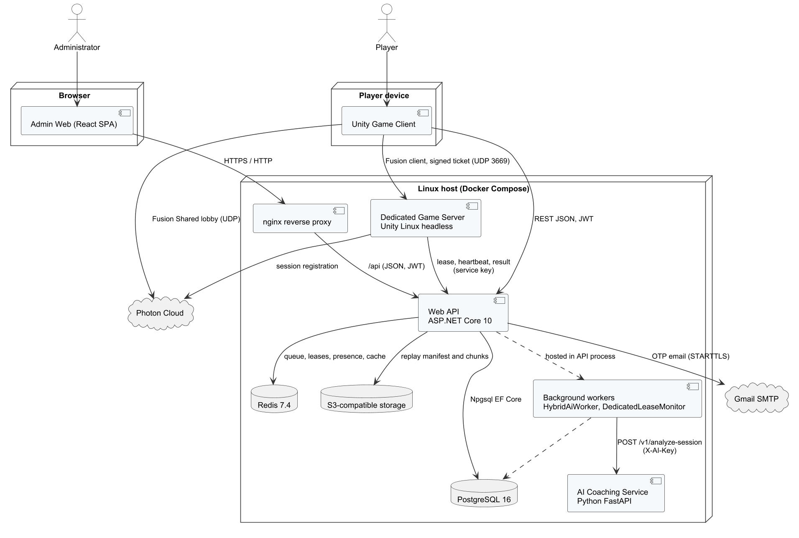
Figure 1. System architecture (component view)
Note: the figure was drawn on 12/11/2026. It names the host proxy nginx and shows the game client calling the API directly; since 13/11/2026 the client and the admin web reach the API through the Caddy HTTPS reverse proxy, as described in Table 2.
Table 1. Architecture components
Component | Technology | Responsibility
Unity game client | Unity 6000.6.2f1, C#, uGUI, Input System | Scenes and UI, local physics and rules for training and bot matches, Photon Fusion client, offline training store, REST client (ApiClient) to the Web API
Dedicated game server | Unity Linux headless build, Photon Fusion 2.1.3 (server mode) | Authoritative simulation of online matches; validates signed tickets; sends heartbeats, telemetry, replay and result to the Web API
Web API | ASP.NET Core (.NET 10), layered API → Services → Repositories → Entities | REST endpoints, JWT authentication, business rules, transactions through IUnitOfWork and Npgsql EF Core
Background workers | Hosted services in the Web API | HybridAiWorker (analysis jobs), DedicatedLeaseMonitor (expired leases), ModerationExpiryWorker (expired suspensions), AnalyticsProjectionWorker (daily aggregates), PasswordRecoveryMailQueue (e-mail sending)
AI coaching service | Python 3.12, FastAPI, scikit-learn | Rule engine for technique errors, summary and drill recommendations, gated tier model; internal API protected by an API key
Admin web application | React 18, TypeScript 5, Vite 5, React Query, Axios | Administration screens served by nginx; calls the Web API with the administrator's JWT
PostgreSQL 16 | Relational database | 51 tables: accounts, profiles, content, matches, economy, moderation, telemetry and coaching
Redis 7.4 | In-memory store | Matchmaking queue and search state, dedicated-server lease, presence, leaderboard cache (15 s)
Object storage | S3-compatible container | Replay manifests and compressed chunks
Photon Cloud | External service | Fusion session lookup and relay for clients and the dedicated server
Gmail SMTP | External service | Delivery of verification and password-reset e-mails

Online matches support two authority modes recorded in GameMatches.AuthorityMode. In dedicated mode, enabled by the configuration flag DedicatedServer:Enabled (true on staging), the dedicated server runs the simulation and is the only authority for points, faults and the result. In shared mode, kept for local development without a server, the room host runs the simulation through Photon Fusion shared mode. The staging deployment has one dedicated-server container, so one authoritative match runs at a time; the API reports the slot as busy and the client waits (Report 3, MSG36). Scaling to more matches requires more server containers and is outside release 1.0.

Deployment
Figure 2 shows the staging deployment on the host tad-min.io.vn (Ubuntu 24.04, Docker Engine). On each push to main the GitHub Actions workflow dockerhub.yml first reads the release that is deployed and plans which checks and images the changed files need (plan-release.py). It then runs the selected checks – twelve IntegrationChecks groups on PostgreSQL and Redis, the FastAPI tests and the admin web type check – and builds the Unity Linux dedicated server with GameCI when the Unity project changed. Publish (publish-release.sh) removes the credentials from the settings files, builds the changed images among api, ai, web and server, pushes them to Docker Hub with the tag <component>-<commit>-<run>-<attempt> and smoke-tests the four image digests with Docker Compose on the runner. Deploy (ssh-deploy.sh) locks the release on the host, takes a PostgreSQL dump and checks it with pg_restore, copies docker-compose.linux.yml and Database.sql, writes the four image digests into the host .env file, runs docker compose up and records the deployed release. Status on 13/11/2026: the pipeline passes. Of its 32 runs, 29 did not pass: two configuration failures on 05/11/2026, 18 runs that did not start while the GitHub account was locked for a billing issue (06/11 to 11/11), six failures of the dedicated-server build (11/11 and 12/11), one failed FastAPI test and two failed deployment steps. Runs 27, 28 and 30 of 13/11/2026 completed every job in about 15 minutes each, and run 30 deployed the release that is running now. The four earlier staging releases (Docker Hub tags api-, ai-, web- and server-manual-<date-time>, 08/11 to 10/11/2026) were built and started by hand. Since 13/11/2026 a Caddy reverse proxy on the host serves the admin web and the Web API over HTTPS; Table 2 lists the ports that are reachable from the Internet.

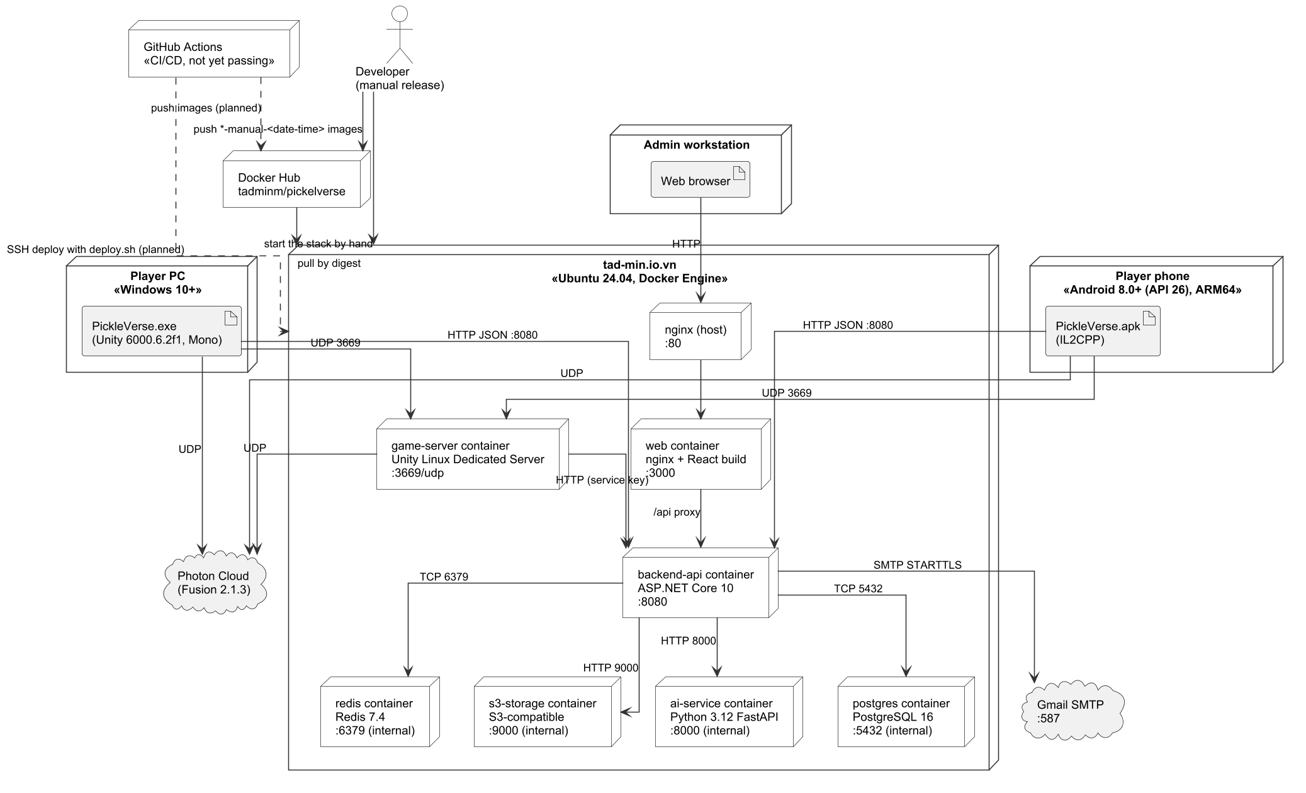
Figure 2. Deployment diagram of the staging environment

Note: the figure was drawn on 12/11/2026. It still shows the pipeline as not passing, the manual release, the former proxy on port 80 and the clients calling port 8080; the paragraph above and Table 2 describe the deployment of 13/11/2026 (pipeline passing, Caddy reverse proxy with HTTPS on port 443 in front of the API and the admin web).
Table 2. Deployment nodes
Node / container | Image or artifact | Port | Notes
Host reverse proxy | Caddy with deploy/linux/Caddyfile | 80/tcp, 443/tcp | Port 80 redirects to HTTPS. Port 443 terminates TLS (Let's Encrypt certificate, TLS 1.3) and forwards /api and /health/ready to backend-api and every other path to the web container
web | tadminm/pickelverse:web-<release> | 3000/tcp (bound to 127.0.0.1) | nginx serving the React build of the admin web; reached only through the reverse proxy
backend-api | tadminm/pickelverse:api-<release> | 8080/tcp (bound to 127.0.0.1) | Web API and background workers; reached from the Internet only through the reverse proxy since 13/11/2026 (port 8080 was public before)
game-server | tadminm/pickelverse:server-<release> | 3669/udp | Unity dedicated server; limited to 2 CPUs and 2 GB RAM
ai-service | tadminm/pickelverse:ai-<release> | 8000/tcp (internal) | FastAPI coaching service, reachable only from backend-api
postgres | postgres:16-alpine | 5432/tcp (internal) | Volume for data; schema and seed from src/Database.sql; dumped before each deployment
redis | redis:7.4-alpine | 6379/tcp (internal) | Coordination data (queue, leases, presence, cache) with an append-only file on the host volume
s3-storage | ghcr.io/shyim/local-s3 (S3-compatible server) | 9000/tcp (internal) | Bucket pickleverse for replays
Player PC / phone | PickleVerse.exe (Windows, Mono) / PickleVerse.apk (Android 8.0+, IL2CPP, ARM64) | – | Connects to the API, Photon Cloud and the game server

1.2 Package Diagram
The three code bases are organised in layers. Dependencies point only downwards: a package may use the packages below it but never the reverse. Figures 3 to 5 show the packages of the Web API, the Unity client and the admin web with the AI service.

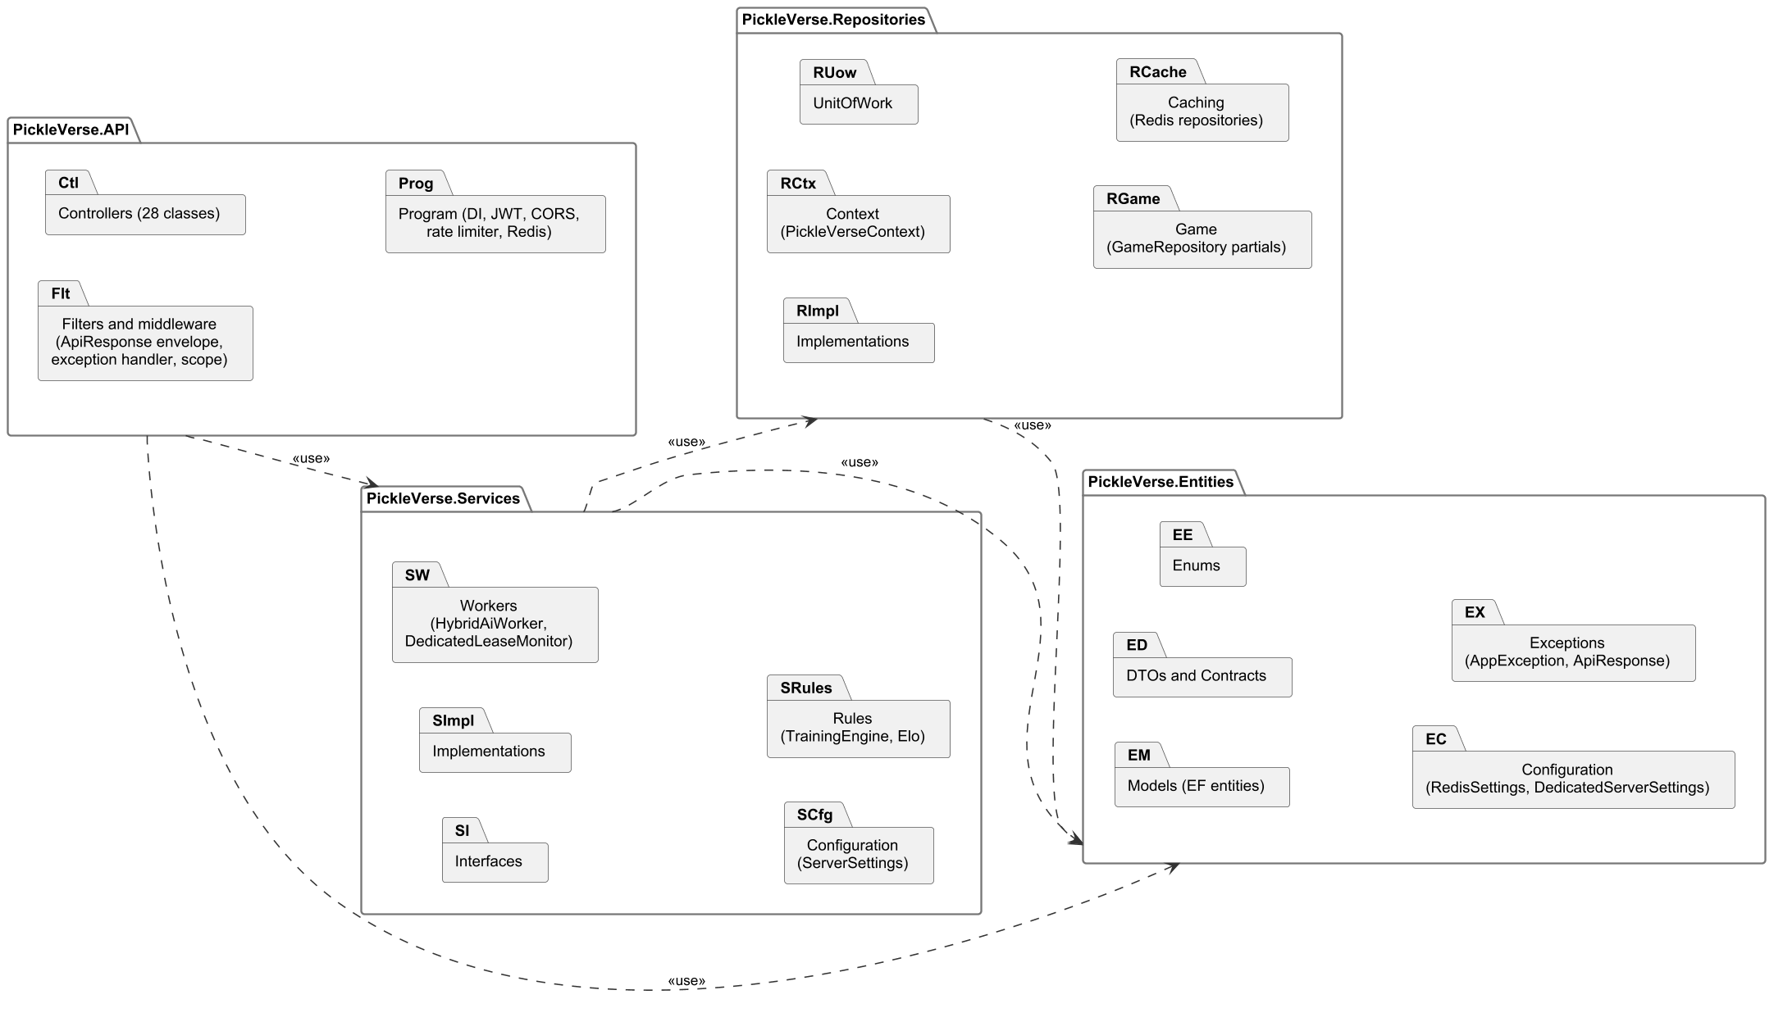
Figure 3. Package diagram of the Web API solution

Table 3. Web API package descriptions
No | Package | Description
01 | PickleVerse.API | Entry point: 28 controller classes in 24 files, Program.cs (dependency injection, JWT, CORS, rate limiter, Redis), filters that wrap responses in ApiResponse<T>, the global exception handler that maps service exceptions to HTTP status codes
02 | PickleVerse.Services | Business logic: service interfaces (Interfaces) and implementations (Implementations), background workers, typed settings (ServerSettings) and pure rule classes (TrainingEngine, ProgressionEngine, EloPolicy)
03 | PickleVerse.Repositories | Data access: PickleVerseContext (Npgsql EF Core mapping of the 51 tables), IUnitOfWork, repositories, GameRepository partial classes for match and progress persistence, Redis repositories for queues, leases and caches
04 | PickleVerse.Entities | Shared model: EF entity classes, DTOs and contracts, enums, configuration models (RedisSettings, DedicatedServerSettings) and exception/response types (AppException, ApiResponse)

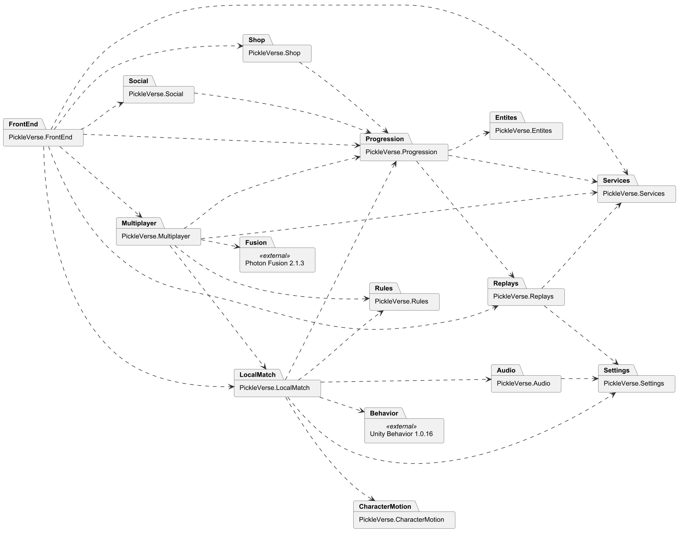
Figure 4. Package diagram of the Unity client (assembly definitions)
Table 4. Unity client package descriptions
No | Package | Description
01 | PickleVerse.FrontEnd | Menus and screens: login, loading, menu, mode selection, settings entry, overlays, history and missions popups
02 | PickleVerse.Multiplayer | Online flow: MultiplayerApp, PhotonSession, room state, NetworkMatch and NetworkPlayer, dedicated-server client and reconnection
03 | PickleVerse.LocalMatch | Local gameplay: BotMatch, MatchActor, ball flight, paddle contact, shot input, LocalBot and BhTreeBot, training and tutorial directors
04 | PickleVerse.Rules | Engine-independent rules shared by local and online play (scoring, faults, court geometry)
05 | PickleVerse.Progression | ProgressionRuntime, training engine on the client, offline training store, wallet and profile cache
06 | PickleVerse.Services | ApiClient, AccountService and backend settings
07 | PickleVerse.Entites | Data contracts shared by client assemblies (room models, DTOs); the name keeps the original spelling of the assembly
08 | PickleVerse.Shop | Shop and collection scenes
09 | PickleVerse.Social | Friends, blocking and leaderboard UI
10 | PickleVerse.Replays | Replay recording, upload and the replay viewer
11 | PickleVerse.Settings | Settings scene: audio, graphics, key binding and touch layout
12 | PickleVerse.Audio | Music player and sound effects policy
13 | PickleVerse.CharacterMotion | Character animation controller and movement blending

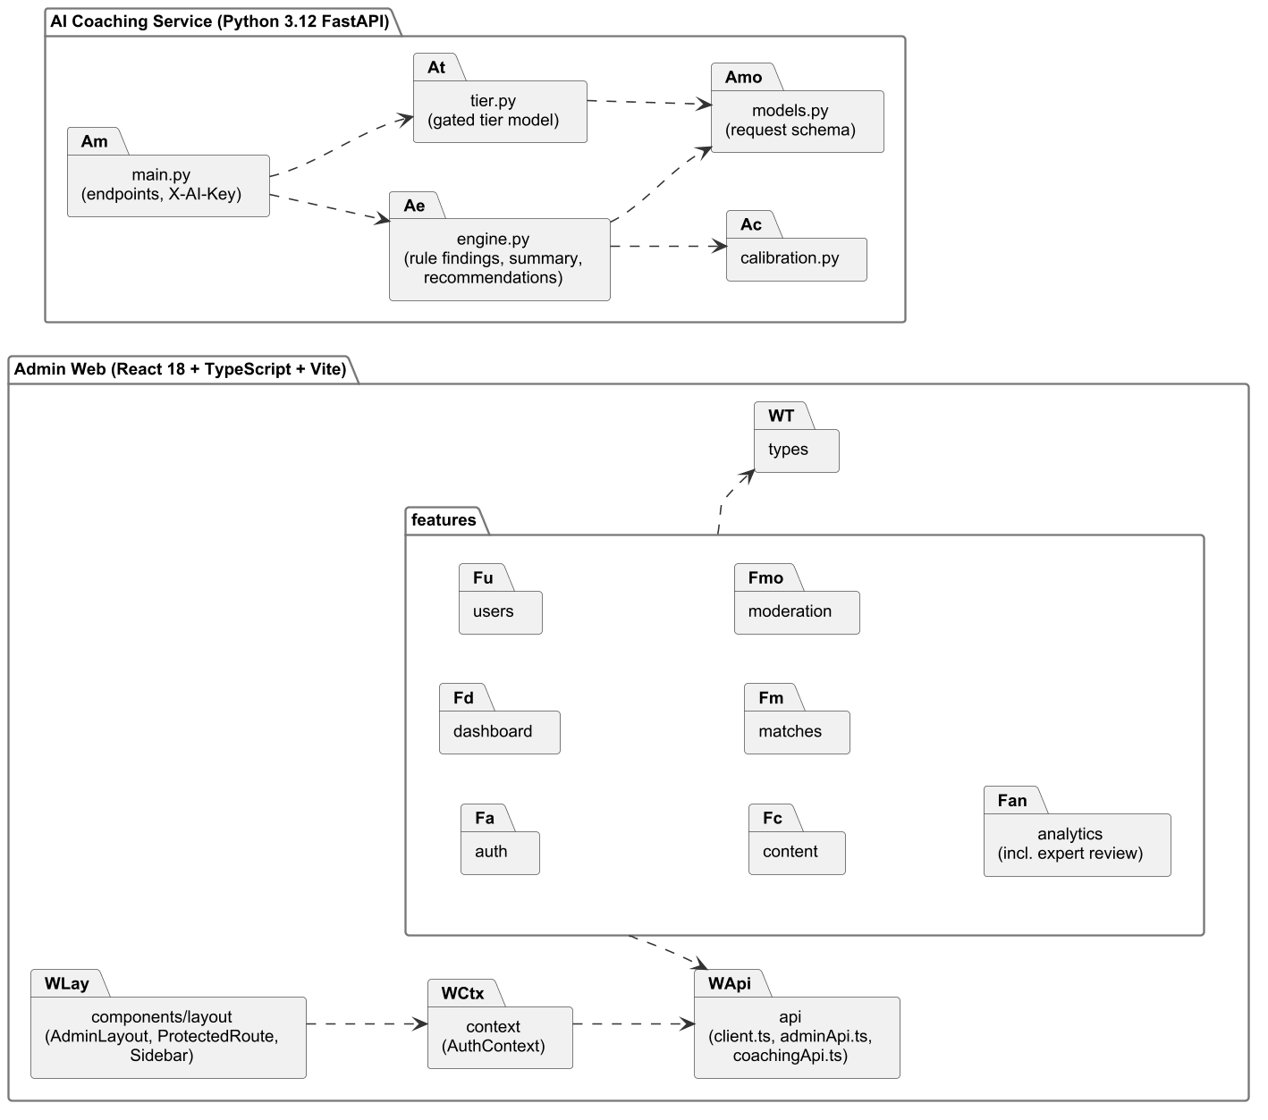
Figure 5. Package diagram of the admin web application and the AI coaching service
Table 5. Admin web and AI service package descriptions
No | Package | Description
01 | features (admin web) | One folder per area: auth, dashboard, users, content, matches, moderation, analytics (including expert review); each holds its pages
02 | api | Axios client with the JWT interceptor (client.ts) and typed API modules (adminApi.ts, coachingApi.ts)
03 | context | AuthContext: stores the session and exposes sign-in and sign-out
04 | components/layout | AdminLayout, Sidebar and ProtectedRoute, which redirects users without the Admin role to the login page
05 | main.py (AI service) | FastAPI application, request validation and the X-AI-Key check
06 | engine.py | Rule-based findings for 15 error codes, summary and at most three recommendations
07 | tier.py | Gated tier model: 8 features, minimum confidence 0.65, minimum 20 opportunities
08 | calibration.py / models.py | Threshold calibration against expert labels; request and response schemas

1.3 Technology Stack
Table 6. Technology stack
Layer | Technology and version | Purpose
Game client | Unity 6000.6.2f1, C#, uGUI, Input System, Unity Behavior 1.0.16, Photon Fusion 2.1.3 | Gameplay, UI, bot behaviour graph, networking
Game server | Unity 6000.6.2f1 Linux dedicated server build | Authoritative online matches
Web API | ASP.NET Core on .NET 10, Npgsql EF Core 10, StackExchange.Redis 3.4, BCrypt.Net-Next 4.2, MailKit 4.17, AWSSDK.S3 4.0, JwtBearer 10 | REST API, persistence, caching, password hashing, e-mail
AI service | Python 3.12, FastAPI, Pydantic, scikit-learn | Coaching analysis and tier model
Admin web | React 18, TypeScript 5, Vite 5, TanStack React Query 5, Axios 1.6, Recharts 2, Tailwind CSS 3 | Administration UI
Data | PostgreSQL 16, Redis 7.4, S3-compatible storage | Persistence, coordination, replays
DevOps | Docker, Docker Compose, Docker Hub, Caddy (HTTPS reverse proxy), Ubuntu 24.04; GitHub Actions workflow with plan, check, build, publish and deploy jobs, passing since 13/11/2026 | Build, delivery and hosting

1.4 Architecture Decisions
Table 7 records the main decisions that differ from the registered proposal, the alternatives considered and their consequences. Report 1 (LI-08) refers to this table.
Table 7. Architecture decisions
# | Decision | Alternatives | Reason | Consequence
1 | ASP.NET Core Web API (.NET 10) | Spring Boot; FastAPI | The team writes C# for Unity; sharing the language reduces context switching and lets DTOs be checked against the Unity client in IntegrationChecks | The AI service stays in Python; two runtimes on the server
2 | Photon Fusion 2 with a dedicated server | Netcode for GameObjects with Relay (prototype 07–21/10/2026); Mirror | The NGO prototype showed unstable relayed connections; Fusion provides input authority, a server mode and tick-based state replication on which client prediction is built | Dependency on Photon Cloud and its CCU plan (Report 2, risk 4)
3 | Custom fixed-step ball simulation (120 Hz) | Unity PhysX rigidbody | Deterministic, engine-independent flight and bounce that the server and replays can reproduce exactly | Collision with paddle and net is implemented by the team (sphere sweep against a contact box)
4 | uGUI for the game interface | UI Toolkit | Existing art assets and world-space panels were built with uGUI; better support for runtime animation | Two UI systems are not mixed; layout code is in C#
5 | Server-authoritative results and rewards | Client-reported results | Prevents cheating on Elo, currency and missions | Bot matches are reported by the client; only Elo-neutral practice uses this path except Ranked Bot, whose result is validated against the server-created match
6 | Single schema file (src/Database.sql) without migrations during development | EF Core migrations | The schema changed often; one reviewed file is the single source for schema and seed data | Database resets are allowed only on the development instance (AGENTS.md)
7 | Gated AI tier model with rule fallback | Always show the model output | Too little labelled real data; a wrong tier would mislead beginners | The tier is hidden until the acceptance criteria of NFR-06 are met

2. Database Design
The logical database design is derived directly from src/Database.sql (51 tables, 366 columns, 71 foreign keys). To keep the diagrams readable the schema is divided into seven subject areas (Figures 6 to 12). Each diagram uses crow's-foot notation: * marks NOT NULL columns, «PK» and «FK» mark keys, and tables drawn without columns belong to another area and are shown only for their relationships. Table names follow the PascalCase convention of the EF model; the AI tables (ai*) and ratingledger use lower case because they were created for the Python service and the rating ledger and are mapped explicitly in PickleVerseContext.
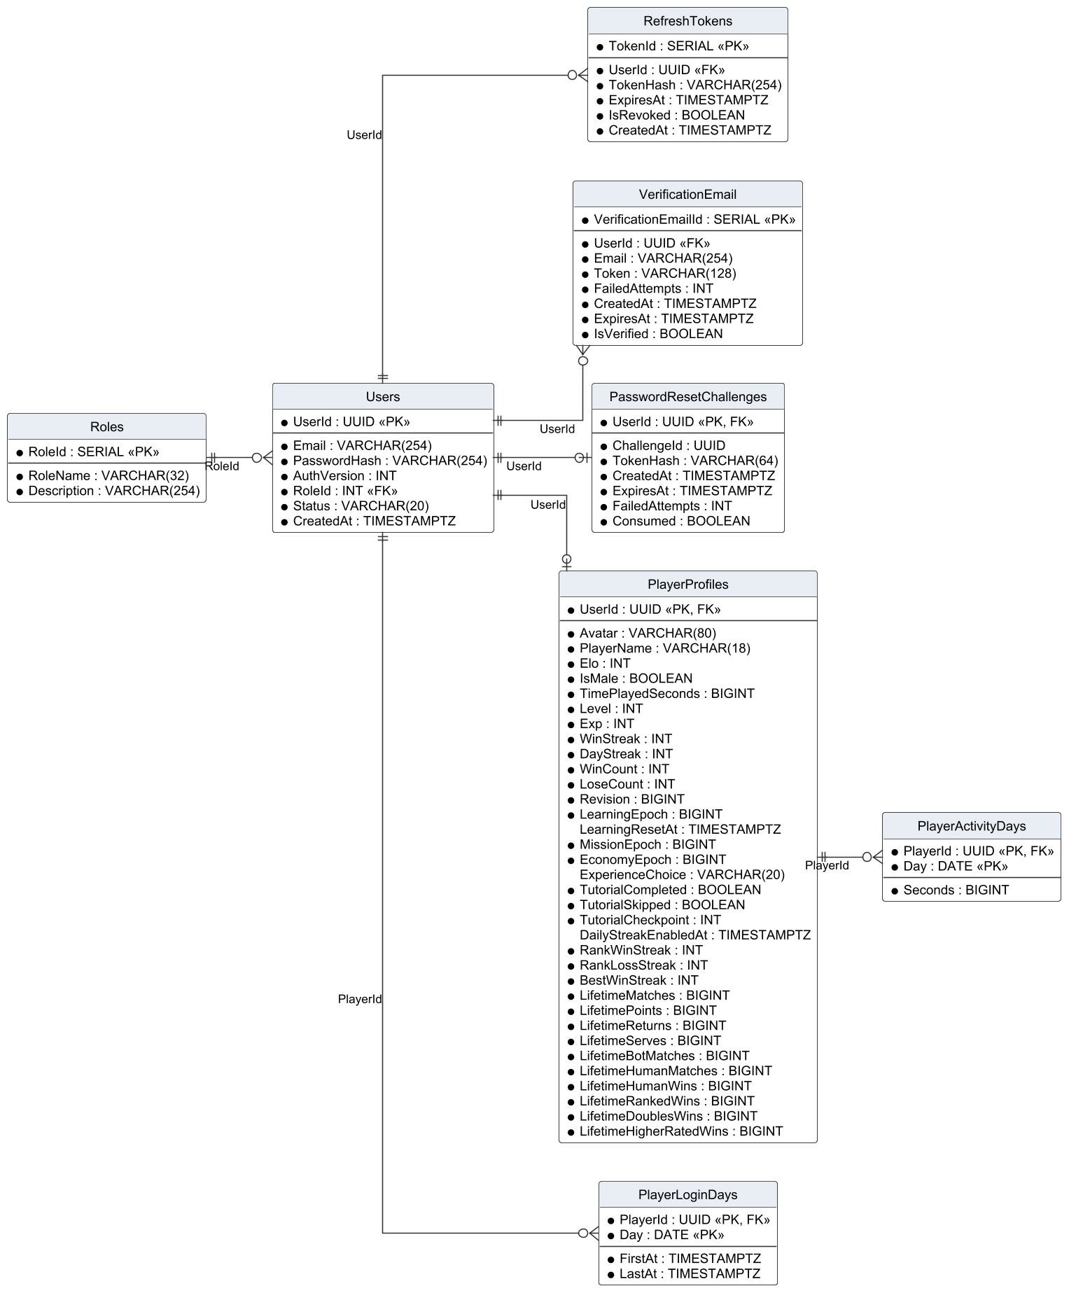
Figure 6. Logical ERD – accounts and profiles
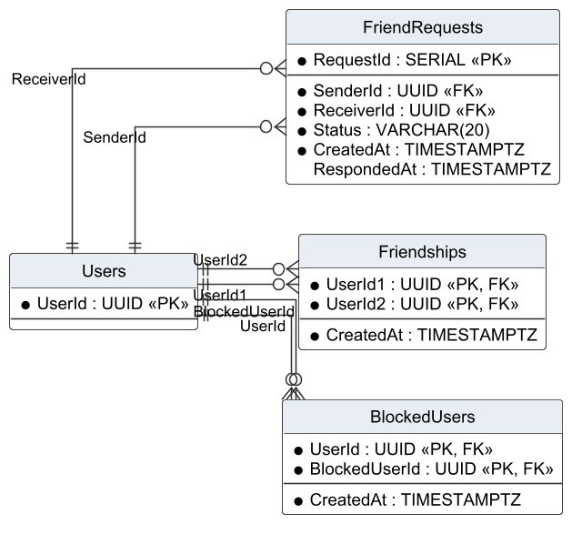
Figure 7. Logical ERD – friends and blocking
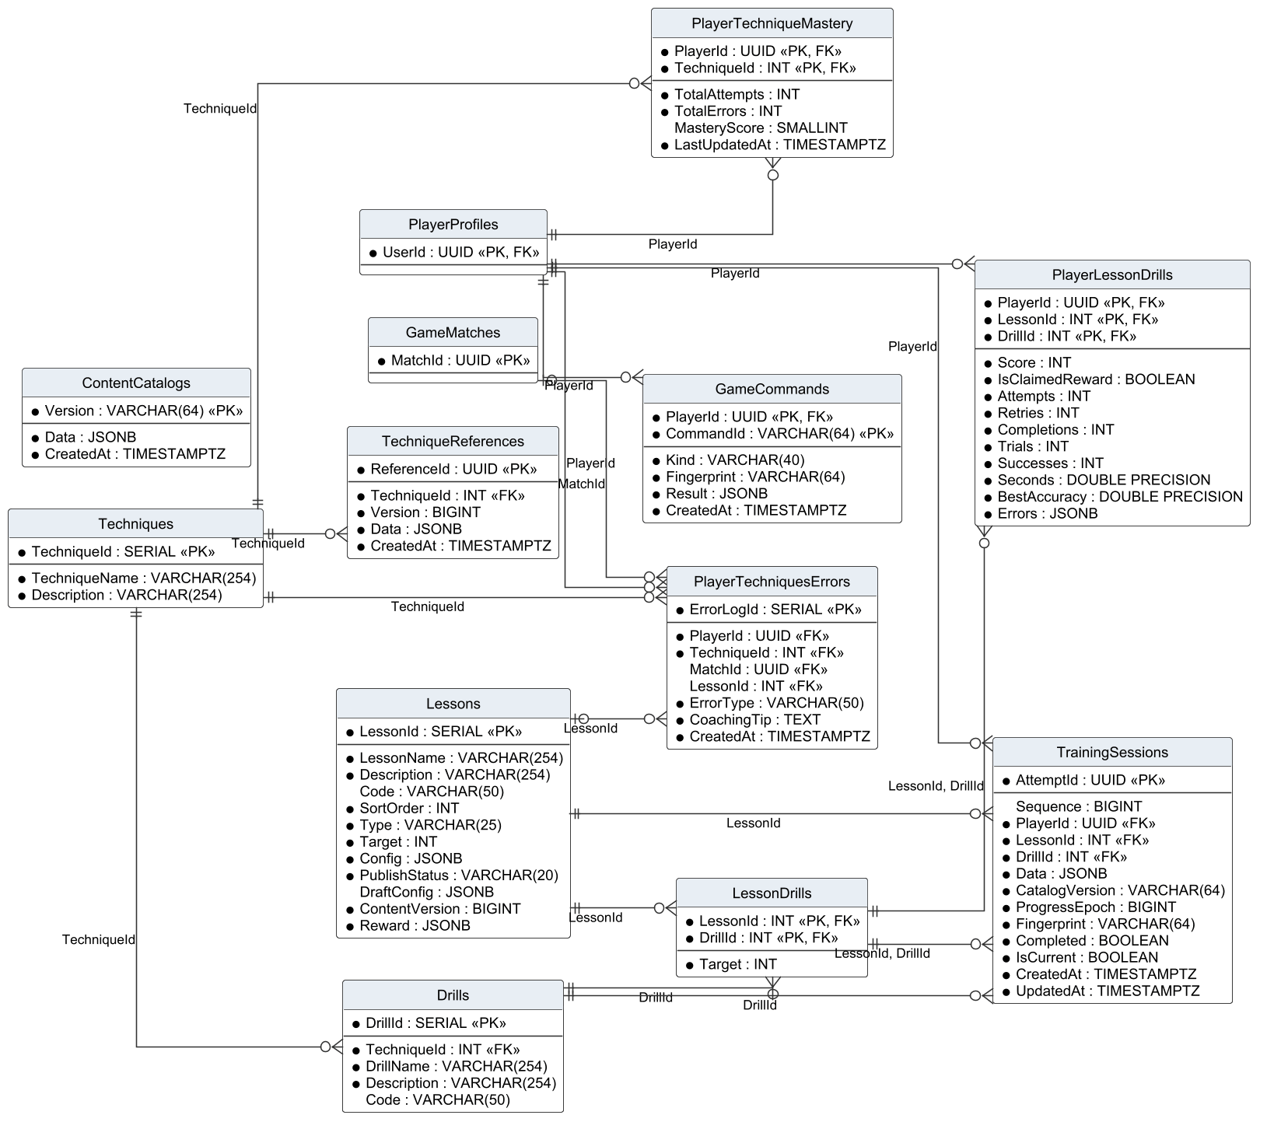
Figure 8. Logical ERD – techniques, lessons and training
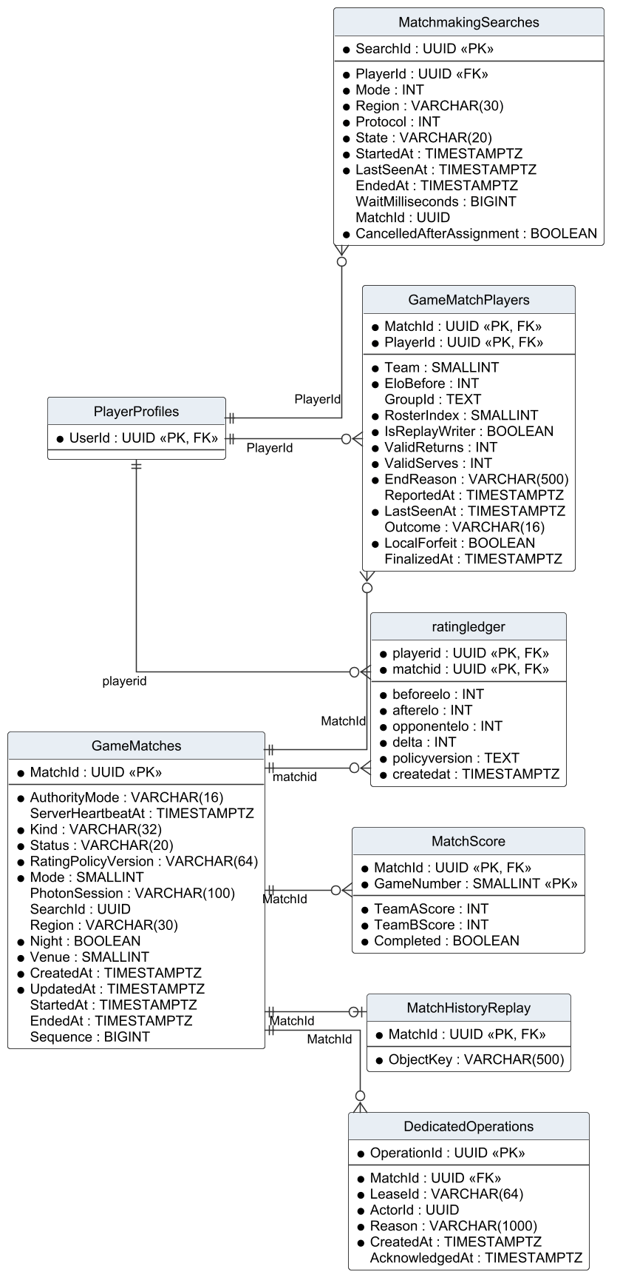
Figure 9. Logical ERD – matches, ratings, replays and matchmaking
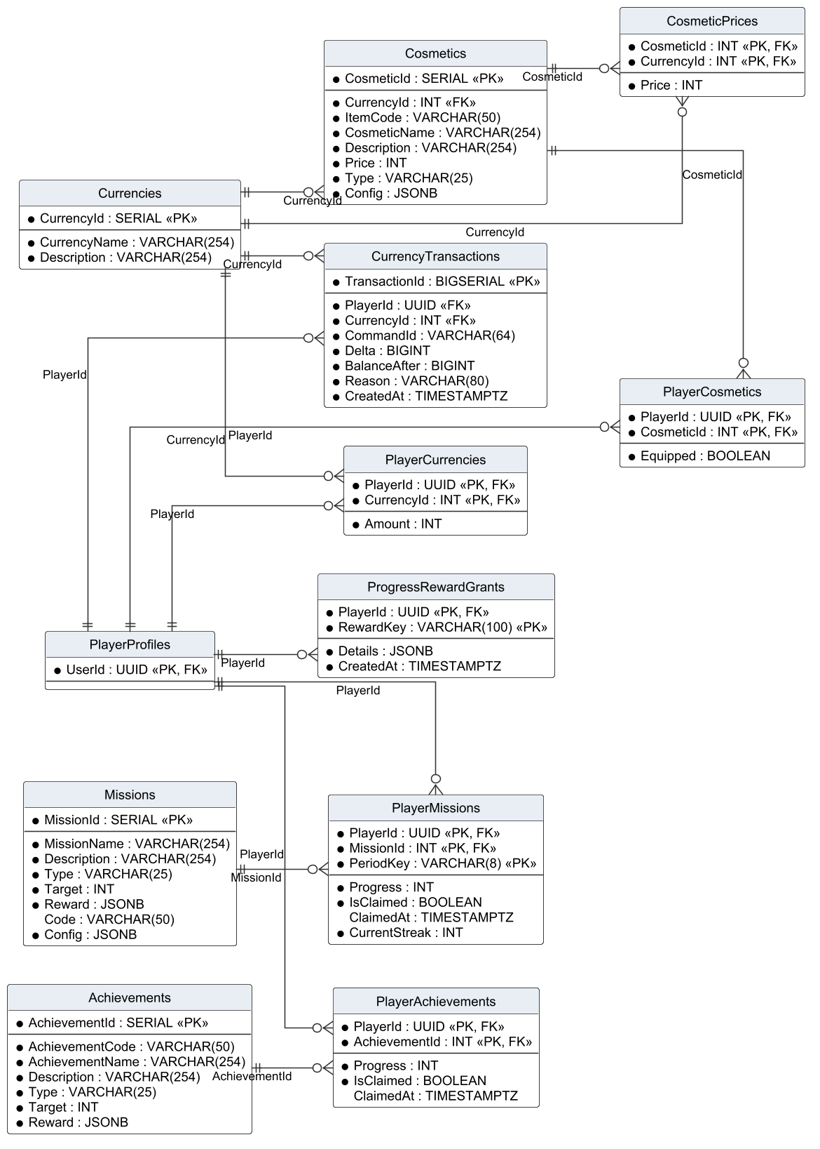
Figure 10. Logical ERD – currencies, cosmetics, missions and achievements
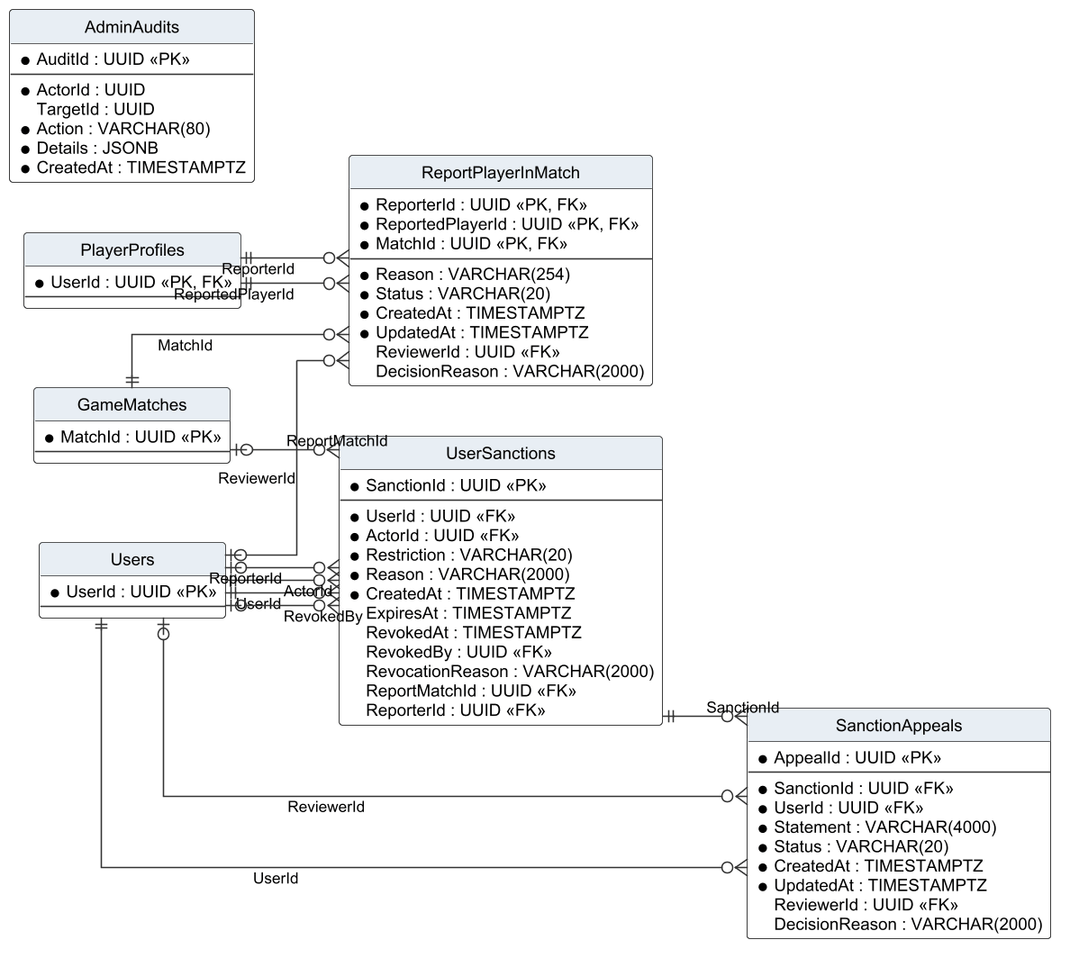
Figure 11. Logical ERD – reports, sanctions, appeals and audit
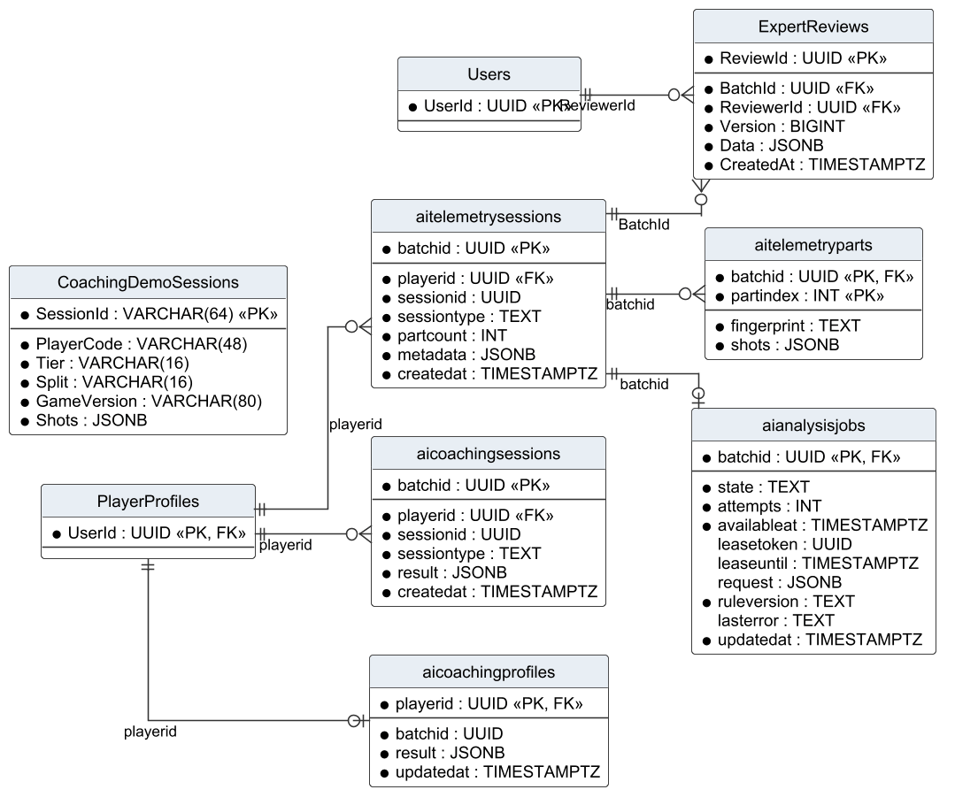
Figure 12. Logical ERD – telemetry, coaching and expert review
Table Descriptions
Table 8. Table descriptions (51 tables)
No | Table | Description
01 | Roles | Role catalogue (Player, Admin).  - Primary keys: RoleId  - Foreign keys: none
02 | Users | Account: e-mail, BCrypt password hash, role, status (ACTIVE, SUSPENDED, BANNED), creation time and the auth version used to revoke tokens. Whether the e-mail is verified is read from VerificationEmail.IsVerified.  - Primary keys: UserId  - Foreign keys: RoleId → Roles
03 | RefreshTokens | Refresh tokens stored as SHA-256 hashes with expiry and revocation time.  - Primary keys: TokenId  - Foreign keys: UserId → Users
04 | VerificationEmail | E-mail verification record of an account: HMAC of the current code, expiry, failed attempts and the IsVerified flag.  - Primary keys: VerificationEmailId  - Foreign keys: UserId → Users
05 | PasswordResetChallenges | The current password-reset challenge of an account (one per user).  - Primary keys: UserId  - Foreign keys: UserId → Users
06 | PlayerProfiles | Game profile of an account: display name, avatar, gender of the character, onboarding and tutorial state, level, XP, Elo, wins, losses, streaks, reset epochs and lifetime statistics. Equipped items are stored in PlayerCosmetics.Equipped.  - Primary keys: UserId  - Foreign keys: UserId → Users
07 | FriendRequests | Friend requests with status PENDING, ACCEPTED or DECLINED.  - Primary keys: RequestId  - Foreign keys: SenderId → Users; ReceiverId → Users
08 | Friendships | Accepted friendships stored once per pair (UserId1 < UserId2).  - Primary keys: UserId1, UserId2  - Foreign keys: UserId1 → Users; UserId2 → Users
09 | BlockedUsers | Blocks from one user to another.  - Primary keys: UserId, BlockedUserId  - Foreign keys: UserId → Users; BlockedUserId → Users
10 | GameMatches | Matches of every kind with mode, kind, authority mode, status (PREPARING, PLAYING, FINISHED, CANCELLED), rating policy and timestamps.  - Primary keys: MatchId  - Foreign keys: none
11 | PlayerLoginDays | Days (Vietnam time) on which a player signed in; used for retention.  - Primary keys: PlayerId, Day  - Foreign keys: PlayerId → Users
12 | PlayerActivityDays | Days on which a player was active, with active seconds.  - Primary keys: PlayerId, Day  - Foreign keys: PlayerId → PlayerProfiles
13 | MatchmakingSearches | Durable log of ranked searches with status SEARCHING, MATCHED, BOT, CANCELLED or TIMEOUT.  - Primary keys: SearchId  - Foreign keys: PlayerId → PlayerProfiles
14 | ReportPlayerInMatch | Player reports, one per reporter, reported player and match, with status and decision.  - Primary keys: ReporterId, ReportedPlayerId, MatchId  - Foreign keys: ReviewerId → Users; ReporterId → PlayerProfiles; ReportedPlayerId → PlayerProfiles; MatchId → GameMatches
15 | UserSanctions | Suspensions and bans with actor, reason, expiry and revocation data.  - Primary keys: SanctionId  - Foreign keys: UserId → Users; ActorId → Users; RevokedBy → Users; ReportMatchId → GameMatches; ReporterId → Users
16 | SanctionAppeals | Appeals, at most one per sanction, with statement, status and decision.  - Primary keys: AppealId  - Foreign keys: SanctionId → UserSanctions; UserId → Users; ReviewerId → Users
17 | MatchHistoryReplay | Object-storage key of the replay manifest of a match.  - Primary keys: MatchId  - Foreign keys: MatchId → GameMatches
18 | Currencies | Currency catalogue (TOKENPAD, ELITE TOKEN).  - Primary keys: CurrencyId  - Foreign keys: none
19 | PlayerCurrencies | Wallet balance of a player per currency.  - Primary keys: PlayerId, CurrencyId  - Foreign keys: PlayerId → PlayerProfiles; CurrencyId → Currencies
20 | Cosmetics | Cosmetic items with code, type, default price and currency, and display configuration.  - Primary keys: CosmeticId  - Foreign keys: CurrencyId → Currencies
21 | PlayerCosmetics | Items owned by a player and the equipped flag.  - Primary keys: PlayerId, CosmeticId  - Foreign keys: PlayerId → PlayerProfiles; CosmeticId → Cosmetics
22 | Achievements | Achievement definitions with type, target and reward.  - Primary keys: AchievementId  - Foreign keys: none
23 | PlayerAchievements | Achievement progress and claim time of a player.  - Primary keys: PlayerId, AchievementId  - Foreign keys: PlayerId → PlayerProfiles; AchievementId → Achievements
24 | Missions | Daily and weekly mission definitions with target and reward.  - Primary keys: MissionId  - Foreign keys: none
25 | PlayerMissions | Mission progress of a player in one period (PeriodKey) and the claim time.  - Primary keys: PlayerId, MissionId, PeriodKey  - Foreign keys: PlayerId → PlayerProfiles; MissionId → Missions
26 | Techniques | Techniques taught by the curriculum.  - Primary keys: TechniqueId  - Foreign keys: none
27 | TechniqueReferences | Versioned reference values used to judge a technique.  - Primary keys: ReferenceId  - Foreign keys: TechniqueId → Techniques
28 | Lessons | Lessons with code, group, order, target, reward (JSONB), configuration (JSONB), prerequisite and status (DRAFT, PUBLISHED, UNPUBLISHED).  - Primary keys: LessonId  - Foreign keys: none
29 | Drills | Drills that practise one technique.  - Primary keys: DrillId  - Foreign keys: TechniqueId → Techniques
30 | LessonDrills | Drills of a lesson with their target (many-to-many).  - Primary keys: LessonId, DrillId  - Foreign keys: LessonId → Lessons; DrillId → Drills
31 | PlayerTechniqueMastery | Mastery score of a player per technique.  - Primary keys: PlayerId, TechniqueId  - Foreign keys: PlayerId → PlayerProfiles; TechniqueId → Techniques
32 | PlayerTechniquesErrors | Technique errors detected for a player in a lesson or match.  - Primary keys: ErrorLogId  - Foreign keys: PlayerId → PlayerProfiles; TechniqueId → Techniques; MatchId → GameMatches; LessonId → Lessons
33 | PlayerLessonDrills | Best result of a player per lesson drill: stars, accuracy, timing, attempts and first-pass time.  - Primary keys: PlayerId, LessonId, DrillId  - Foreign keys: PlayerId → PlayerProfiles; LessonId, DrillId → LessonDrills
34 | CosmeticPrices | Prices of an item in each accepted currency.  - Primary keys: CosmeticId, CurrencyId  - Foreign keys: CosmeticId → Cosmetics; CurrencyId → Currencies
35 | GameCommands | Idempotency log of client commands (purchase, claim, sync) per player and command ID.  - Primary keys: PlayerId, CommandId  - Foreign keys: PlayerId → PlayerProfiles
36 | TrainingSessions | Each training attempt with lesson, drill, shots, hits, timing, stars and receipt status.  - Primary keys: AttemptId  - Foreign keys: PlayerId → PlayerProfiles; LessonId → Lessons; DrillId → Drills; LessonId, DrillId → LessonDrills
37 | MatchScore | Score of each game of a match (weak entity identified by match and game number).  - Primary keys: MatchId, GameNumber  - Foreign keys: MatchId → GameMatches
38 | GameMatchPlayers | Participants of a match: team, party group, roster slot, Elo before the match, replay-writer flag, valid serves and returns, end reason, last-seen time and outcome (WIN, LOSE, INTERRUPTED). Names, characters and bot accounts are joined from the profile tables.  - Primary keys: MatchId, PlayerId  - Foreign keys: MatchId → GameMatches; PlayerId → PlayerProfiles
39 | CurrencyTransactions | Ledger of every currency change with reason and reference.  - Primary keys: TransactionId  - Foreign keys: PlayerId → PlayerProfiles; CurrencyId → Currencies
40 | ratingledger | Elo before, delta and after for one player in one ranked match.  - Primary keys: playerid, matchid  - Foreign keys: playerid → PlayerProfiles; matchid → GameMatches
41 | aitelemetrysessions | Telemetry batch of a drill or match with source, mode and status.  - Primary keys: batchid  - Foreign keys: playerid → PlayerProfiles
42 | ExpertReviews | Expert labels (level, errors, data group) for a telemetry batch.  - Primary keys: ReviewId  - Foreign keys: BatchId → aitelemetrysessions; ReviewerId → Users
43 | CoachingDemoSessions | Simulated demonstration sessions kept apart from real player data.  - Primary keys: SessionId  - Foreign keys: none
44 | aitelemetryparts | Compressed parts of a telemetry batch.  - Primary keys: batchid, partindex  - Foreign keys: batchid → aitelemetrysessions
45 | aianalysisjobs | Analysis job of a batch with status pending, processing, completed or failed, attempts and error.  - Primary keys: batchid  - Foreign keys: batchid → aitelemetrysessions
46 | aicoachingsessions | Coaching result of a batch: findings, summary and recommendations.  - Primary keys: batchid  - Foreign keys: playerid → PlayerProfiles
47 | aicoachingprofiles | Aggregated coaching profile of a player.  - Primary keys: playerid  - Foreign keys: playerid → PlayerProfiles
48 | ContentCatalogs | Published versions of the content catalogue sent to clients.  - Primary keys: Version  - Foreign keys: none
49 | ProgressRewardGrants | Log of one-time progression rewards (for example THOT, GEMSTONE) per player.  - Primary keys: PlayerId, RewardKey  - Foreign keys: PlayerId → PlayerProfiles
50 | DedicatedOperations | Operations on dedicated matches (stop requests and their acknowledgement).  - Primary keys: OperationId  - Foreign keys: MatchId → GameMatches
51 | AdminAudits | Audit trail of administrative actions with actor, action, target and data.  - Primary keys: AuditId  - Foreign keys: none

2.1 Data Dictionary of the Core Tables
The core tables of the account, match, training and moderation domains are listed column by column. Types are PostgreSQL types; * marks NOT NULL.
Table 9. Data dictionary – Users
Column | Type | Null | Key | Notes
UserId | UUID | * | PK
Email | VARCHAR(254) | *
PasswordHash | VARCHAR(254) | *
AuthVersion | INT | *
RoleId | INT | * | FK → Roles
Status | VARCHAR(20) | * |  | ACTIVE, SUSPENDED, BANNED
CreatedAt | TIMESTAMPTZ | *

Table 10. Data dictionary – PlayerProfiles
Column | Type | Null | Key | Notes
UserId | UUID | * | PK, FK → Users
Avatar | VARCHAR(80) | *
PlayerName | VARCHAR(18) | *
Elo | INT | *
IsMale | BOOLEAN | *
TimePlayedSeconds | BIGINT | *
Level | INT | *
Exp | INT | *
WinStreak | INT | *
DayStreak | INT | *
WinCount | INT | *
LoseCount | INT | *
Revision | BIGINT | *
LearningEpoch | BIGINT | *
LearningResetAt | TIMESTAMPTZ
MissionEpoch | BIGINT | *
EconomyEpoch | BIGINT | *
ExperienceChoice | VARCHAR(20)
TutorialCompleted | BOOLEAN | *
TutorialSkipped | BOOLEAN | *
TutorialCheckpoint | INT | *
DailyStreakEnabledAt | TIMESTAMPTZ
RankWinStreak | INT | *
RankLossStreak | INT | *
BestWinStreak | INT | *
LifetimeMatches | BIGINT | *
LifetimePoints | BIGINT | *
LifetimeReturns | BIGINT | *
LifetimeServes | BIGINT | *
LifetimeBotMatches | BIGINT | *
LifetimeHumanMatches | BIGINT | *
LifetimeHumanWins | BIGINT | *
LifetimeRankedWins | BIGINT | *
LifetimeDoublesWins | BIGINT | *
LifetimeHigherRatedWins | BIGINT | *

Table 11. Data dictionary – GameMatches
Column | Type | Null | Key | Notes
AuthorityMode | VARCHAR(16) | * |  | shared or dedicated
ServerHeartbeatAt | TIMESTAMPTZ
MatchId | UUID | * | PK
Kind | VARCHAR(32) | *
Status | VARCHAR(20) | * |  | PREPARING, PLAYING, FINISHED, CANCELLED
RatingPolicyVersion | VARCHAR(64) | *
Mode | SMALLINT | *
PhotonSession | VARCHAR(100)
SearchId | UUID
Region | VARCHAR(30)
Night | BOOLEAN | *
Venue | SMALLINT | *
CreatedAt | TIMESTAMPTZ | *
UpdatedAt | TIMESTAMPTZ | *
StartedAt | TIMESTAMPTZ
EndedAt | TIMESTAMPTZ
Sequence | BIGINT

Table 12. Data dictionary – GameMatchPlayers
Column | Type | Null | Key | Notes
MatchId | UUID | * | PK, FK → GameMatches
PlayerId | UUID | * | PK, FK → PlayerProfiles
Team | SMALLINT | *
EloBefore | INT | *
GroupId | TEXT
RosterIndex | SMALLINT | *
IsReplayWriter | BOOLEAN | *
ValidReturns | INT | *
ValidServes | INT | *
EndReason | VARCHAR(500) | *
ReportedAt | TIMESTAMPTZ
LastSeenAt | TIMESTAMPTZ | *
Outcome | VARCHAR(16)
LocalForfeit | BOOLEAN | *
FinalizedAt | TIMESTAMPTZ

Table 13. Data dictionary – MatchScore
Column | Type | Null | Key | Notes
MatchId | UUID | * | PK, FK → GameMatches
GameNumber | SMALLINT | * | PK
TeamAScore | INT | *
TeamBScore | INT | *
Completed | BOOLEAN | *

Table 14. Data dictionary – ratingledger
Column | Type | Null | Key | Notes
playerid | UUID | * | PK, FK → PlayerProfiles
matchid | UUID | * | PK, FK → GameMatches
beforeelo | INT | *
afterelo | INT | *
opponentelo | INT | *
delta | INT | *
policyversion | TEXT | *
createdat | TIMESTAMPTZ | *

Table 15. Data dictionary – Lessons
Column | Type | Null | Key | Notes
LessonId | SERIAL | * | PK
LessonName | VARCHAR(254) | *
Description | VARCHAR(254) | *
Code | VARCHAR(50)
SortOrder | INT | *
Type | VARCHAR(25) | *
Target | INT | *
Config | JSONB | *
PublishStatus | VARCHAR(20) | *
DraftConfig | JSONB
ContentVersion | BIGINT | *
Reward | JSONB | *

Table 16. Data dictionary – TrainingSessions
Column | Type | Null | Key | Notes
AttemptId | UUID | * | PK
Sequence | BIGINT
PlayerId | UUID | * | FK → PlayerProfiles
LessonId | INT | * | FK → LessonDrills
DrillId | INT | * | FK → LessonDrills
Data | JSONB | *
CatalogVersion | VARCHAR(64) | *
ProgressEpoch | BIGINT | *
Fingerprint | VARCHAR(64) | *
Completed | BOOLEAN | *
IsCurrent | BOOLEAN | *
CreatedAt | TIMESTAMPTZ | *
UpdatedAt | TIMESTAMPTZ | *

Table 17. Data dictionary – UserSanctions
Column | Type | Null | Key | Notes
SanctionId | UUID | * | PK
UserId | UUID | * | FK → Users
ActorId | UUID | * | FK → Users
Restriction | VARCHAR(20) | * |  | BANNED or SUSPENDED; SUSPENDED requires ExpiresAt
Reason | VARCHAR(2000) | *
CreatedAt | TIMESTAMPTZ | *
ExpiresAt | TIMESTAMPTZ
RevokedAt | TIMESTAMPTZ
RevokedBy | UUID |  | FK → Users
RevocationReason | VARCHAR(2000)
ReportMatchId | UUID |  | FK → GameMatches
ReporterId | UUID |  | FK → Users

Table 18. Data dictionary – SanctionAppeals
Column | Type | Null | Key | Notes
AppealId | UUID | * | PK
SanctionId | UUID | * | FK → UserSanctions | UNIQUE: one appeal per sanction
UserId | UUID | * | FK → Users
Statement | VARCHAR(4000) | *
Status | VARCHAR(20) | * |  | PENDING, CHECKING, ACCEPTED, DECLINED
CreatedAt | TIMESTAMPTZ | *
UpdatedAt | TIMESTAMPTZ | *
ReviewerId | UUID |  | FK → Users
DecisionReason | VARCHAR(2000)

2.2 Design Notes
• Team game totals are not stored in GameMatches; they are derived from the completed MatchScore rows, which avoids inconsistent copies (AGENTS.md).
• GameMatchPlayers keeps only facts that belong to the participant in that match, including the fixed Elo input needed before a rating ledger row exists; names and cosmetics are joined from the profile tables.
• PlayerProfiles is wide (35 columns) because it is the hot read model of the menu; statistics that change together are kept in one row to avoid joins on every screen.
• TrainingSessions references Lessons, Drills and the composite LessonDrills key: the composite key guarantees that the drill belongs to the lesson, and the single keys keep historical attempts when a lesson is re-configured.
• Lessons.Reward and Lessons.Config are JSONB because each lesson type has different parameters; the API validates them before saving.
• AdminAudits stores the actor ID without a foreign key so that audit records survive the deletion of an administrator account.
• CoachingDemoSessions holds simulated data in its own table so that it can never be mixed with real sessions used for AI evaluation.
• Idempotency: GameCommands, TrainingSessions receipts and the UNIQUE constraints on rewards (ProgressRewardGrants, PlayerMissions period key) make retried requests safe.

3. Detailed Design
Each subsection gives the class diagram of one feature group, the specification of its classes and the sequence diagrams of its main functions. Client classes (Unity) and server classes (Web API) are drawn in the same diagram only when the diagram shows their interaction; the boundary is the HTTP API, marked as a dependency to the controller.

3.1 Account and Authentication
This feature group implements FR-01 to FR-05. The Unity AccountScreen calls AccountService, which uses ApiClient to reach AuthController. AuthService performs the rules of BR-01 to BR-05 through IUnitOfWork and sends e-mails through IEmailSender.

3.1.1 Class Diagram
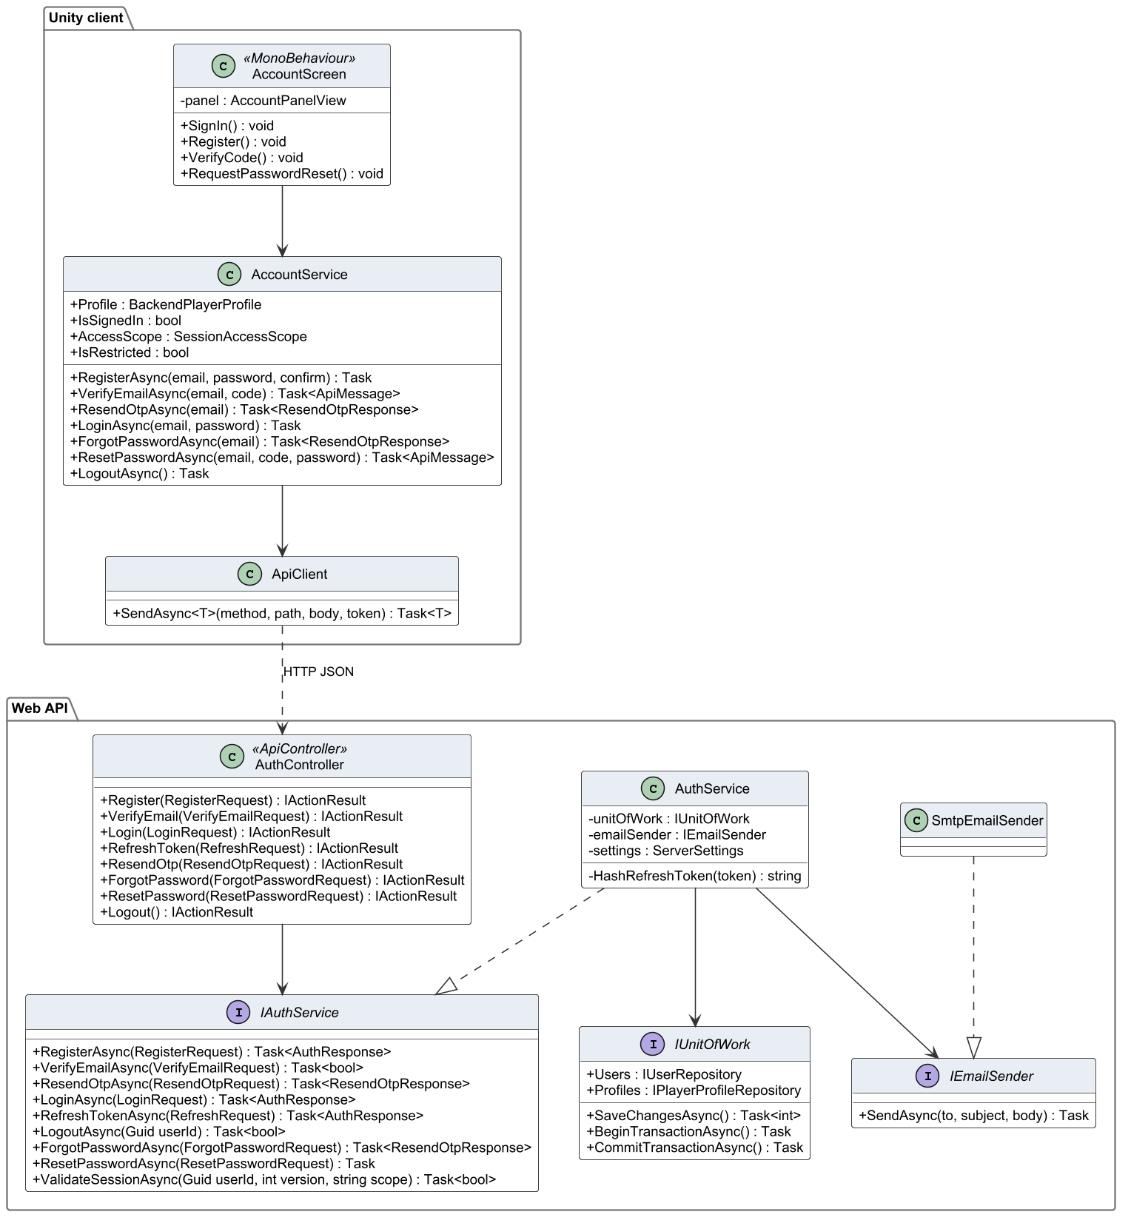
Figure 13. Class diagram – account and authentication

3.1.2 Class Specifications
Table 19. Class specifications – account and authentication
Class | Responsibility | Main attributes | Main operations
AccountScreen  «MonoBehaviour» | Login, register, verification and password-reset pages of the Login scene; client-side validation | - panel : AccountPanelView | + SignIn() : void  + Register() : void  + VerifyCode() : void  + RequestPasswordReset() : void
AccountService | Client facade for authentication; keeps the session, scope and profile and refreshes tokens | + Profile : BackendPlayerProfile  + IsSignedIn : bool  + AccessScope : SessionAccessScope  + IsRestricted : bool | + RegisterAsync(email, password, confirm) : Task  + VerifyEmailAsync(email, code) : Task<ApiMessage>  + ResendOtpAsync(email) : Task<ResendOtpResponse>  + LoginAsync(email, password) : Task  + ForgotPasswordAsync(email) : Task<ResendOtpResponse>  + ResetPasswordAsync(email, code, password) : Task<ApiMessage>  + LogoutAsync() : Task
ApiClient | Sends HTTP requests with the bearer token and unwraps the ApiResponse envelope | – | + SendAsync<T>(method, path, body, token) : Task<T>
AuthController  «ApiController» | REST endpoints /api/Auth/*; rate-limited | – | + Register(RegisterRequest) : IActionResult  + VerifyEmail(VerifyEmailRequest) : IActionResult  + Login(LoginRequest) : IActionResult  + RefreshToken(RefreshRequest) : IActionResult  + ResendOtp(ResendOtpRequest) : IActionResult  + ForgotPassword(ForgotPasswordRequest) : IActionResult  + ResetPassword(ResetPasswordRequest) : IActionResult  + Logout() : IActionResult
IAuthService  «interface» | Contract of the authentication use cases | – | + RegisterAsync(RegisterRequest) : Task<AuthResponse>  + VerifyEmailAsync(VerifyEmailRequest) : Task<bool>  + ResendOtpAsync(ResendOtpRequest) : Task<ResendOtpResponse>  + LoginAsync(LoginRequest) : Task<AuthResponse>  + RefreshTokenAsync(RefreshRequest) : Task<AuthResponse>  + LogoutAsync(Guid userId) : Task<bool>  + ForgotPasswordAsync(ForgotPasswordRequest) : Task<ResendOtpResponse>  + ResetPasswordAsync(ResetPasswordRequest) : Task  + ValidateSessionAsync(Guid userId, int version, string scope) : Task<bool>
AuthService | Registration, OTP, sign-in, token issue and rotation, password reset, session validation | - unitOfWork : IUnitOfWork  - emailSender : IEmailSender  - settings : ServerSettings | - HashRefreshToken(token) : string
IEmailSender  «interface» | Abstraction for sending e-mail | – | + SendAsync(to, subject, body) : Task
SmtpEmailSender | Sends e-mail through Gmail SMTP with STARTTLS | – | –
IUnitOfWork  «interface» | Gives services access to repositories and one shared transaction | + Users : IUserRepository  + Profiles : IPlayerProfileRepository | + SaveChangesAsync() : Task<int>  + BeginTransactionAsync() : Task  + CommitTransactionAsync() : Task

3.1.3 Register and verify e-mail
The visitor registers; the service hashes the password, stores the HMAC of a six-digit code and queues the e-mail. The alternative fragments show a confirmation mismatch, a registered e-mail, a valid code and an invalid or expired code.
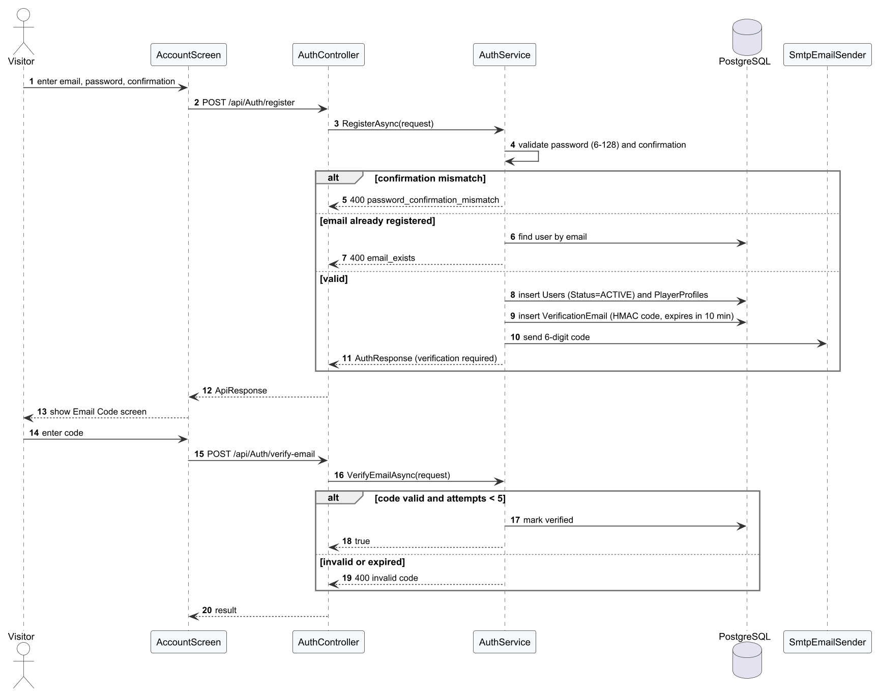
Figure 14. Sequence diagram – Register and verify e-mail

3.1.4 Sign in
The service checks the password hash and the account state. A wrong password, an unverified e-mail and a restricted account return different results; an active account receives the JWT and refresh token, after which the client loads the profile.
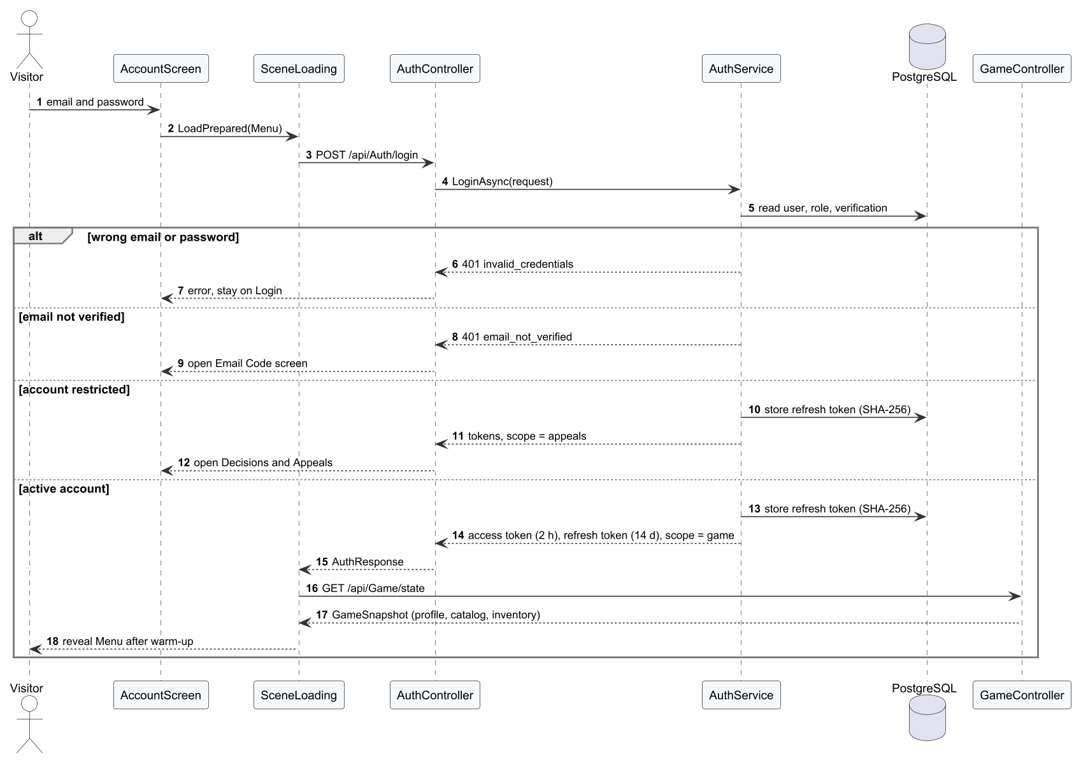
Figure 15. Sequence diagram – Sign in

3.1.5 Reset password
The reset request always returns the same message; the mail queue sends the code only for a verified account. A valid code changes the hash and revokes every refresh token.

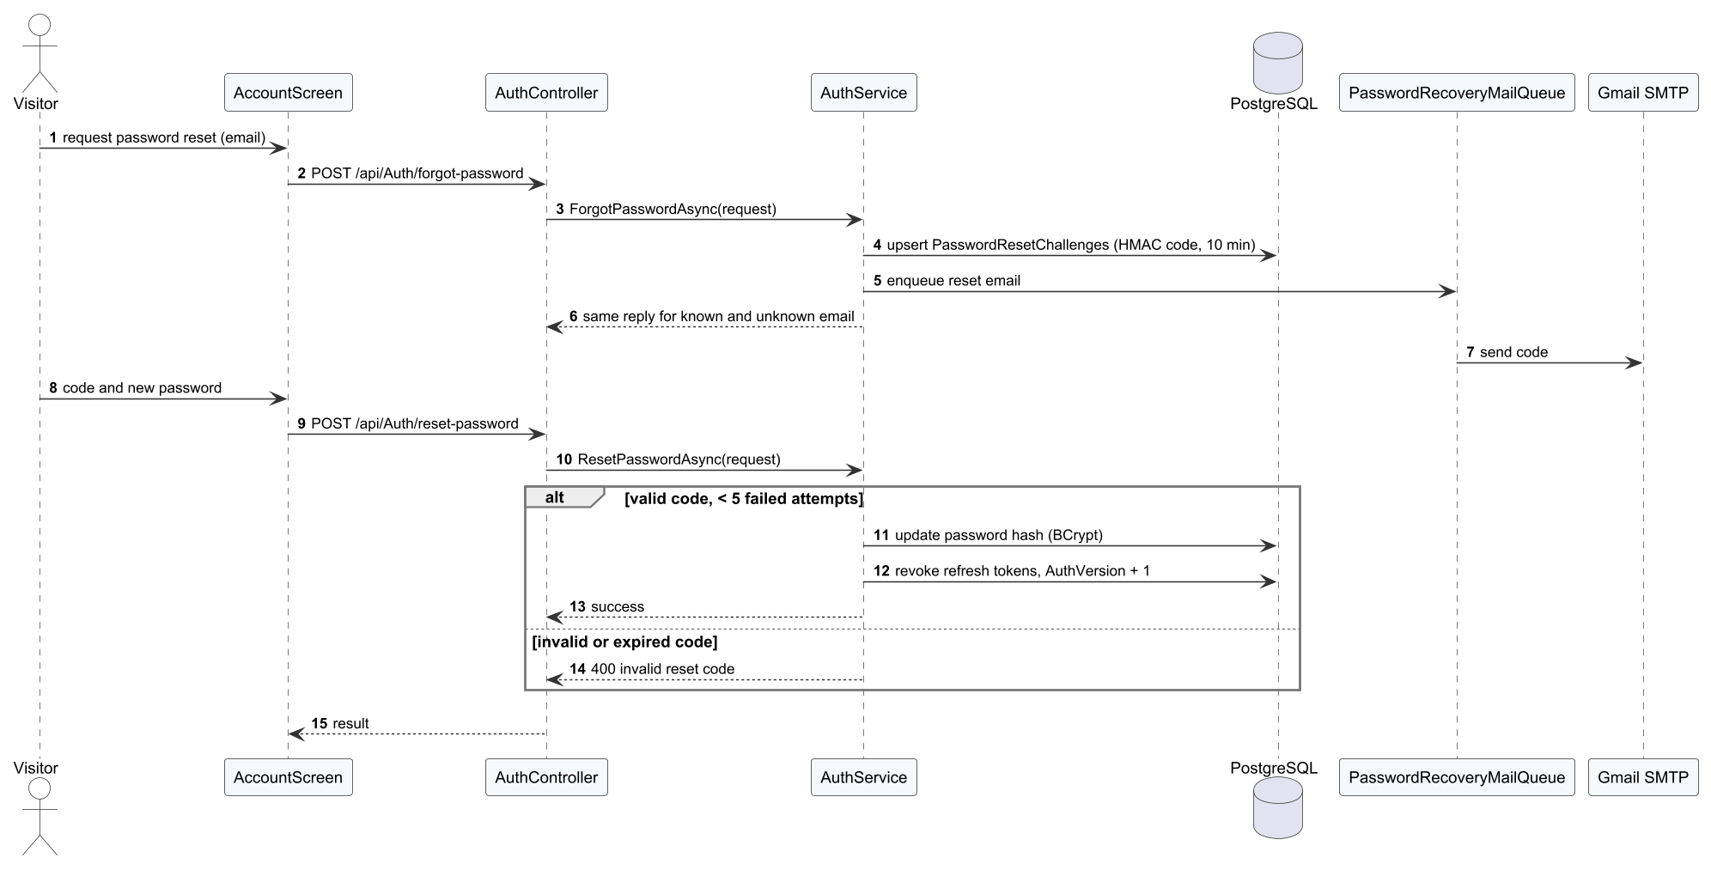
Figure 16. Sequence diagram – Reset password

3.2 Gameplay Core and Ball Physics
The gameplay core implements FR-11 to FR-13. BotMatch drives the match phases. Each MatchActor reads its intent from ShotInput (player) or a bot. PaddleContact accepts the hit, ShotTrajectory computes the launch velocity, BallFlight advances the ball and SinglesRules decides the outcome. The rule and physics classes have no Unity dependencies, so the same code runs in the client, in the dedicated server and in EditMode unit tests. The camera follows the common sports-game convention of a view from behind the player's own baseline: MatchCamera and the online camera both call CourtFollowView, which keeps the player's feet above the bottom HUD band (shot cue on PC, touch controls on Android) and widens the view slightly so that the far baseline stays visible; HudActorClearance moves the shot cue if it would still cover the player (defect D-03).
Table 20. Gameplay and physics parameters
Parameter | Value | Source / meaning
Simulation step | 120 Hz (1/120 s) | BallFlight fixed step, independent of frame rate
Gravity | 9.81 m/s² | Ball flight
Bounce restitution | 0.73 | Vertical speed kept after a bounce
Ball radius | 0.037 m | Line calls use the ball edge
Court half width / half length / kitchen | 3.048 / 6.7056 / 2.1336 m | SinglesRules.Court, official dimensions
Contact window | ±65 ms | PaddleContact; outside the window the swing misses
Perfect contact | ≤ 0.145 m and ±30 ms | Higher speed and accuracy
Serve timer | 10 s | Fault ServeTimeout
Contact delay per shot | serve 0.80 s, dink 0.367 s, drop 0.533 s, smash 0.50 s, volley/reset 0.233 s, drive 0.433 s | ShotIntent.ContactDelay: time from release to the animation's contact frame
Camera height / distance / field of view | 5.3 m / 4.25 m / 56° | CourtFollowView: position behind the player's baseline
Feet line | 25 % of screen height on PC, 32 % on Android | CourtFollowView.DesktopFeetLine / TouchFeetLine: the feet are never drawn lower
Extra field of view | up to 8° | Added only when needed to keep the far baseline and the opponent's head in view

3.2.1 Class Diagram
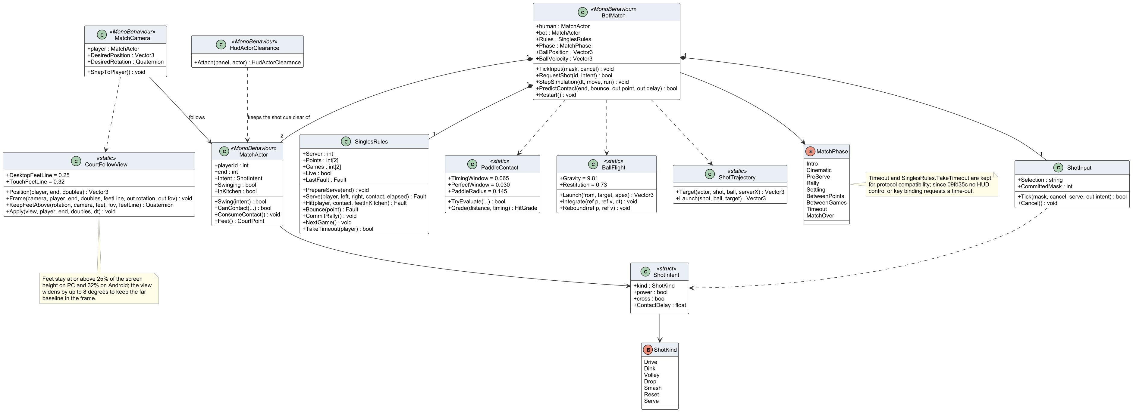
Figure 17. Class diagram – gameplay core (bot match)

3.2.2 Class Specifications
Table 21. Class specifications – gameplay core
Class | Responsibility | Main attributes | Main operations
BotMatch  «MonoBehaviour» | Orchestrates a local singles match: phases, serve, rally, scoring and result | + human : MatchActor  + bot : MatchActor  + Rules : SinglesRules  + Phase : MatchPhase  + BallPosition : Vector3  + BallVelocity : Vector3 | + TickInput(mask, cancel) : void  + RequestShot(id, intent) : bool  + StepSimulation(dt, move, run) : void  + PredictContact(end, bounce, out point, out delay) : bool  + Restart() : void
MatchActor  «MonoBehaviour» | Moves and animates one player and performs hits | + playerId : int  + end : int  + Intent : ShotIntent  + Swinging : bool  + InKitchen : bool | + Swing(intent) : bool  + CanContact(...) : bool  + ConsumeContact() : void  + Feet() : CourtPoint
SinglesRules | Decides faults, points, side-outs, games and match end (BR-10 to BR-15) | + Server : int  + Points : int[2]  + Games : int[2]  + Live : bool  + LastFault : Fault | + PrepareServe(end) : void  + Serve(player, left, right, contact, elapsed) : Fault  + Hit(player, contact, feetInKitchen) : Fault  + Bounce(point) : Fault  + CommitRally() : void  + NextGame() : void  + TakeTimeout(player) : bool
ShotInput | Decodes the J/K/L/U/I key state into one shot intent on the first release | + Selection : string  + CommittedMask : int | + Tick(mask, cancel, serve, out intent) : bool  + Cancel() : void
ShotIntent  «struct» | Requested shot kind with power and cross modifiers | + kind : ShotKind  + power : bool  + cross : bool  + ContactDelay : float | –
ShotKind  «enum» | Seven shot kinds of the local game | Drive  Dink  Volley  Drop  Smash  Reset  Serve | –
PaddleContact  «static» | Checks the contact window (±65 ms) and the contact quality (Perfect, Good) | + TimingWindow = 0.065  + PerfectWindow = 0.030  + PaddleRadius = 0.145 | + TryEvaluate(...) : bool  + Grade(distance, timing) : HitGrade
BallFlight  «static» | Fixed-step ball flight: gravity, drag-free arc and bounce with restitution 0.73 | + Gravity = 9.81  + Restitution = 0.73 | + Launch(from, target, apex) : Vector3  + Integrate(ref p, ref v, dt) : void  + Rebound(ref p, ref v) : void
ShotTrajectory  «static» | Computes launch velocity for a target point and flight time | – | + Target(actor, shot, ball, serverX) : Vector3  + Launch(shot, ball, target) : Vector3
MatchPhase  «enum» | Phases of a match (Intro, Cinematic, PreServe, Rally, Settling, BetweenPoints, BetweenGames, MatchOver); Timeout remains in the enum, with SinglesRules.TakeTimeout, only for protocol compatibility and is no longer entered | Intro  Cinematic  PreServe  Rally  Settling  BetweenPoints  BetweenGames  Timeout  MatchOver | –
MatchCamera  «MonoBehaviour» | Follows the local player behind the baseline and smooths position and rotation | + player : MatchActor  + DesiredPosition : Vector3  + DesiredRotation : Quaternion | + SnapToPlayer() : void
CourtFollowView  «static» | Shared framing rule for local and online matches: keeps the player's feet above the bottom HUD band and the far baseline in view | + DesktopFeetLine = 0.25  + TouchFeetLine = 0.32 | + Position(player, end, doubles) : Vector3  + Frame(camera, player, end, doubles, feetLine, out rotation, out fov) : void  + KeepFeetAbove(rotation, camera, feet, fov, feetLine) : Quaternion  + Apply(view, player, end, doubles, dt) : void
HudActorClearance  «MonoBehaviour» | Moves the shot-cue panel so that it never covers the player | – | + Attach(panel, actor) : HudActorClearance

3.3 Training and Offline Synchronisation
Training implements FR-06 to FR-10. TrainingDirector runs a drill locally with the gameplay core and evaluates it with TrainingEngine. Online, the attempt is sent at once; offline, OfflineTrainingStore keeps it until the device reconnects. On the server OnlineGameService re-evaluates the attempt with the same engine and returns a receipt.

3.3.1 Class Diagram
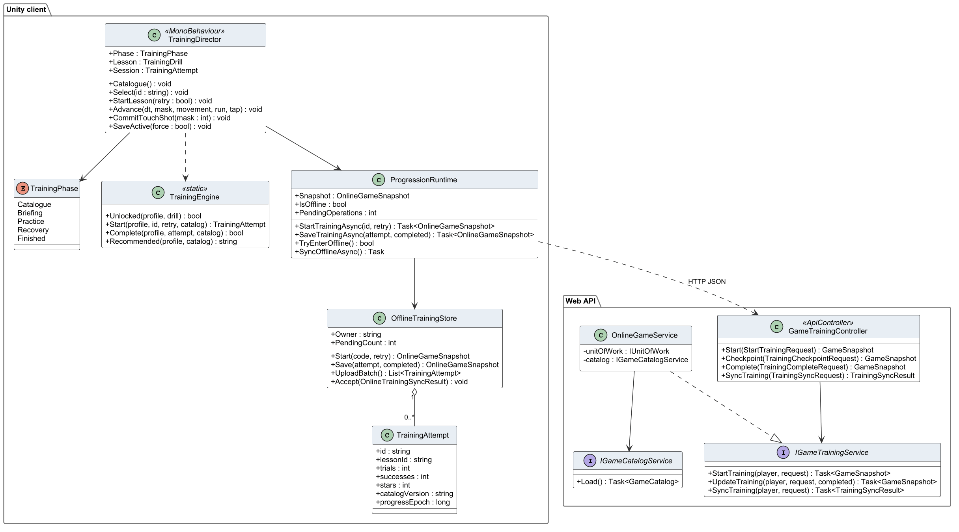
Figure 18. Class diagram – training and synchronisation

3.3.2 Class Specifications
Table 22. Class specifications – training
Class | Responsibility | Main attributes | Main operations
TrainingDirector  «MonoBehaviour» | Runs a drill in the Training scene: briefing, shots, feedback and result popup | + Phase : TrainingPhase  + Lesson : TrainingDrill  + Session : TrainingAttempt | + Catalogue() : void  + Select(id : string) : void  + StartLesson(retry : bool) : void  + Advance(dt, mask, movement, run, tap) : void  + CommitTouchShot(mask : int) : void  + SaveActive(force : bool) : void
TrainingPhase  «enum» | Phases of the training screen | Catalogue  Briefing  Practice  Recovery  Finished | –
TrainingEngine  «static» | Pure rules for drill evaluation: hits, timing and stars (BR-18) | – | + Unlocked(profile, drill) : bool  + Start(profile, id, retry, catalog) : TrainingAttempt  + Complete(profile, attempt, catalog) : bool  + Recommended(profile, catalog) : string
ProgressionRuntime | Client-side cache of profile, wallet, catalogue and the synchronisation queue | + Snapshot : OnlineGameSnapshot  + IsOffline : bool  + PendingOperations : int | + StartTrainingAsync(id, retry) : Task<OnlineGameSnapshot>  + SaveTrainingAsync(attempt, completed) : Task<OnlineGameSnapshot>  + TryEnterOffline() : bool  + SyncOfflineAsync() : Task
OfflineTrainingStore | Durable local queue of offline attempts with request IDs | + Owner : string  + PendingCount : int | + Start(code, retry) : OnlineGameSnapshot  + Save(attempt, completed) : OnlineGameSnapshot  + UploadBatch() : List<TrainingAttempt>  + Accept(OnlineTrainingSyncResult) : void
TrainingAttempt | Data of one drill attempt sent to the server | + id : string  + lessonId : string  + trials : int  + successes : int  + stars : int  + catalogVersion : string  + progressEpoch : long | –
GameTrainingController  «ApiController» | REST endpoints for starting, completing and synchronising training | – | + Start(StartTrainingRequest) : GameSnapshot  + Checkpoint(TrainingCheckpointRequest) : GameSnapshot  + Complete(TrainingCompleteRequest) : GameSnapshot  + SyncTraining(TrainingSyncRequest) : TrainingSyncResult
IGameTrainingService  «interface» | Contract of the training use cases | – | + StartTraining(player, request) : Task<GameSnapshot>  + UpdateTraining(player, request, completed) : Task<GameSnapshot>  + SyncTraining(player, request) : Task<TrainingSyncResult>
OnlineGameService | Server implementation of training, match settlement, matchmaking and economy use cases | - unitOfWork : IUnitOfWork  - catalog : IGameCatalogService | –
IGameCatalogService  «interface» | Provides the published content catalogue and its version | – | + Load() : Task<GameCatalog>

3.3.3 Practise a drill online
The server first checks that the lesson is published and unlocked, then records each trial; at the end it applies stars and the first-pass reward in one transaction.
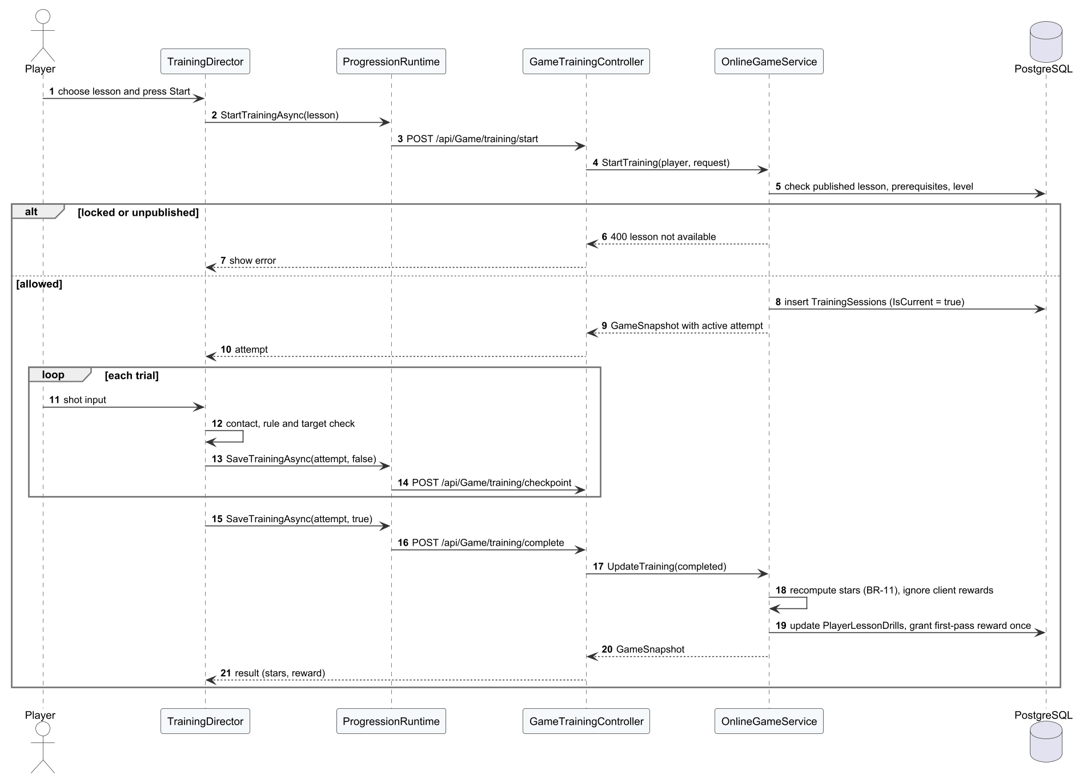
Figure 19. Sequence diagram – Practise a drill online

3.3.4 Synchronise offline attempts
Each queued attempt is sent with its request ID. A new and valid attempt is applied, an already applied one is answered DUPLICATE, and a stale or invalid one is REJECTED.

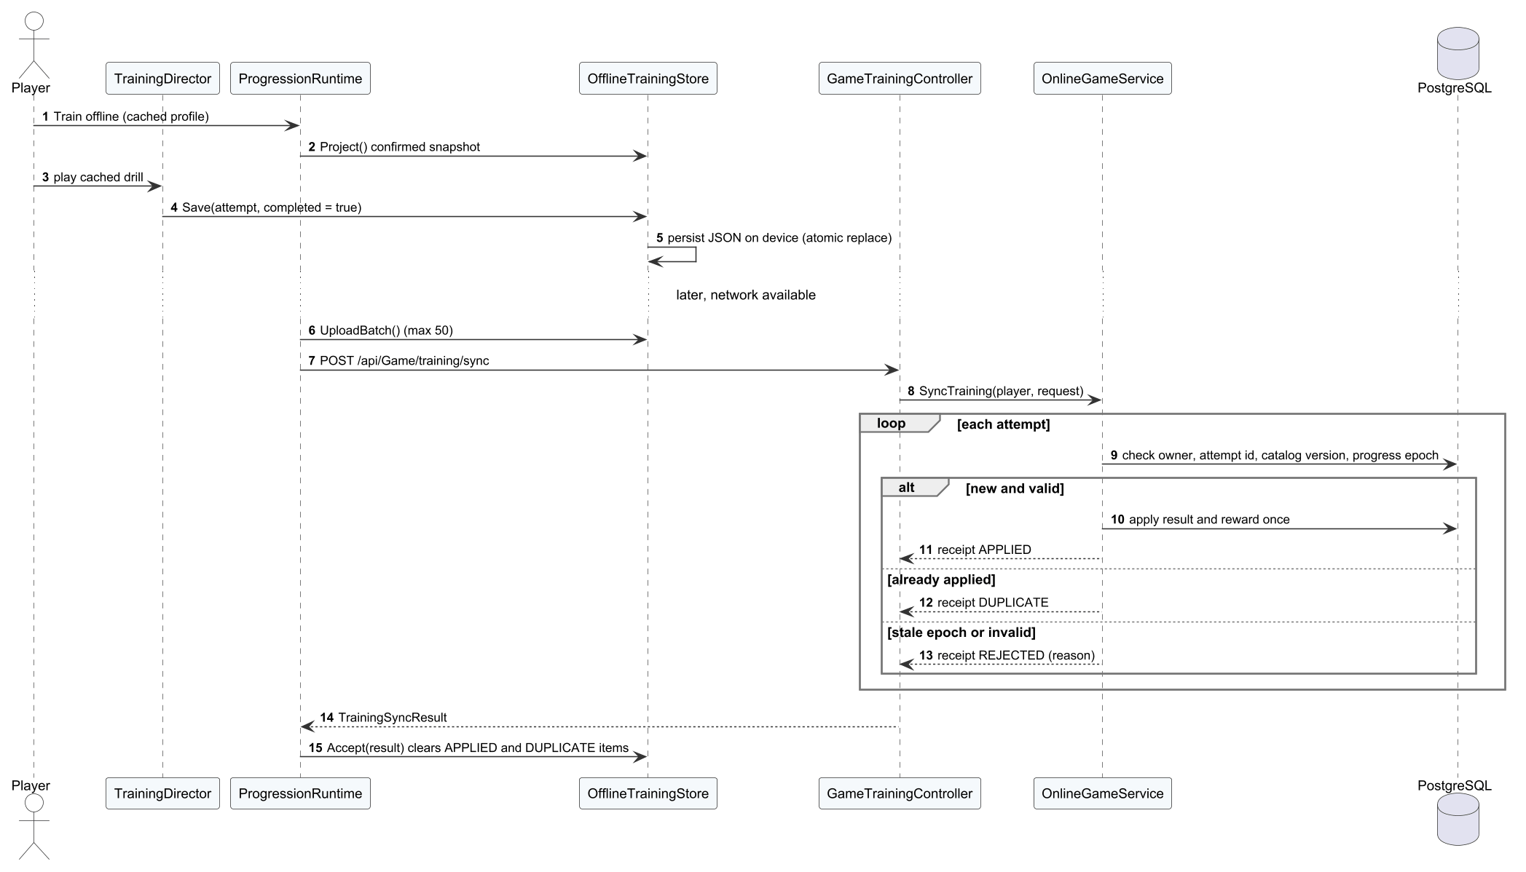
Figure 20. Sequence diagram – Synchronise offline attempts

3.4 Bot AI
The bot design implements FR-13 and BR-31. LocalBot provides three fixed levels. BhTreeBot executes a Unity Behavior graph whose decisions (position, shot choice, aggression, deliberate errors) are parameterised by BotPolicy and a BotTierProfile selected from the opponent's Elo. The IAdaptiveBotContext interface hides whether the bot plays locally or on the dedicated server, so the same bot is used for practice and for the ranked bot fallback.
Table 23. Bot parameters
Parameter | Value | Source / meaning
Fixed levels | Easy, Medium, Hard | LocalBot: fixed reaction and accuracy
Adaptive tiers | Elo < 500 beginner; < 2000 intermediate; ≥ 2000 advanced | BotPolicy tier selection
Ranked bot Elo | own + 120 (own − 100 after 5 losses) | EloPolicy.BotElo (BR-26)
Ranked bot accuracy | min(100, 25 + (Elo − 100) / 120) % | EloPolicy.BotAccuracy

3.4.1 Class Diagram
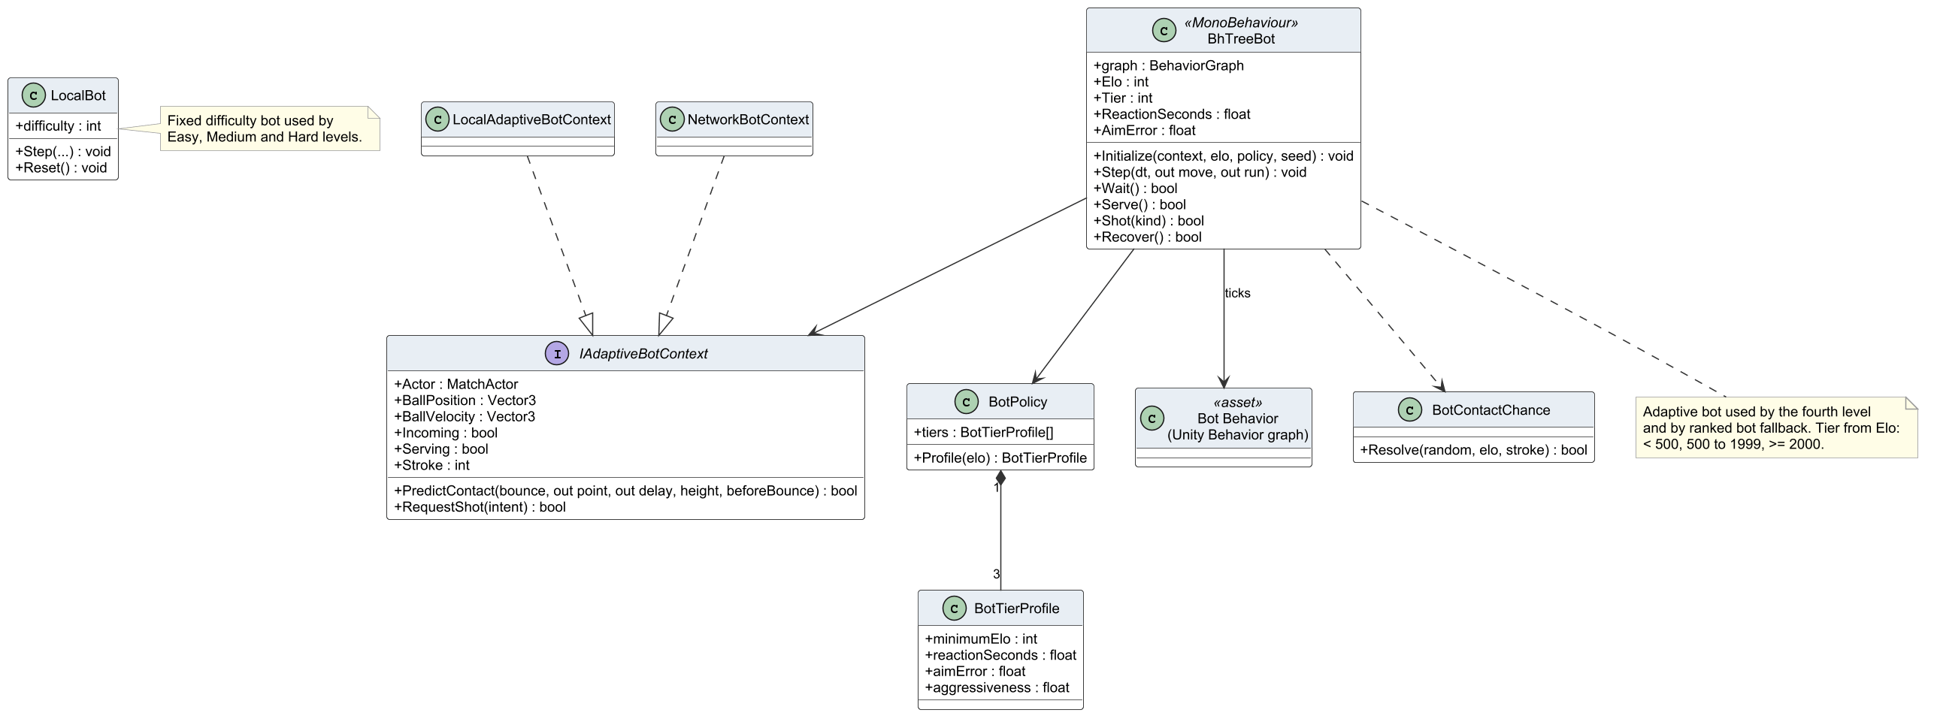
Figure 21. Class diagram – bots

3.4.2 Class Specifications
Table 24. Class specifications – bot AI
Class | Responsibility | Main attributes | Main operations
IAdaptiveBotContext  «interface» | Information the bot needs about ball, court and opponent, independent of local or network play | + Actor : MatchActor  + BallPosition : Vector3  + BallVelocity : Vector3  + Incoming : bool  + Serving : bool  + Stroke : int | + PredictContact(bounce, out point, out delay, height, beforeBounce) : bool  + RequestShot(intent) : bool
LocalAdaptiveBotContext | Bot context for a local bot match | – | –
NetworkBotContext | Bot context for a ranked bot on the dedicated server | – | –
BhTreeBot  «MonoBehaviour» | Adaptive bot driven by the Unity Behavior graph; tier chosen from Elo | + graph : BehaviorGraph  + Elo : int  + Tier : int  + ReactionSeconds : float  + AimError : float | + Initialize(context, elo, policy, seed) : void  + Step(dt, out move, out run) : void  + Wait() : bool  + Serve() : bool  + Shot(kind) : bool  + Recover() : bool
BotPolicy | Maps a tier to reaction time, accuracy, aggression and error rate | + tiers : BotTierProfile[] | + Profile(elo) : BotTierProfile
BotTierProfile | Parameter set of one bot tier | + minimumElo : int  + reactionSeconds : float  + aimError : float  + aggressiveness : float | –
LocalBot | Fixed-level bot (Easy, Medium, Hard) with deterministic settings | + difficulty : int | + Step(...) : void  + Reset() : void
Bot Behavior (Unity Behavior graph)  «asset» | Behaviour tree asset: position, choose shot, hit, recover | – | –
BotContactChance | Probability that the bot reaches and returns a ball | – | + Resolve(random, elo, stroke) : bool

3.4.3 Play a bot match
The loop fragment repeats rallies until one side wins two games; at the end the client reports the result to GameMatchesController, which settles rewards.
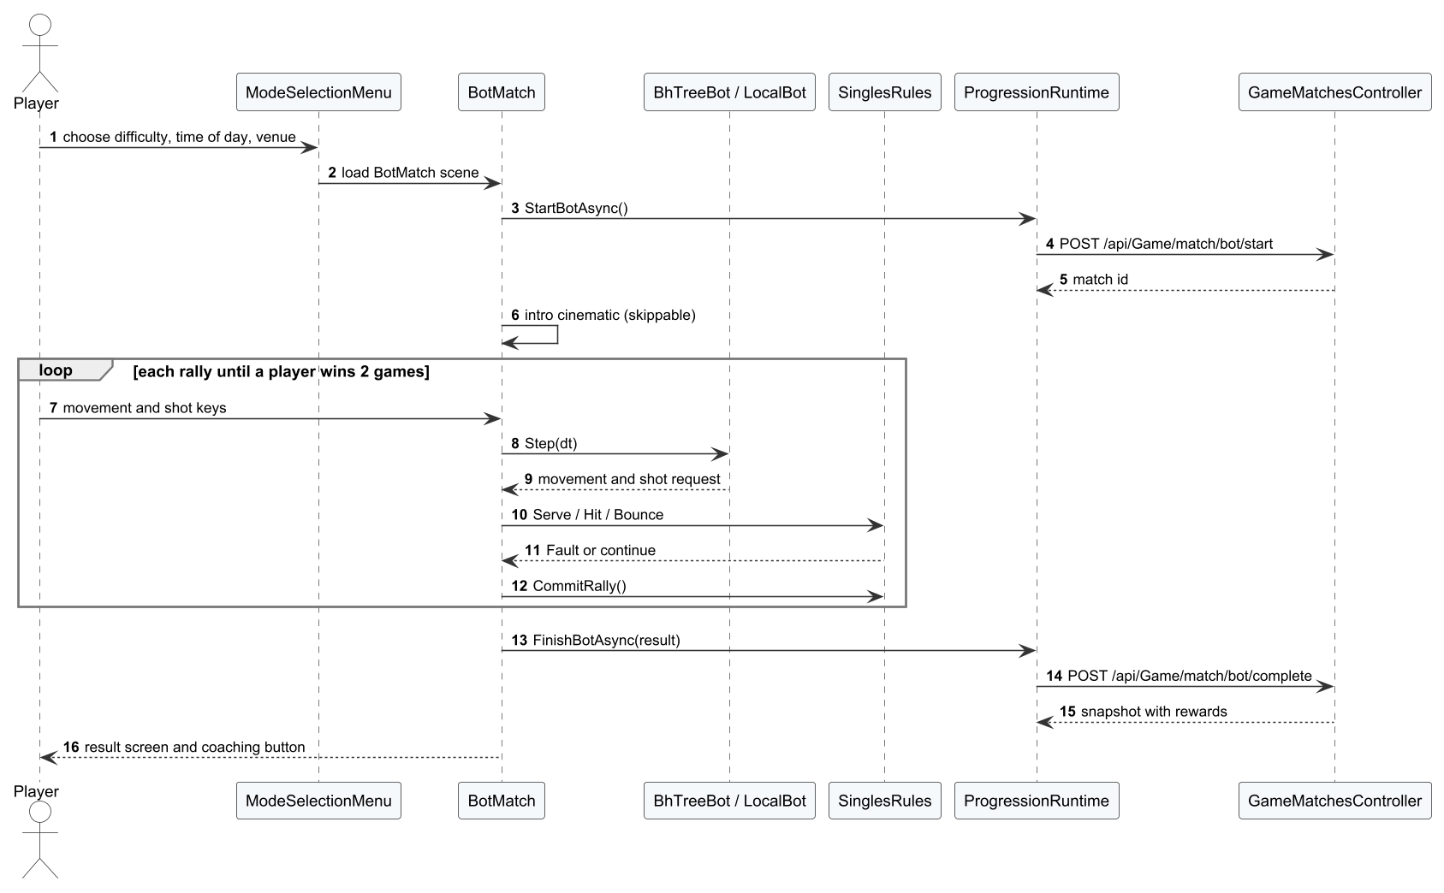
Figure 22. Sequence diagram – Play a bot match

3.5 Online Matchmaking and Netcode
Online play implements FR-14 to FR-18. MultiplayerApp is a state machine over FlowState; PlayMultiplayerPresenter and LobbyFriendsSidebar form the lobby screen. Unity Gaming Services code from the earlier prototype (files guarded by PICKLEVERSE_LEGACY_NGO) is not compiled; the live path uses only Photon Fusion and the Web API. Ranked singles, quick doubles (unrated 2v2, filled from solo players and parties of two, no bot fallback) and private rooms share the same ready check and dedicated-server allocation. PhotonSession connects to Fusion; NetworkMatch and NetworkPlayer replicate state from the dedicated server, which is the only authority. Table below gives the netcode design: clients send input only, predict their own movement and reconcile with the server frame; remote players are interpolated.
Table 25. Netcode design parameters
Parameter | Value | Source / meaning
Authority | Dedicated server (Fusion server mode) | Shared mode is kept only for local development without a server
Client input | DedicatedInput {Movement, Running, Sequence} | Sent every tick; shot commands travel as reliable messages (JSON, at most 16 KB) and are judged on the server
Local prediction | Own player only | The client applies its input at once and keeps the unacknowledged moves in a sequence-numbered list
Server frame | PlayerFrame {position, velocity, sequence, motionEpoch, movement, running} | Networked state of each player; sequence acknowledges the last input applied
Reconciliation | Replay unacknowledged moves from the server state | Acknowledged moves are dropped; the visible correction is smoothed and clamped to 1.5 m; a new motionEpoch (serve reset, teleport) forces a hard reset
Movement integration | 120 Hz sub-steps | Same step as the authority, so prediction and server agree
Remote players and ball | Interpolated in Render | Fusion snapshot interpolation
Lag compensation | Disabled | Hits are judged on the server's own state
Tick rate | Fusion project default | No explicit override in the project settings
Protocol version | 18 | Client and server must match or the connection is refused
Reconnection | client 30 s; server keeps the slot 30 s; API interrupts after 35 s without heartbeat (heartbeat every 8 s) | MultiplayerSettings.reconnectSeconds, NetworkMatch reservations, OnlineMatch settings (BR-28)

3.5.1 Class Diagram
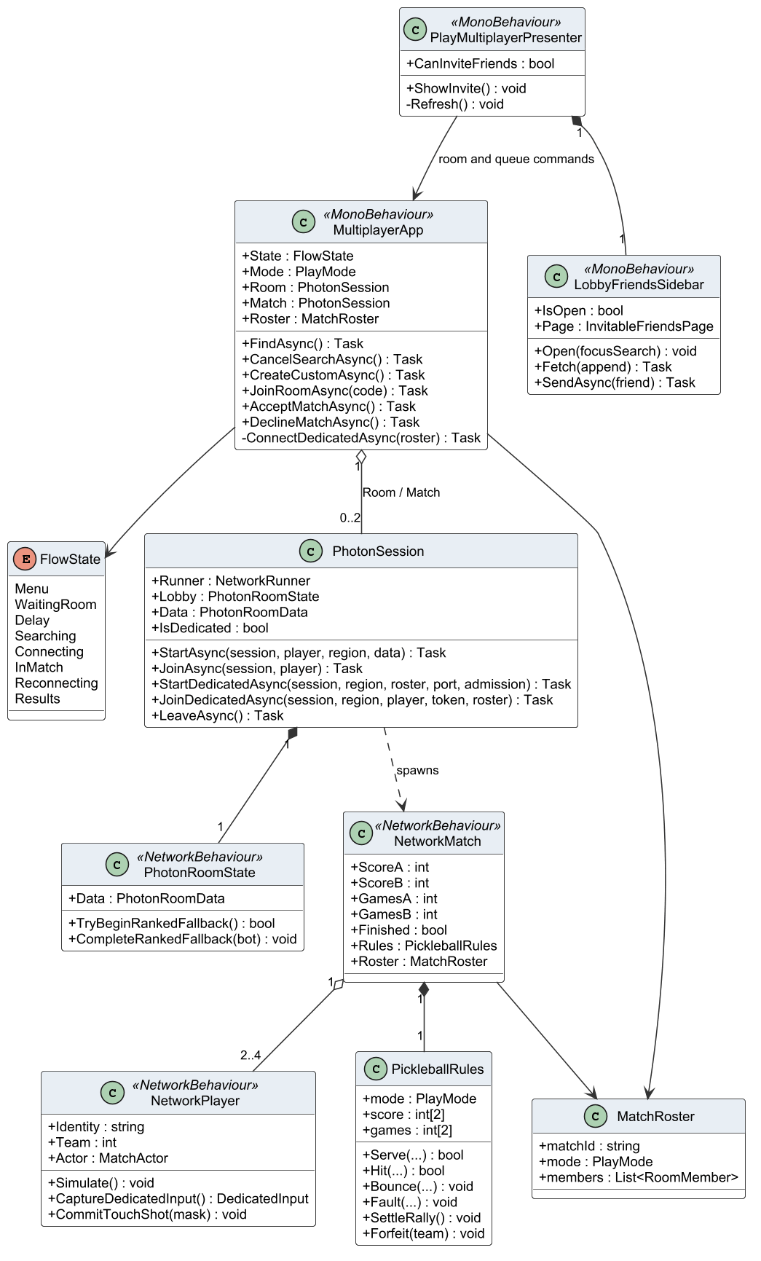
Figure 23. Class diagram – online client

3.5.2 Class Specifications
Table 26. Class specifications – online play
Class | Responsibility | Main attributes | Main operations
MultiplayerApp  «MonoBehaviour» | Online flow controller: lobby, search, ready check, loading, match, reconnection and results | + State : FlowState  + Mode : PlayMode  + Room : PhotonSession  + Match : PhotonSession  + Roster : MatchRoster | + FindAsync() : Task  + CancelSearchAsync() : Task  + CreateCustomAsync() : Task  + JoinRoomAsync(code) : Task  + AcceptMatchAsync() : Task  + DeclineMatchAsync() : Task  - ConnectDedicatedAsync(roster) : Task
FlowState  «enum» | States of the online flow (Menu, WaitingRoom, Delay, Searching, Connecting, InMatch, Reconnecting, Results) | Menu  WaitingRoom  Delay  Searching  Connecting  InMatch  Reconnecting  Results | –
PhotonSession | Starts and joins Fusion sessions in shared or client mode and handles disconnects | + Runner : NetworkRunner  + Lobby : PhotonRoomState  + Data : PhotonRoomData  + IsDedicated : bool | + StartAsync(session, player, region, data) : Task  + JoinAsync(session, player) : Task  + StartDedicatedAsync(session, region, roster, port, admission) : Task  + JoinDedicatedAsync(session, region, player, token, roster) : Task  + LeaveAsync() : Task
PhotonRoomState  «NetworkBehaviour» | Networked room state: roster, phase and host | + Data : PhotonRoomData | + TryBeginRankedFallback() : bool  + CompleteRankedFallback(bot) : void
NetworkMatch  «NetworkBehaviour» | Networked match state replicated from the authority: score, phase and ball | + ScoreA : int  + ScoreB : int  + GamesA : int  + GamesB : int  + Finished : bool  + Rules : PickleballRules  + Roster : MatchRoster | –
NetworkPlayer  «NetworkBehaviour» | Networked player: input, position and animation | + Identity : string  + Team : int  + Actor : MatchActor | + Simulate() : void  + CaptureDedicatedInput() : DedicatedInput  + CommitTouchShot(mask) : void
PickleballRules | Rules engine used by the network match (singles and doubles) | + mode : PlayMode  + score : int[2]  + games : int[2] | + Serve(...) : bool  + Hit(...) : bool  + Bounce(...) : void  + Fault(...) : void  + SettleRally() : void  + Forfeit(team) : void
MatchRoster | Teams, slots, bot flags and mode of a match | + matchId : string  + mode : PlayMode  + members : List<RoomMember> | –
PlayMultiplayerPresenter  «MonoBehaviour» | Online lobby screen: singles or doubles room, room code, search timer, invite button and ready state | + CanInviteFriends : bool | + ShowInvite() : void  - Refresh() : void
LobbyFriendsSidebar  «MonoBehaviour» | Collapsible friends column of the lobby: paged list of friends who can be invited, search and send invitation | + IsOpen : bool  + Page : InvitableFriendsPage | + Open(focusSearch) : void  + Fetch(append) : Task  + SendAsync(friend) : Task

3.5.3 Class Diagram – dedicated server coordination
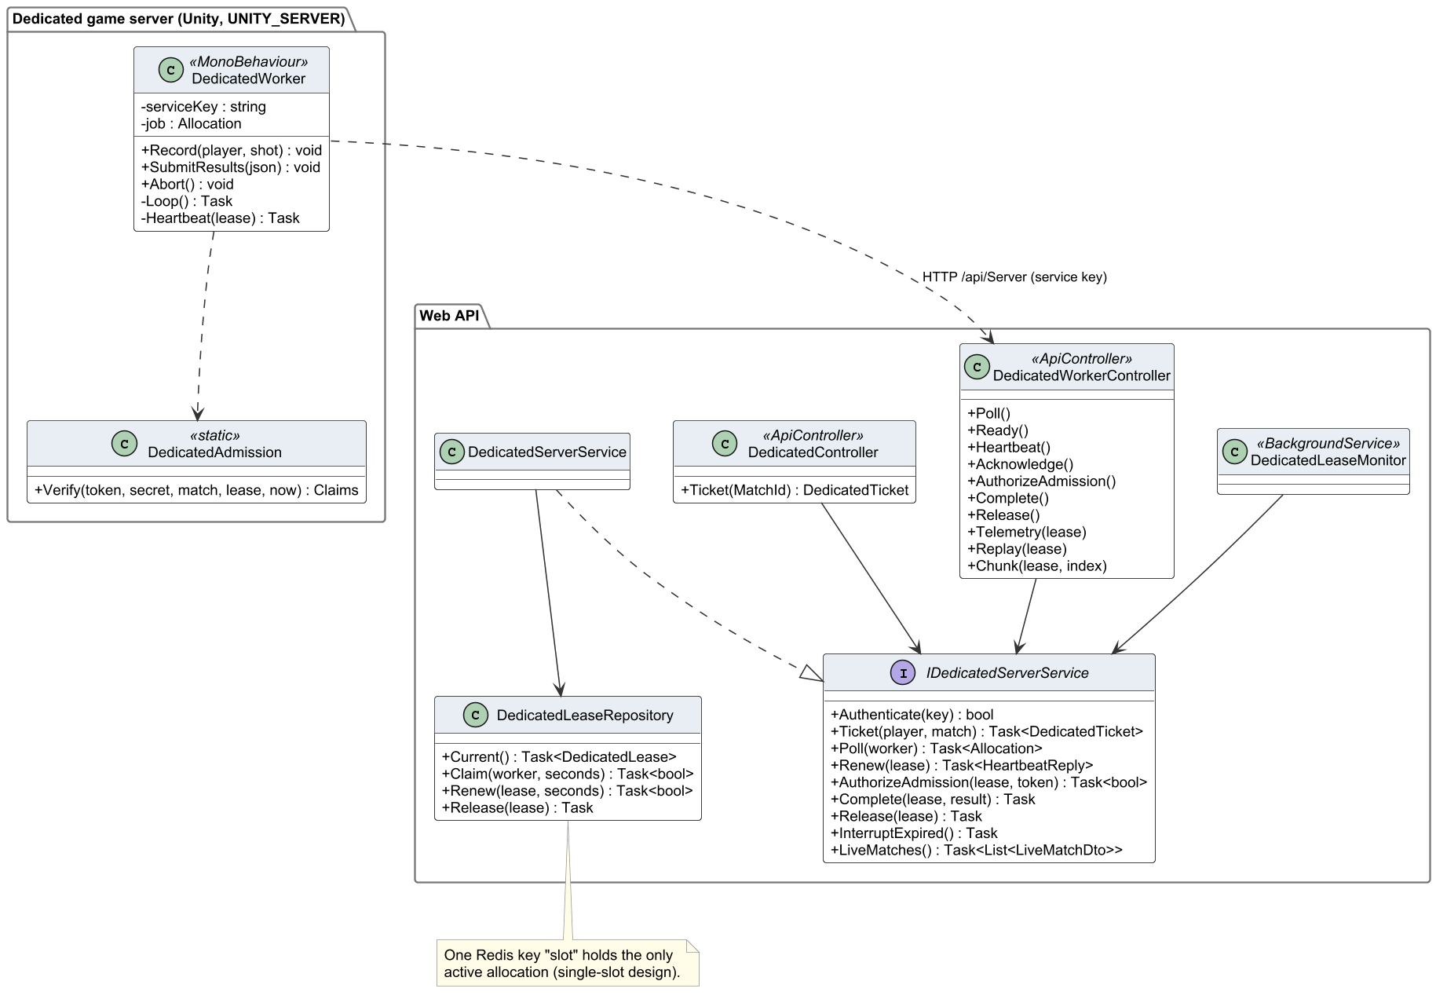
Figure 24. Class diagram – dedicated server coordination
Table 27. Class specifications – dedicated server
Class | Responsibility | Main attributes | Main operations
DedicatedWorker  «MonoBehaviour» | Main loop of the dedicated server: lease, admission, heartbeats, telemetry, replay and result | - serviceKey : string  - job : Allocation | + Record(player, shot) : void  + SubmitResults(json) : void  + Abort() : void  - Loop() : Task  - Heartbeat(lease) : Task
DedicatedAdmission  «static» | Validates HMAC tickets and admits players to the session | – | + Verify(token, secret, match, lease, now) : Claims
DedicatedWorkerController  «ApiController» | Service-key endpoints /api/Server/* used only by the dedicated server: poll, ready, heartbeat, admission, operation acknowledgement, telemetry, replay chunks, result and release | – | + Poll()  + Ready()  + Heartbeat()  + Acknowledge()  + AuthorizeAdmission()  + Complete()  + Release()  + Telemetry(lease)  + Replay(lease)  + Chunk(lease, index)
DedicatedController  «ApiController» | Player endpoint /api/Game/dedicated/ticket: reserves the slot and returns the signed connection ticket | – | + Ticket(MatchId) : DedicatedTicket
IDedicatedServerService  «interface» | Contract of dedicated-server coordination | – | + Authenticate(key) : bool  + Ticket(player, match) : Task<DedicatedTicket>  + Poll(worker) : Task<Allocation>  + Renew(lease) : Task<HeartbeatReply>  + AuthorizeAdmission(lease, token) : Task<bool>  + Complete(lease, result) : Task  + Release(lease) : Task  + InterruptExpired() : Task  + LiveMatches() : Task<List<LiveMatchDto>>
DedicatedServerService | Allocates the slot, signs tickets, records heartbeats and settles results | – | –
DedicatedLeaseRepository | Redis lease of the single server slot with expiry | – | + Current() : Task<DedicatedLease>  + Claim(worker, seconds) : Task<bool>  + Renew(lease, seconds) : Task<bool>  + Release(lease) : Task
DedicatedLeaseMonitor  «BackgroundService» | Background worker that releases expired leases and interrupts orphan matches | – | –

3.5.4 Find a ranked or quick doubles match
The client polls the search. For singles the alternatives show a human opponent inside the Elo window and the bot fallback after 180 seconds. For quick doubles the captain sends the party members; the API fills two sides of two from parties and solo players, the match is unrated and there is no bot fallback. In both modes all players must accept, and a decline or timeout closes the offer.
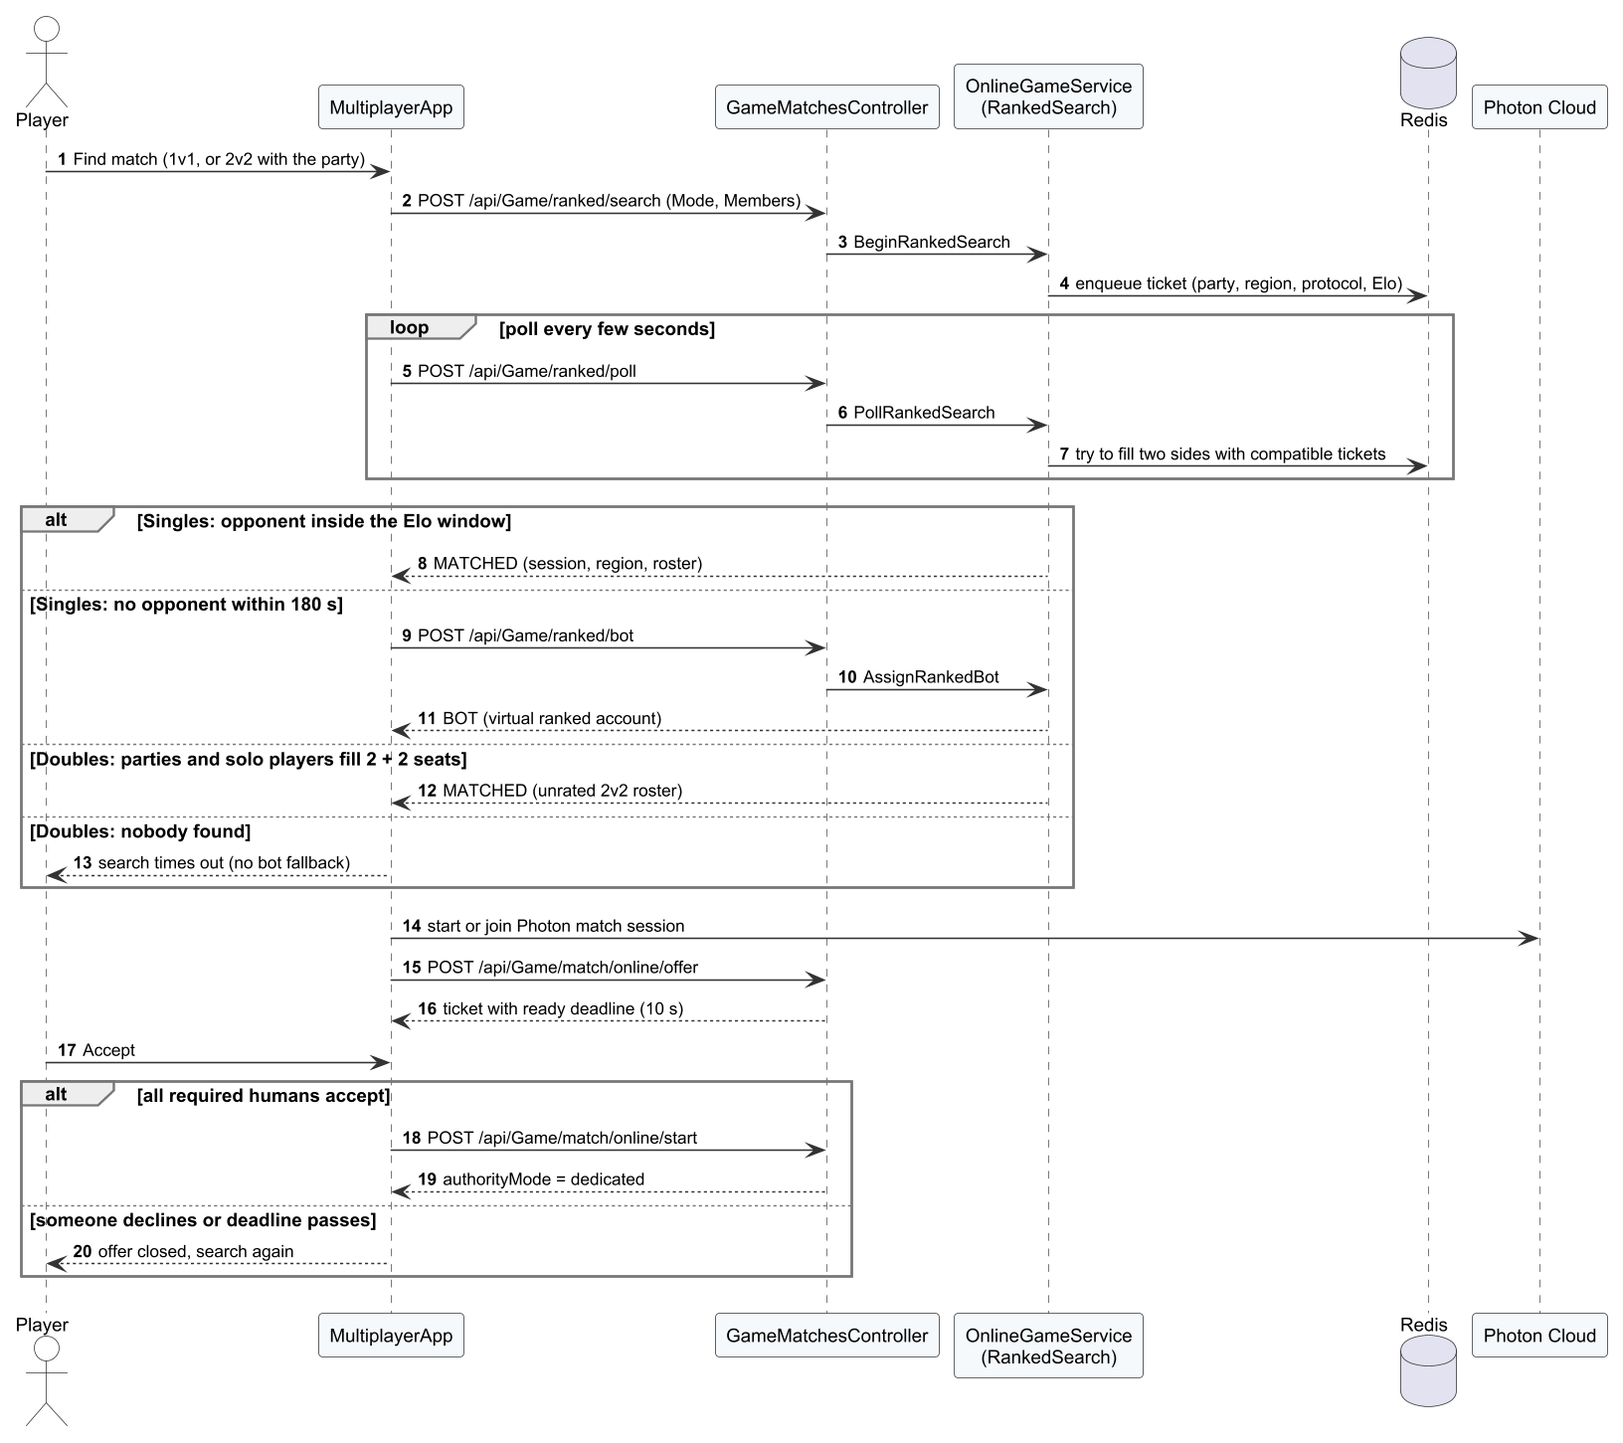
Figure 25. Sequence diagram – Find a ranked or quick doubles match

3.5.5 Invite a friend to a room
The invitation is rejected when the friend is not in the lobby, is blocked or the room is full; otherwise the friend polls and accepts it.
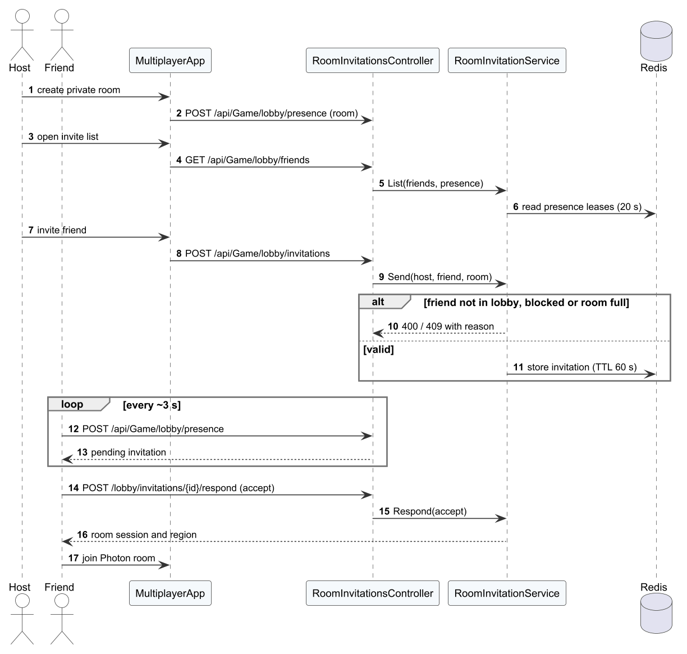
Figure 26. Sequence diagram – Invite a friend to a room

3.5.6 Allocate the dedicated server and play
The server waits for work on /api/Server/poll. When the slot is busy the client waits. When the slot is reserved the API signs tickets; the client polls every 500 ms until the server is ready; during play the server sends heartbeats and at the end telemetry, replay and the result.
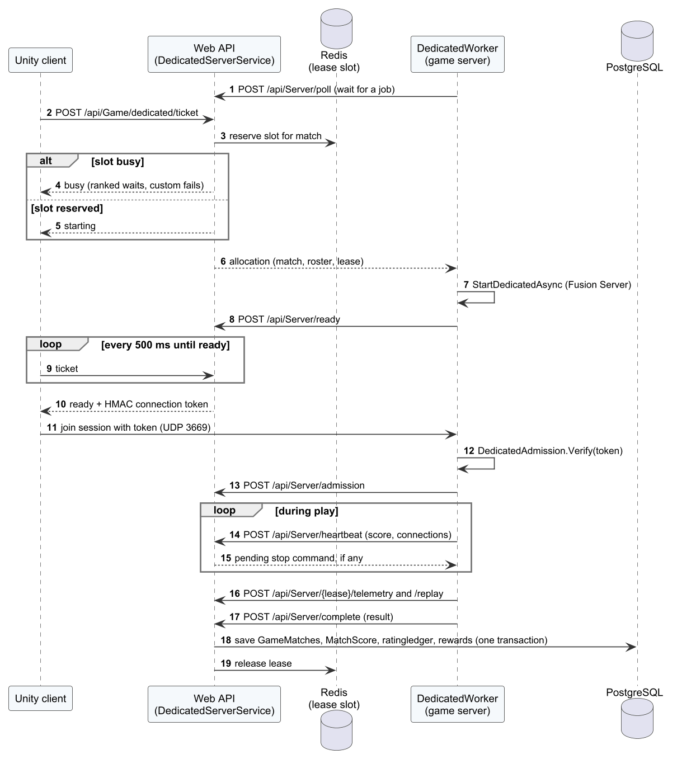
Figure 27. Sequence diagram – Allocate the dedicated server and play

3.6 AI Coaching
AI coaching implements FR-19 and NFR-05/NFR-06. Telemetry is uploaded by CoachingRuntime (drills and bot matches) or DedicatedWorker (online matches). HybridCoachingService stores it and creates an analysis job; HybridAiWorker calls the FastAPI service, which runs the rule engine and, when approved, the tier model.
Table 28. AI coaching parameters
Parameter | Value | Source / meaning
Model features | 8 | mean_abs_timing, late_rate, early_rate, kitchen_rate, momentum_rate, target_rate, recovery_rate, input_error_rate
Tiers | beginner, intermediate, advanced | tier.py
Minimum confidence / opportunities | 0.65 / 20 | Below these values no tier is returned
Finding acceptance | precision ≥ 0.80, recall ≥ 0.70 | calibration.py, NFR-06
Model approval | real data, ≥ 10 holdout players per tier, macro-F1 ≥ 0.70 and ≥ baseline + 0.05 | train.py
Recommendations | at most 3 | engine.py

3.6.1 Class Diagram
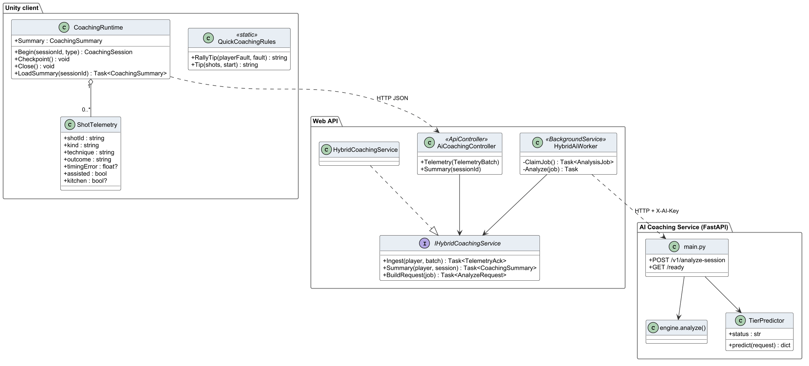
Figure 28. Class diagram – AI coaching

3.6.2 Class Specifications
Table 29. Class specifications – AI coaching
Class | Responsibility | Main attributes | Main operations
QuickCoachingRules  «static» | Client-side quick tip shown when offline or before the AI result arrives | – | + RallyTip(playerFault, fault) : string  + Tip(shots, start) : string
CoachingRuntime | Uploads telemetry, polls the analysis job and shows the coaching popup | + Summary : CoachingSummary | + Begin(sessionId, type) : CoachingSession  + Checkpoint() : void  + Close() : void  + LoadSummary(sessionId) : Task<CoachingSummary>
ShotTelemetry | Per-shot record: timing, contact, landing, position and errors | + shotId : string  + kind : string  + technique : string  + outcome : string  + timingError : float?  + assisted : bool  + kitchen : bool? | –
AiCoachingController  «ApiController» | REST endpoints for telemetry upload and coaching results | – | + Telemetry(TelemetryBatch)  + Summary(sessionId)
IHybridCoachingService  «interface» | Contract of telemetry ingestion and coaching retrieval | – | + Ingest(player, batch) : Task<TelemetryAck>  + Summary(player, session) : Task<CoachingSummary>  + BuildRequest(job) : Task<AnalyzeRequest>
HybridCoachingService | Stores telemetry, creates analysis jobs and returns results | – | –
HybridAiWorker  «BackgroundService» | Sends pending jobs to the AI service with retries and stores the result | – | - ClaimJob() : Task<AnalysisJob>  - Analyze(job) : Task
main.py | FastAPI entry point: /v1/analyze-session and health | + POST /v1/analyze-session  + GET /ready | –
engine.analyze() | Rule-based analysis producing findings, summary and recommendations | – | –
TierPredictor | Loads the approved model and predicts the tier with a confidence threshold | + status : str | + predict(request) : dict

3.6.3 Analyse a session
The worker marks the job processing and calls the service; on success the result is stored and the job completed, on failure the job is retried and finally marked failed.

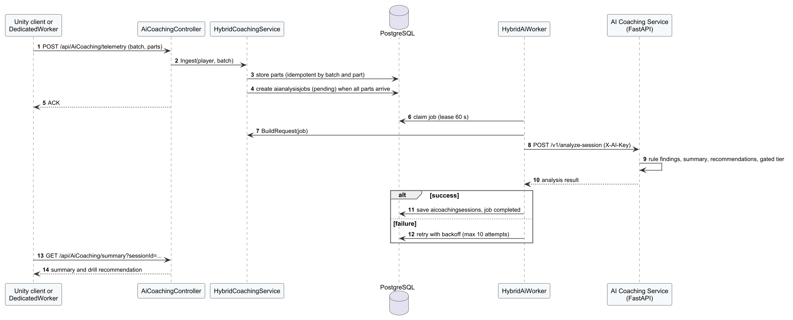
Figure 29. Sequence diagram – Analyse a session

3.7 Progress, Economy, Social and Replays
This group implements FR-20 to FR-26. The client screens share ProgressionRuntime. On the server, OnlineGameService settles rewards and purchases, OnlineSocialService manages friends and the leaderboard, and IMatchReplayService stores replays; GameRepository performs the EF Core queries and row locks inside the unit of work.

3.7.1 Class Diagram
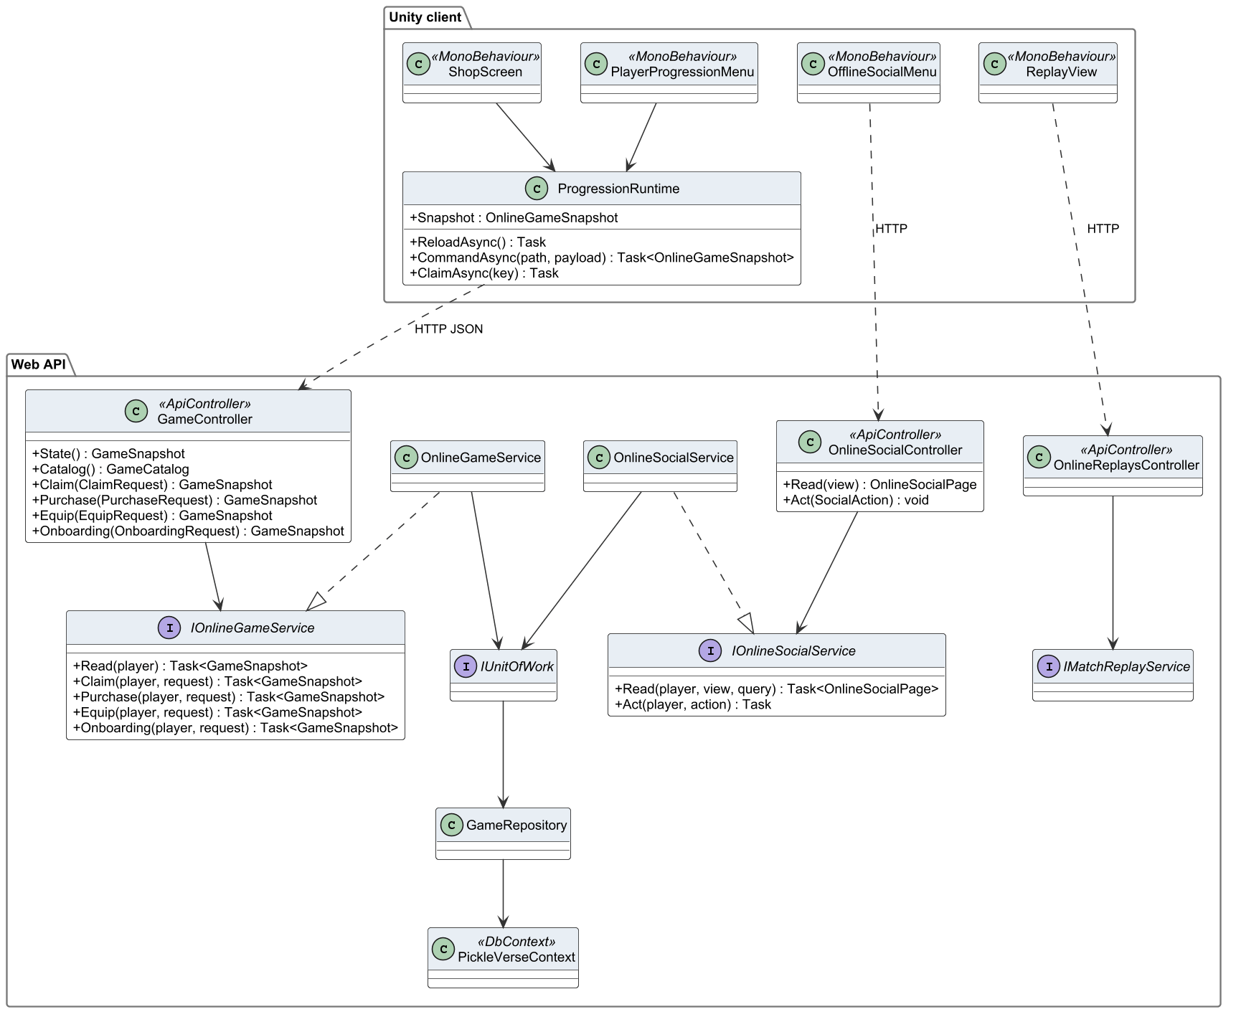
Figure 30. Class diagram – progress, economy, social and replays

3.7.2 Class Specifications
Table 30. Class specifications – progress, economy and social
Class | Responsibility | Main attributes | Main operations
ProgressionRuntime | Client-side cache of profile, wallet, catalogue and the synchronisation queue | + Snapshot : OnlineGameSnapshot | + ReloadAsync() : Task  + CommandAsync(path, payload) : Task<OnlineGameSnapshot>  + ClaimAsync(key) : Task
PlayerProgressionMenu  «MonoBehaviour» | Progress, missions and history popups | – | –
OfflineSocialMenu  «MonoBehaviour» | Friends and leaderboard drawer | – | –
ShopScreen  «MonoBehaviour» | Shop scene: list, preview and purchase | – | –
ReplayView  «MonoBehaviour» | Replay viewer: download and playback controls | – | –
GameController  «ApiController» | REST endpoints for profile, wallet, catalogue, purchase and claims | – | + State() : GameSnapshot  + Catalog() : GameCatalog  + Claim(ClaimRequest) : GameSnapshot  + Purchase(PurchaseRequest) : GameSnapshot  + Equip(EquipRequest) : GameSnapshot  + Onboarding(OnboardingRequest) : GameSnapshot
OnlineSocialController  «ApiController» | REST endpoints for friends, blocking and leaderboard | – | + Read(view) : OnlineSocialPage  + Act(SocialAction) : void
OnlineReplaysController  «ApiController» | REST endpoints for replay upload and download | – | –
IOnlineGameService  «interface» | Contract of progression, economy and match use cases | – | + Read(player) : Task<GameSnapshot>  + Claim(player, request) : Task<GameSnapshot>  + Purchase(player, request) : Task<GameSnapshot>  + Equip(player, request) : Task<GameSnapshot>  + Onboarding(player, request) : Task<GameSnapshot>
IOnlineSocialService  «interface» | Contract of social use cases | – | + Read(player, view, query) : Task<OnlineSocialPage>  + Act(player, action) : Task
IMatchReplayService  «interface» | Contract of replay storage | – | –
OnlineGameService | Server implementation of training, match settlement, matchmaking and economy use cases | – | –
OnlineSocialService | Friend requests, friendships, blocks and leaderboard cache | – | –
IUnitOfWork  «interface» | Gives services access to repositories and one shared transaction | – | –
GameRepository | EF Core queries and locks for matches, progression and economy | – | –
PickleVerseContext  «DbContext» | EF Core DbContext mapping the 51 tables | – | –

3.7.3 Purchase a cosmetic
The command ID makes the purchase idempotent: an already processed request returns the stored receipt; otherwise ownership and balance are checked and the debit, ledger entry and ownership are written in one transaction.
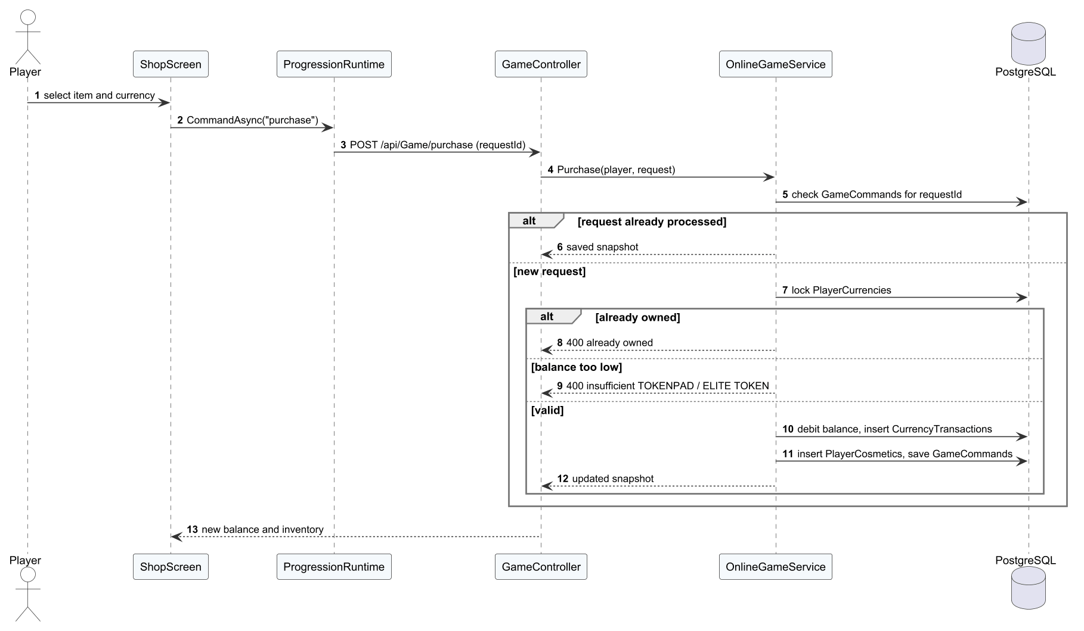
Figure 31. Sequence diagram – Purchase a cosmetic

3.8 Administration and Moderation
Administration implements FR-27 to FR-33. Every admin controller requires the Admin role; services write an AdminAudits record in the same transaction as the change.

3.8.1 Class Diagram
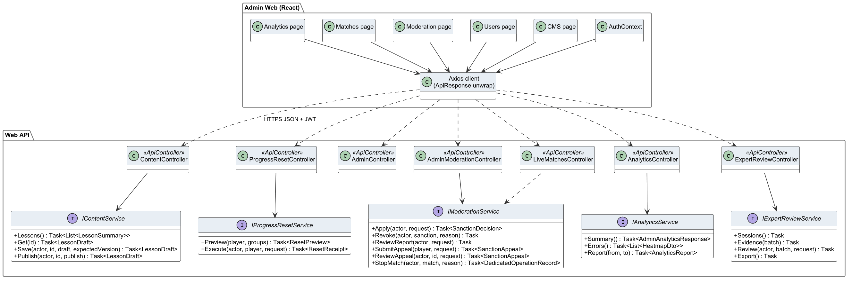
Figure 32. Class diagram – administration web and admin API

3.8.2 Class Specifications
Table 31. Class specifications – administration
Class | Responsibility | Main attributes | Main operations
AuthContext | Admin web session state and role check | – | –
CMS page | Lesson, drill, item and mission forms | – | –
Users page | Account search and actions | – | –
Moderation page | Reports, sanctions and appeals | – | –
Matches page | Live matches and stop dialog | – | –
Analytics page | Charts for the selected date range | – | –
Axios client (ApiResponse unwrap) | HTTP client that adds the JWT and unwraps the ApiResponse envelope | – | –
ContentController  «ApiController» | Admin endpoints for lessons and catalogue | – | –
ProgressResetController  «ApiController» | Admin endpoints for reset preview and execution | – | –
AdminController  «ApiController» | Admin endpoints for users, roles, sanctions and e-mail activation | – | –
AdminModerationController  «ApiController» | Admin endpoints for reports, appeals and match stop | – | –
LiveMatchesController  «ApiController» | Admin endpoints for live and finished matches | – | –
AnalyticsController  «ApiController» | Admin endpoints for analytics summary and error heat map | – | –
ExpertReviewController  «ApiController» | Admin endpoints for expert labelling and dataset export | – | –
IContentService  «interface» | Contract of content management | – | + Lessons() : Task<List<LessonSummary>>  + Get(id) : Task<LessonDraft>  + Save(actor, id, draft, expectedVersion) : Task<LessonDraft>  + Publish(actor, id, publish) : Task<LessonDraft>
IProgressResetService  «interface» | Contract of progress reset | – | + Preview(player, groups) : Task<ResetPreview>  + Execute(actor, player, request) : Task<ResetReceipt>
IModerationService  «interface» | Contract of moderation use cases | – | + Apply(actor, request) : Task<SanctionDecision>  + Revoke(actor, sanction, reason) : Task  + ReviewReport(actor, request) : Task  + SubmitAppeal(player, request) : Task<SanctionAppeal>  + ReviewAppeal(actor, id, request) : Task<SanctionAppeal>  + StopMatch(actor, match, reason) : Task<DedicatedOperationRecord>
IAnalyticsService  «interface» | Contract of analytics queries | – | + Summary() : Task<AdminAnalyticsResponse>  + Errors() : Task<List<HeatmapDto>>  + Report(from, to) : Task<AnalyticsReport>
IExpertReviewService  «interface» | Contract of expert review and export | – | + Sessions() : Task  + Evidence(batch) : Task  + Review(actor, batch, request) : Task  + Export() : Task

3.8.3 Report, sanction and appeal
A player reports; the administrator accepts the report and applies a sanction; the restricted player appeals; the administrator accepts or declines the appeal.
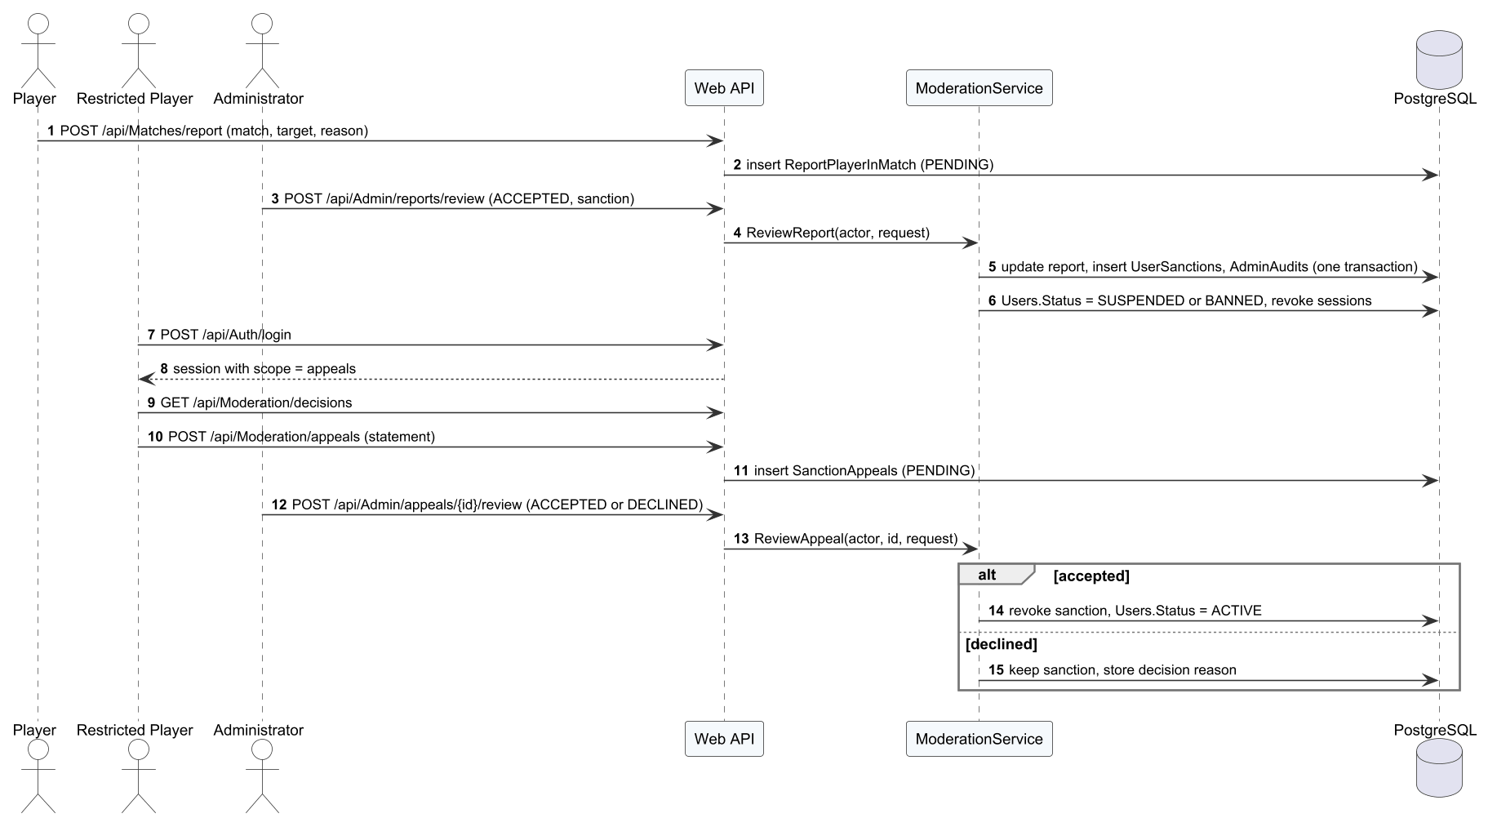
Figure 33. Sequence diagram – Report, sanction and appeal

3.8.4 Reset player progress
The dialog previews the impact; execution is refused when the revision changed after the preview.
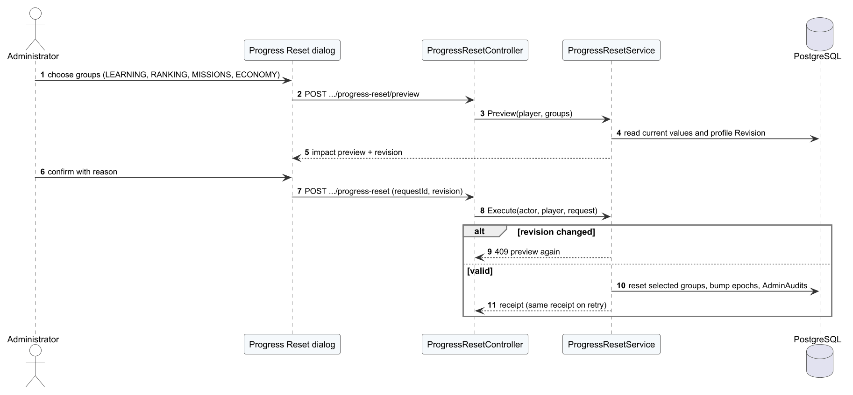
Figure 34. Sequence diagram – Reset player progress

3.8.5 Publish a lesson
Publishing is refused when the expected version changed; otherwise the lesson becomes PUBLISHED and a new catalogue version is produced.
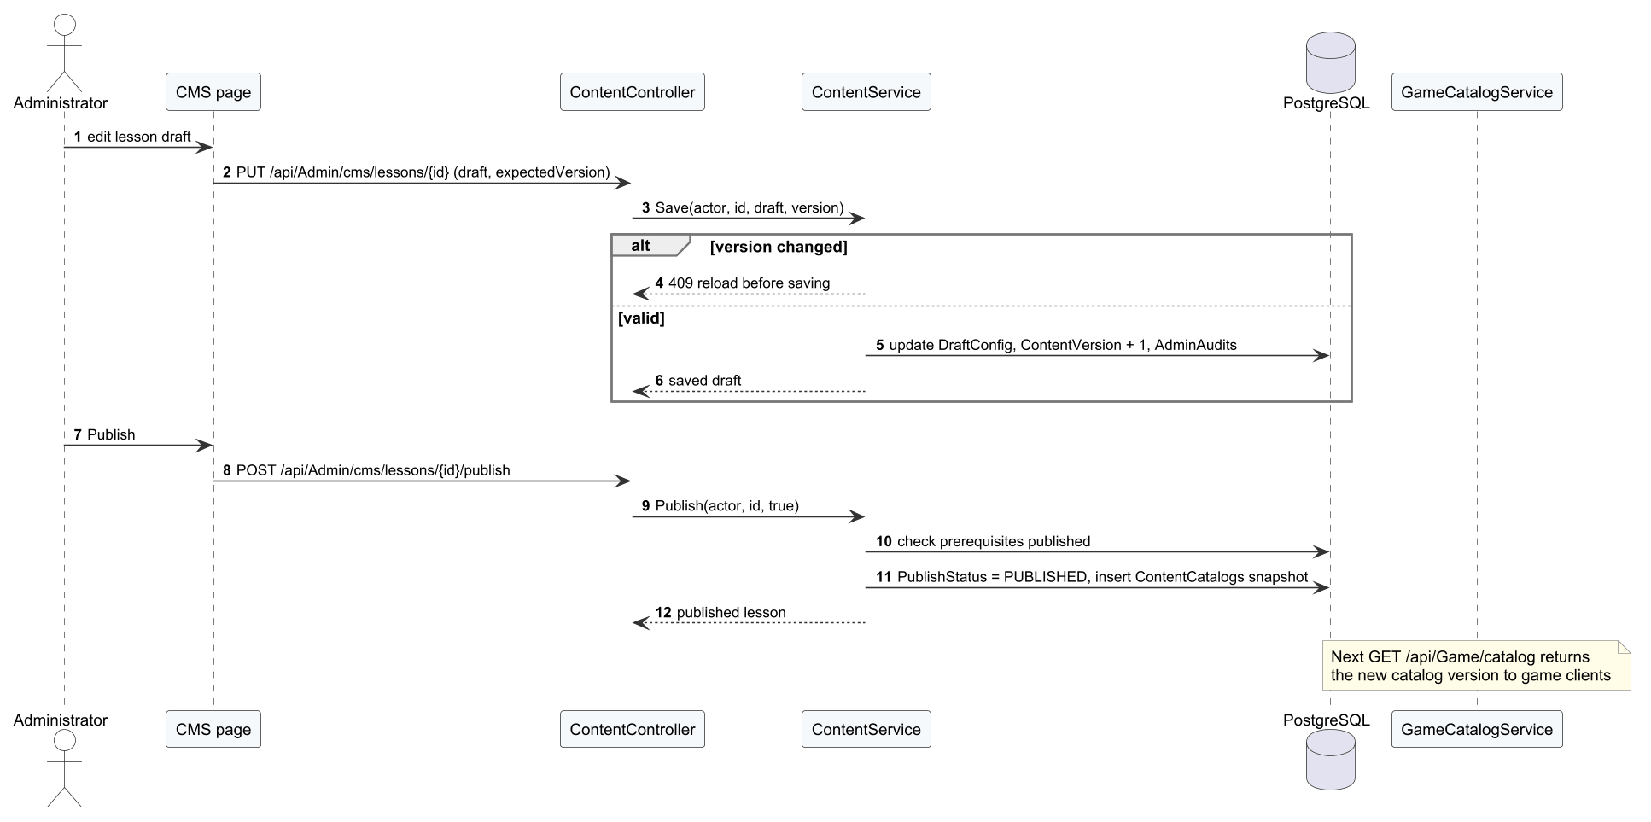
Figure 35. Sequence diagram – Publish a lesson

3.8.6 Stop a live match
The stop request is stored as a dedicated operation; the server reads it with the next heartbeat, ends the match as interrupted and acknowledges.
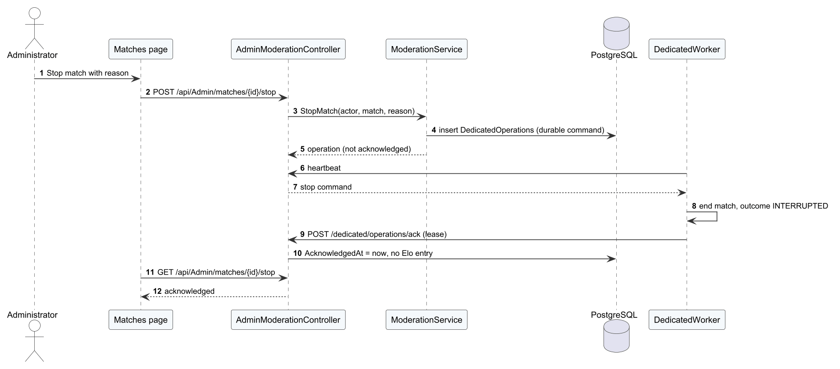
Figure 36. Sequence diagram – Stop a live match

3.9 API Design
The Web API exposes 129 REST endpoints in 28 controller classes (24 source files). The endpoint list below is extracted from the controller attributes by build/api_extract.py, so routes and access levels are those of the code on 12/11/2026. The column Used by shows which program calls each route (game client, dedicated game server or admin web), found by searching the client sources; code compiled only for the old Netcode prototype is ignored. Access: Anonymous (no token), Player (any signed-in account with game scope), Player, Restricted (also allowed for a restricted account with appeals scope), Admin (role Admin), Service key (dedicated server only).
Table 32. API conventions
Item | Design
Base path and format | /api/<Controller>/...; JSON (UTF-8); enum values serialised as strings
Envelope | Success: ApiResponse<T> {success: true, message, data}. Error: ApiResponse {success: false, message, code, errors}
Status codes | 400 validation, 401 missing or expired token, 403 role or scope not allowed, 404 not found, 409 conflict or stale version, 429 rate limit, 503 dependency unavailable, 500 internal (no details)
Authentication | Bearer JWT (HS256) with claims sub/NameIdentifier, email, role (Player, Admin or Restricted), access_scope (game or appeals) and auth_version; refresh tokens rotate
Rate limiting | Policy auth: 20 requests per minute per IP on authentication endpoints; rejection returns 429 with Retry-After: 60
Idempotency | Commands carry a request/command ID stored in GameCommands or receipts
Service calls | Dedicated server: service key header and HMAC-signed tickets; AI service: X-AI-Key header
Documentation | OpenAPI document generated at runtime with the ApiResponse schema

Table 33. Web API endpoints (129)
Controller | Method | Route | Action | Access | Used by
Achievements | GET | /api/Achievements | GetMyAchievements | Player | Not called
Achievements | POST | /api/Achievements/{achievementId}/claim | ClaimReward | Player | Not called
Admin | POST | /api/Admin/cms/cosmetics | CreateCosmetic | Admin | Admin web
Admin | POST | /api/Admin/cms/drills | CreateDrill | Admin | Admin web
Admin | POST | /api/Admin/cms/lessons | CreateLesson | Admin | Admin web
Admin | POST | /api/Admin/cms/missions | CreateMission | Admin | Admin web
Admin | GET | /api/Admin/matches/recent | GetRecentMatches | Admin | Admin web
Admin | GET | /api/Admin/reports | GetReports | Admin | Admin web
Admin | POST | /api/Admin/reports/review | ReviewReport | Admin | Admin web
Admin | GET | /api/Admin/users | GetUsers | Admin | Admin web
Admin | POST | /api/Admin/users/assign-role | AssignRole | Admin | Admin web
Admin | POST | /api/Admin/users/ban | BanUser | Admin | Admin web
Admin | POST | /api/Admin/users/{playerId}/reset-elo | ResetPlayerElo | Admin | Admin web
Admin | POST | /api/Admin/users/{userId}/unban | UnbanUser | Admin | Admin web
Admin | POST | /api/Admin/users/{userId}/verify-email | ManualVerifyUserEmail | Admin | Admin web
AdminModeration | GET | /api/Admin/appeals | Appeals | Admin | Admin web
AdminModeration | POST | /api/Admin/appeals/{id:guid}/review | Review | Admin | Admin web
AdminModeration | GET | /api/Admin/matches/{match:guid}/stop | StopOperation | Admin | Admin web
AdminModeration | POST | /api/Admin/matches/{match:guid}/stop | Stop | Admin | Admin web
AdminModeration | GET | /api/Admin/sanctions | Sanctions | Admin | Admin web
AiCoaching | POST | /api/AiCoaching/log-error | LogTechniqueError | Player | Not called
AiCoaching | GET | /api/AiCoaching/mastery | GetMastery | Player | Not called
AiCoaching | GET | /api/AiCoaching/recommendation | GetRecommendation | Player | Not called
AiCoaching | GET | /api/AiCoaching/summary | Summary | Player | Game client
AiCoaching | POST | /api/AiCoaching/telemetry | Telemetry | Player | Game client
Analytics | GET | /api/Admin/analytics/error-heatmap | Errors | Admin | Admin web
Analytics | GET | /api/Admin/analytics/report | Report | Admin | Admin web
Analytics | GET | /api/Admin/analytics/summary | Summary | Admin | Admin web
AppActivity | POST | /api/Game/activity/checkpoint | Activity | Player | Game client
AppActivity | POST | /api/Game/activity/open | OpenActivity | Anonymous | Game client
Auth | POST | /api/Auth/forgot-password | ForgotPassword | Anonymous | Admin web, Game client
Auth | POST | /api/Auth/login | Login | Anonymous | Admin web, Game client
Auth | POST | /api/Auth/logout | Logout | Player | Game client
Auth | POST | /api/Auth/refresh-token | RefreshToken | Anonymous | Game client
Auth | POST | /api/Auth/register | Register | Anonymous | Game client
Auth | POST | /api/Auth/resend-otp | ResendOtp | Anonymous | Game client
Auth | POST | /api/Auth/reset-password | ResetPassword | Anonymous | Admin web, Game client
Auth | POST | /api/Auth/verify-email | VerifyEmail | Anonymous | Game client
Content | GET | /api/Admin/cms/lessons | List | Admin | Admin web
Content | GET | /api/Admin/cms/lessons/{id:int} | Get | Admin | Admin web
Content | PUT | /api/Admin/cms/lessons/{id:int} | Save | Admin | Admin web
Content | POST | /api/Admin/cms/lessons/{id:int}/publish | Publish | Admin | Admin web
Content | POST | /api/Admin/cms/lessons/{id:int}/unpublish | Unpublish | Admin | Admin web
Dedicated | POST | /api/Game/dedicated/ticket | Ticket | Player | Game client
DedicatedWorker | POST | /api/Server/admission | AuthorizeAdmission | Service key | Game server
DedicatedWorker | POST | /api/Server/complete | Complete | Service key | Game server
DedicatedWorker | POST | /api/Server/heartbeat | Heartbeat | Service key | Game server
DedicatedWorker | POST | /api/Server/operations/ack | Acknowledge | Service key | Game server
DedicatedWorker | POST | /api/Server/poll | Poll | Service key | Game server
DedicatedWorker | POST | /api/Server/ready | Ready | Service key | Game server
DedicatedWorker | POST | /api/Server/release | Release | Service key | Game server
DedicatedWorker | POST | /api/Server/{lease}/replay | Replay | Service key | Game server
DedicatedWorker | POST | /api/Server/{lease}/replay/chunks/{index:int} | Chunk | Service key | Game server
DedicatedWorker | POST | /api/Server/{lease}/telemetry | Telemetry | Service key | Game server
Economy | POST | /api/Economy/buy | BuyCosmetic | Player | Not called
Economy | GET | /api/Economy/currencies | GetCurrencies | Player | Not called
Economy | POST | /api/Economy/equip | EquipCosmetic | Player | Not called
Economy | GET | /api/Economy/my-inventory | GetMyCosmetics | Player | Not called
Economy | GET | /api/Economy/shop | GetShopItems | Player | Not called
ExpertReview | GET | /api/Admin/coaching/dataset/coaching | CoachingDataset | Admin | Admin web
ExpertReview | GET | /api/Admin/coaching/dataset/tier | TierDataset | Admin | Admin web
ExpertReview | GET | /api/Admin/coaching/demo-sessions | DemoSessions | Admin | Admin web
ExpertReview | GET | /api/Admin/coaching/demo-sessions/{sessionId} | DemoEvidence | Admin | Admin web
ExpertReview | GET | /api/Admin/coaching/sessions | Sessions | Admin | Admin web
ExpertReview | GET | /api/Admin/coaching/sessions/{batch:guid} | Evidence | Admin | Admin web
ExpertReview | POST | /api/Admin/coaching/sessions/{batch:guid}/review | Review | Admin | Admin web
Friends | GET | /api/Friends | GetFriends | Player | Not called
Friends | POST | /api/Friends/block/{targetUserId} | BlockUser | Player | Not called
Friends | POST | /api/Friends/request | SendFriendRequest | Player | Not called
Friends | POST | /api/Friends/respond | RespondFriendRequest | Player | Not called
Friends | DELETE | /api/Friends/{friendId} | RemoveFriend | Player | Not called
Game | GET | /api/Game/catalog | Catalog | Player | Game client
Game | POST | /api/Game/claim | Claim | Player | Game client
Game | POST | /api/Game/equip | Equip | Player | Game client
Game | POST | /api/Game/onboarding | Onboarding | Player | Game client
Game | POST | /api/Game/purchase | Purchase | Player | Game client
Game | GET | /api/Game/state | State | Player | Game client
Game | POST | /api/Game/tutorial | Tutorial | Player | Game client
GameMatches | POST | /api/Game/match/bot/complete | FinishBot | Player | Game client
GameMatches | POST | /api/Game/match/bot/start | StartBot | Player | Game client
GameMatches | POST | /api/Game/match/online/heartbeat | HeartbeatOnline | Player | Game client
GameMatches | POST | /api/Game/match/online/leave | LeaveOnline | Player | Game client
GameMatches | POST | /api/Game/match/online/offer | OfferOnline | Player | Game client
GameMatches | POST | /api/Game/match/online/prepare | PrepareOnline | Player | Game client
GameMatches | POST | /api/Game/match/online/report | ReportOnline | Player | Game client
GameMatches | POST | /api/Game/match/online/start | StartOnline | Player | Game client
GameMatches | POST | /api/Game/ranked/bot | Bot | Player | Game client
GameMatches | POST | /api/Game/ranked/cancel | CancelSearch | Player | Game client
GameMatches | POST | /api/Game/ranked/poll | Poll | Player | Game client
GameMatches | POST | /api/Game/ranked/room-ready | PublishRoom | Player | Game client
GameMatches | POST | /api/Game/ranked/search | Search | Player | Game client
GameTraining | POST | /api/Game/training/checkpoint | Checkpoint | Player | Game client
GameTraining | POST | /api/Game/training/complete | Complete | Player | Game client
GameTraining | POST | /api/Game/training/start | Start | Player | Game client
GameTraining | POST | /api/Game/training/sync | SyncTraining | Player | Game client
LiveMatches | GET | /api/Admin/matches/live | Live | Admin | Admin web
Matches | POST | /api/Matches/finish | FinishMatch | Player | Not called
Matches | GET | /api/Matches/my-history | GetMyMatchHistory | Player | Not called
Matches | POST | /api/Matches/report | ReportPlayer | Player | Game client
Matches | GET | /api/Matches/{id:guid}/report-targets | ReportTargets | Player | Game client
Missions | GET | /api/Missions | GetMyMissions | Player | Not called
Missions | POST | /api/Missions/{missionId}/claim | ClaimReward | Player | Not called
Moderation | GET | /api/Moderation/appeals | Appeals | Player, Restricted | Game client
Moderation | POST | /api/Moderation/appeals | Appeal | Player, Restricted | Game client
Moderation | GET | /api/Moderation/decisions | Decisions | Player, Restricted | Game client
OnlineReplays | GET | /api/Game/replays | List | Player | Game client
OnlineReplays | GET | /api/Game/replays/{match:guid} | Read | Player | Game client
OnlineReplays | PUT | /api/Game/replays/{match:guid} | Save | Player | Game client
OnlineReplays | GET | /api/Game/replays/{match:guid}/chunks/{index:int} | Chunk | Player | Game client
OnlineReplays | PUT | /api/Game/replays/{match:guid}/chunks/{index:int} | Upload | Player | Game client
OnlineSocial | GET | /api/Game/social | Read | Player | Game client
OnlineSocial | POST | /api/Game/social | Act | Player | Game client
Profiles | GET | /api/Profiles/leaderboard | GetLeaderboard | Anonymous | Not called
Profiles | GET | /api/Profiles/me | GetMyProfile | Player | Game client
Profiles | PUT | /api/Profiles/me | UpdateProfile | Player | Game client
Profiles | POST | /api/Profiles/sync-time | SyncTime | Player | Not called
Profiles | GET | /api/Profiles/{playerId} | GetProfileById | Anonymous | Game client
ProgressReset | POST | /api/Admin/users/{player:guid}/progress-reset | Reset | Admin | Admin web
ProgressReset | POST | /api/Admin/users/{player:guid}/progress-reset/preview | Preview | Admin | Admin web
Replays | POST | /api/Replays/save | SaveReplay | Player | Not called
Replays | GET | /api/Replays/{matchId} | GetReplay | Player | Admin web
RoomInvitations | GET | /api/Game/lobby/friends | Friends | Player | Game client
RoomInvitations | POST | /api/Game/lobby/invitations | Send | Player | Game client
RoomInvitations | POST | /api/Game/lobby/invitations/{id}/respond | Respond | Player | Game client
RoomInvitations | POST | /api/Game/lobby/presence | Presence | Player | Game client
TechniqueReferences | GET | /api/Admin/cms/techniques/references | References | Admin | Admin web
TechniqueReferences | POST | /api/Admin/cms/techniques/{id:int}/references | Create | Admin | Admin web
Training | GET | /api/Training/lessons | GetLessons | Player | Not called
Training | POST | /api/Training/submit-drill | SubmitDrill | Player | Not called

24 endpoints are marked Not called. They belong to the first resource-style controllers (Achievements, Economy, Friends, Matches, Missions, Profiles, Replays, Training) and to three AiCoaching routes; the game now uses the command-style /api/Game routes for the same data. They still require authentication and pass through the same services, but they are not tested by the clients and are recorded as issue I-12 of the project tracking workbook: they will be removed or documented as public API before release.

3.10 Security Design
Table 34. Security design
Concern | Design
Passwords | BCrypt hash with salt; 6–128 characters; never logged
Tokens | JWT HS256, 2-hour access token; refresh token 14 days stored as SHA-256 hash, rotated on use; auth_version in the token is incremented to revoke all sessions (password reset, ban)
Codes | OTP and reset codes stored as HMAC, 10-minute expiry, 5 attempts, 60-second resend cooldown
Authorisation | Role-based ([Authorize(Roles = "Admin")]) plus access scope: restricted accounts receive scope appeals and can call only moderation endpoints; resource ownership is checked in services (own matches, replays, telemetry)
Transport | HTTPS with TLS 1.2+ behind the reverse proxy. Since 13/11/2026 the staging API and admin web are served only over HTTPS on port 443 (Let's Encrypt certificate, TLS 1.3; port 80 redirects and port 8080 is closed) and the game client uses https://tad-min.io.vn (commit be556a1; Report 5, D-18 fixed)
Secrets | Read from environment variables and the server .env file. Commit be556a1 (13/11/2026) emptied the development credentials in appsettings.json and removed the fallback JWT key from Program.cs: the API refuses to start without a key of at least 32 bytes. The published images are also built from sanitised settings (deploy/api/sanitize_settings.py). The old values remain in the Git history and must be rotated (Report 5, D-17 partly fixed)
Abuse protection | Rate limiting on authentication; server-authoritative online results; idempotent commands; validation of telemetry ownership; HMAC tickets bind a player to a match and slot
CORS | AdminWebPolicy allows only the admin web origins; production serves the admin web and API under the same origin through the reverse proxy
Data protection | Other players never receive e-mail addresses; audit log for administrative actions; since be556a1 the deployment takes a PostgreSQL dump before every release and verifies it with pg_restore (kept under .deploy/backups on the host); there is no scheduled daily backup or off-host copy yet (Report 2, risk 11)
Data at rest | Passwords are BCrypt hashes, refresh tokens SHA-256 hashes and codes HMACs. Database files, backups and replays are not encrypted with AES-256 as the proposal stated; disk encryption of the production host is planned and the deviation is recorded in Report 1 (LI-10)
Error handling | GlobalExceptionHandler maps AppException types to status codes and hides internal details of unexpected exceptions

4. Workflows and State Changes

4.1 Activity Diagrams
Each review workflow is owned by one team member, as committed in the Review 2 form BM04 (W01 Learn and sync a drill – Trần Nguyễn Hiếu Thuận; W02 Play a bot and get a tip – Nguyễn Gia Huy; W03 Play online and save the result – Nguyễn Văn Thành Đạt; W04 Review a report and publish a lesson – Huỳnh Trung Kiên), and is drawn as a UML activity diagram with one swimlane per participant, decisions and exception branches. W04 has two independent parts and therefore two diagrams.

W01 – Learn and sync a drill (owner: Trần Nguyễn Hiếu Thuận)
The player signs in or opens offline training; a beginner is sent to the tutorial; the player practises a drill; the attempt is applied online or queued offline and synchronised when the network returns.
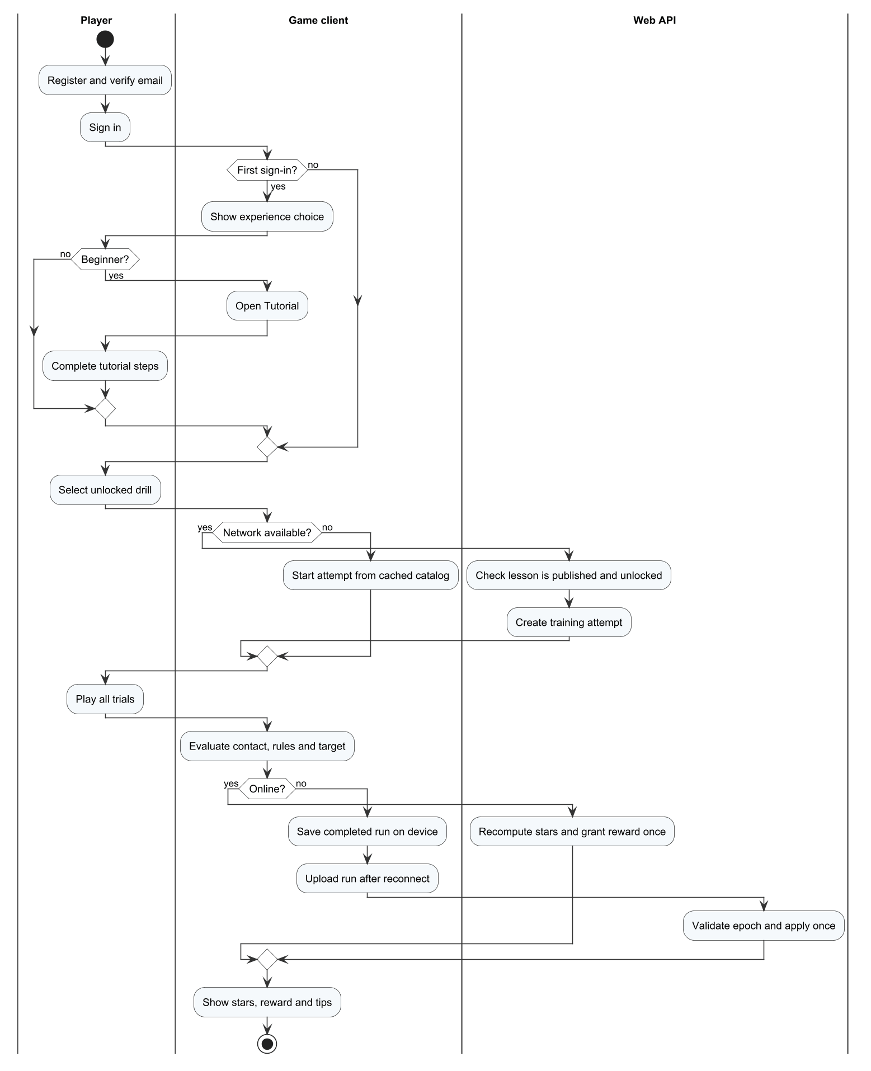
Figure 37. W01 – Learn and sync a drill (owner: Trần Nguyễn Hiếu Thuận)

W02 – Play a bot and get a tip (owner: Nguyễn Gia Huy)
The player sets up a bot match and plays rallies until a side wins; the API settles the result, the AI service analyses the telemetry and the player reads the tip and opens the recommended drill.
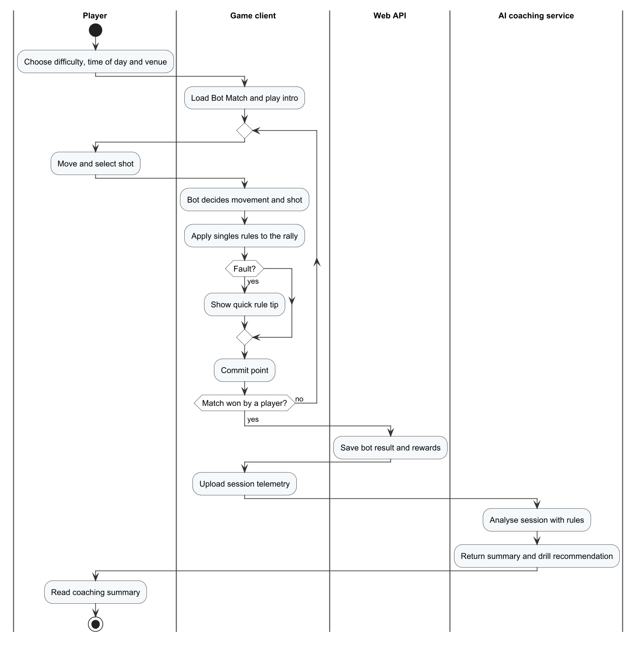
Figure 38. W02 – Play a bot and get a tip (owner: Nguyễn Gia Huy)

W03 – Play online and save the result (owner: Nguyễn Văn Thành Đạt)
The player creates a private room, starts quick doubles (alone or with a party of two) or searches a ranked singles match; only ranked singles has the bot fallback after 180 seconds; all players must accept; the dedicated server runs the match unless it is stopped or the lease is lost, and the API saves the result once.

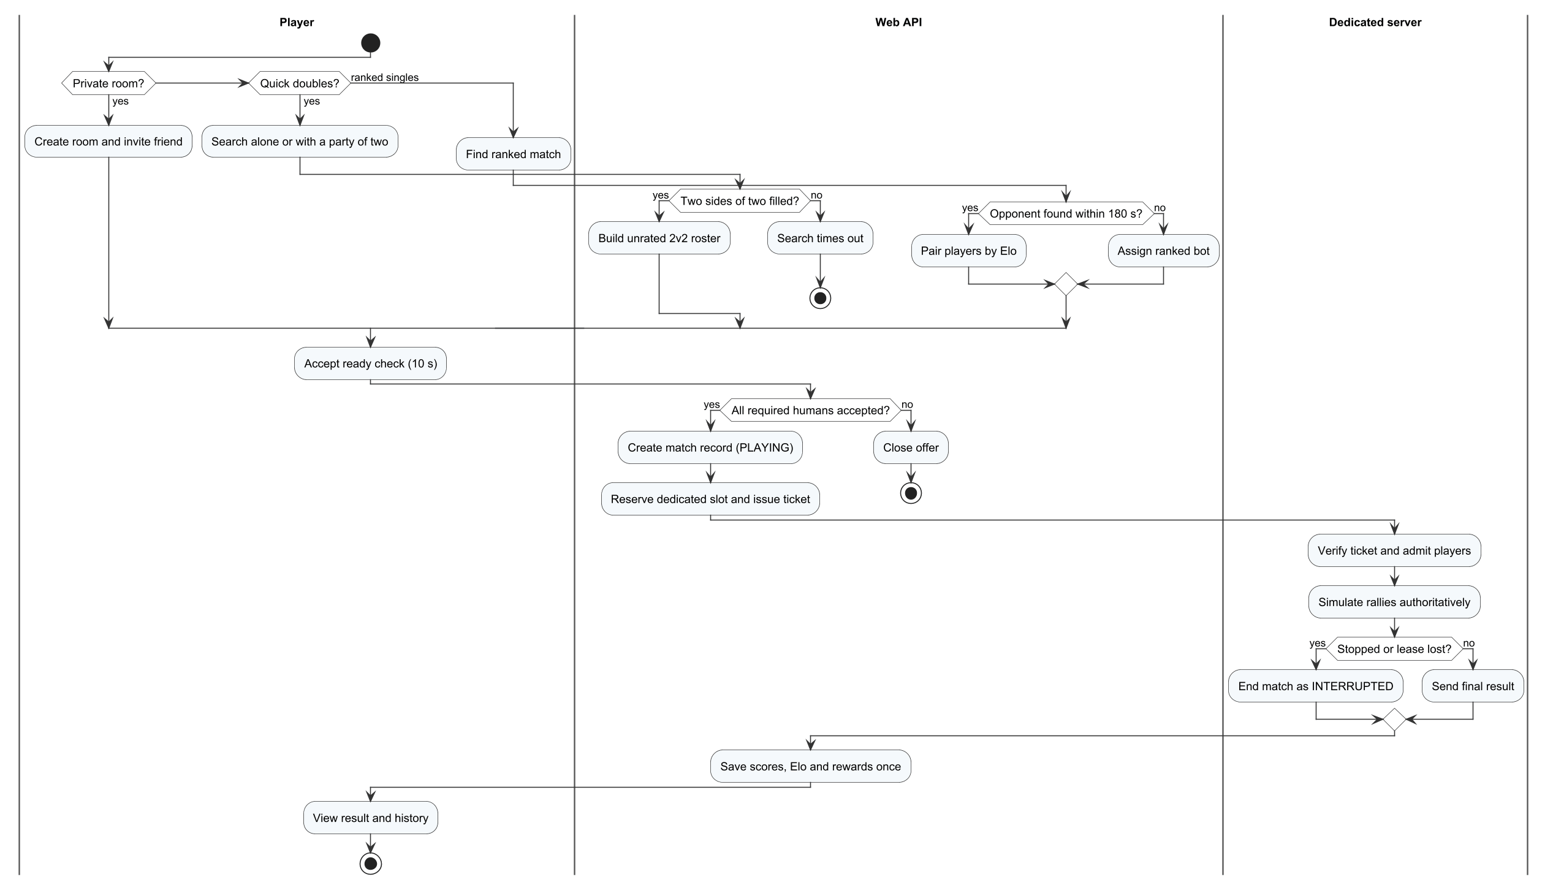
Figure 39. W03 – Play online and save the result (owner: Nguyễn Văn Thành Đạt)

W04 – Review a report and publish a lesson, part 1: report, sanction and appeal (owner: Huỳnh Trung Kiên)
A player reports an opponent; the administrator reviews and may sanction; the restricted player may appeal; the administrator decides the appeal.

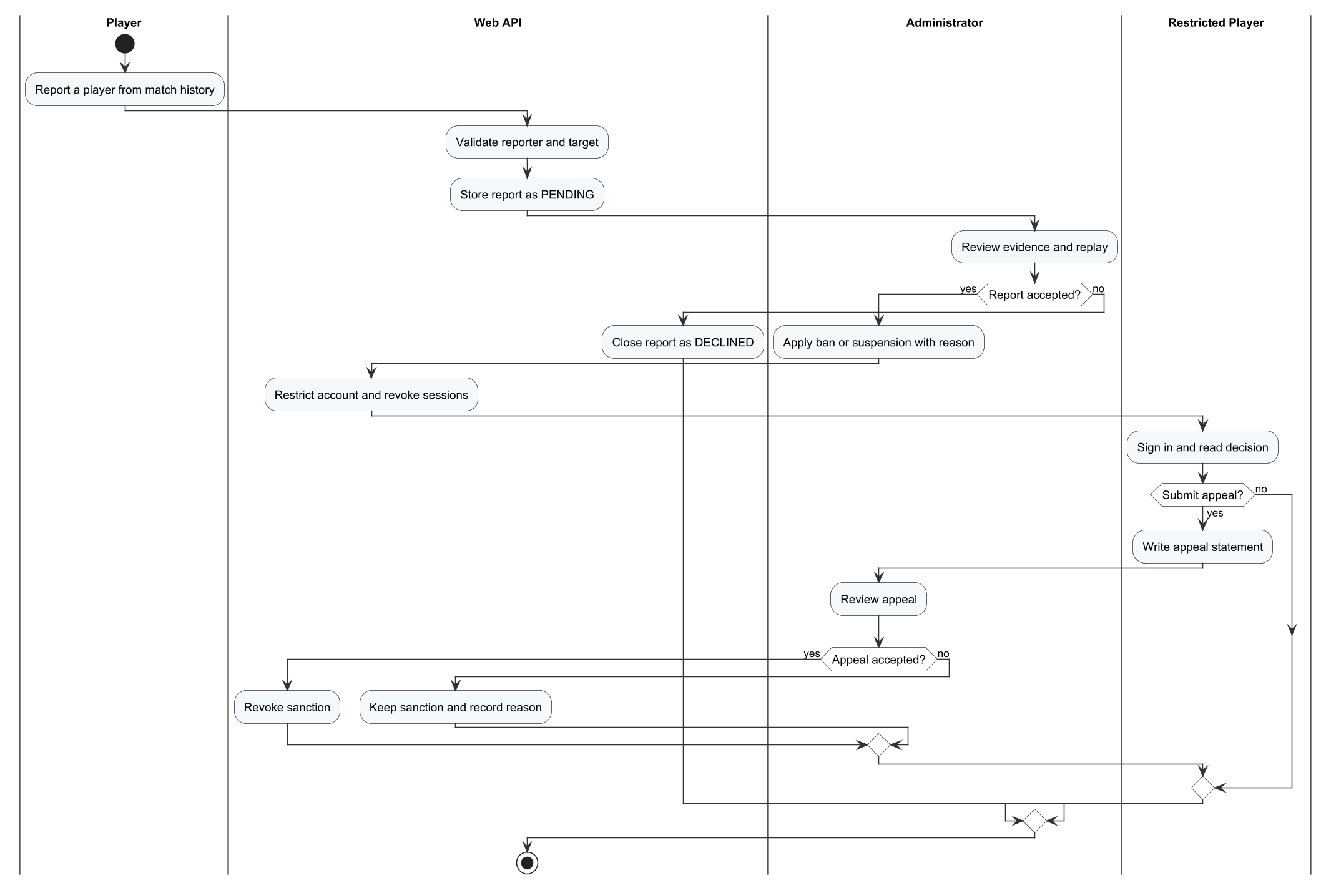
Figure 40. W04 – Review a report and publish a lesson, part 1: report, sanction and appeal (owner: Huỳnh Trung Kiên)

W04 – Review a report and publish a lesson, part 2: publish a lesson (owner: Huỳnh Trung Kiên)
The administrator edits and publishes a lesson; the API checks the expected version and that prerequisites are published; clients receive the new catalogue version.
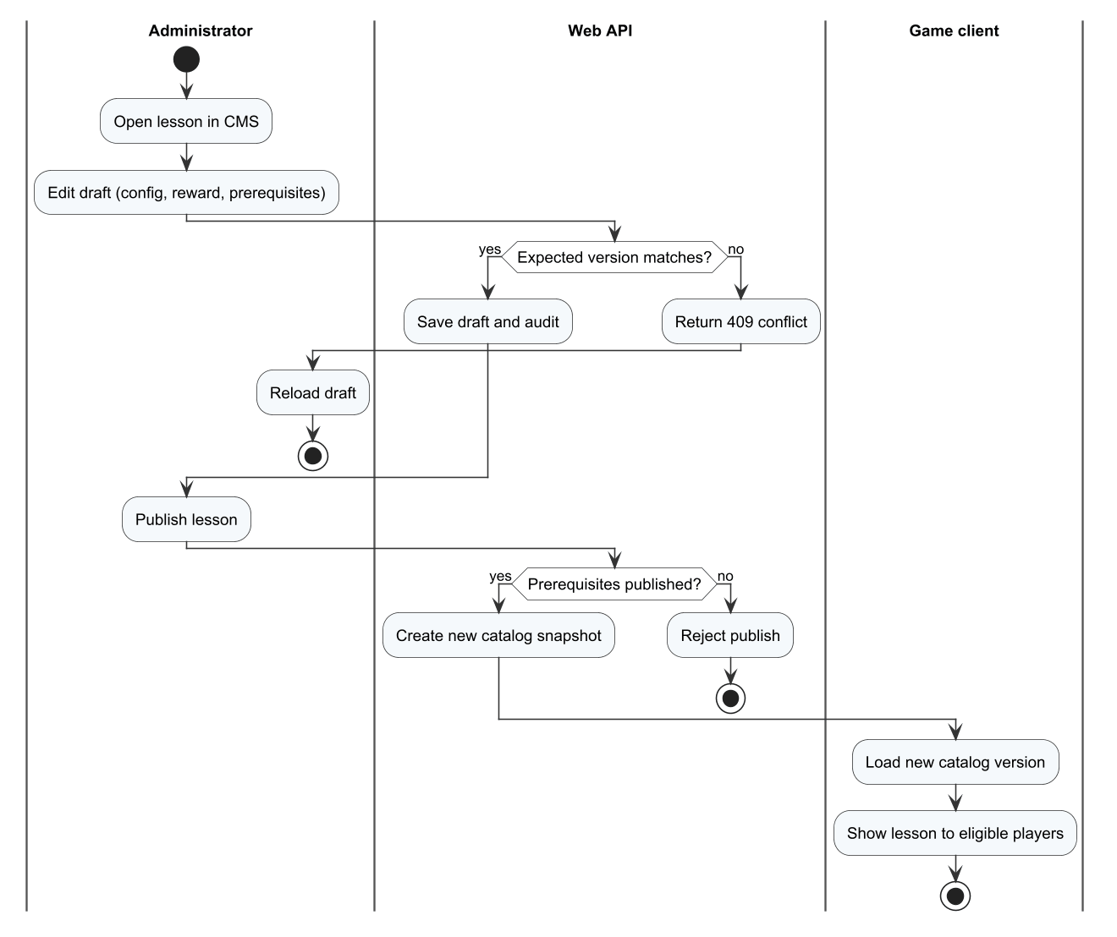
Figure 41. W04 – Review a report and publish a lesson, part 2: publish a lesson (owner: Huỳnh Trung Kiên)

4.2 State Machine Diagrams
The following state machines specify every entity or runtime object with a life cycle. Each transition is labelled event [guard] / action.

SM-01 Account status
ACTIVE, SUSPENDED and BANNED; suspensions end by expiry or revocation, and an accepted appeal revokes the sanction.
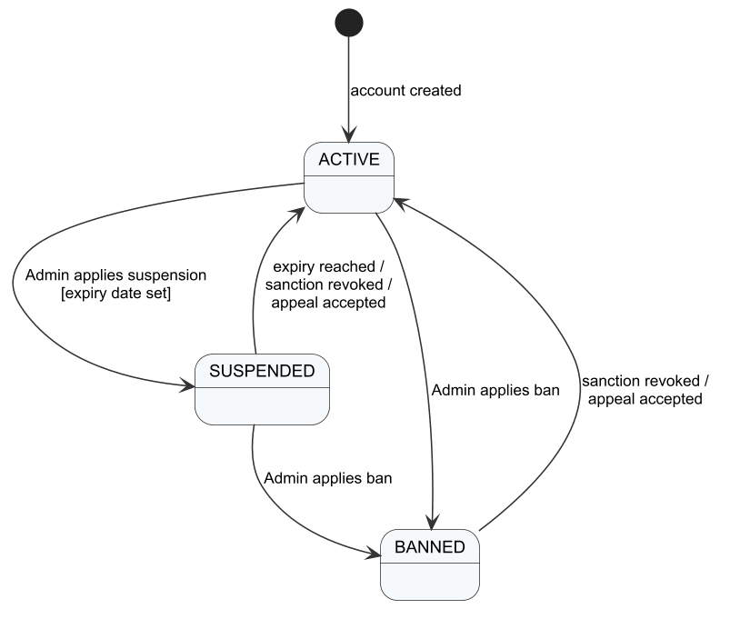
Figure 42. SM-01 Account status

SM-02 E-mail verification code
Pending, verified, expired and locked after 5 wrong attempts; a resend creates a new pending code.
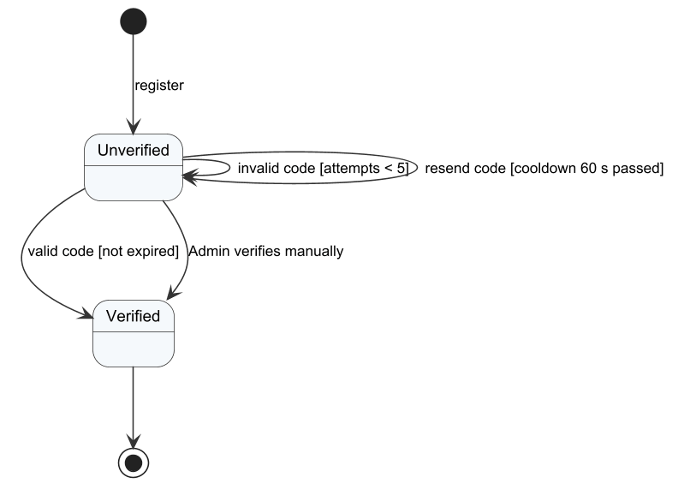
Figure 43. SM-02 E-mail verification code

SM-03 Training attempt and receipt
Briefing, practice, result; the receipt is APPLIED, DUPLICATE or REJECTED.
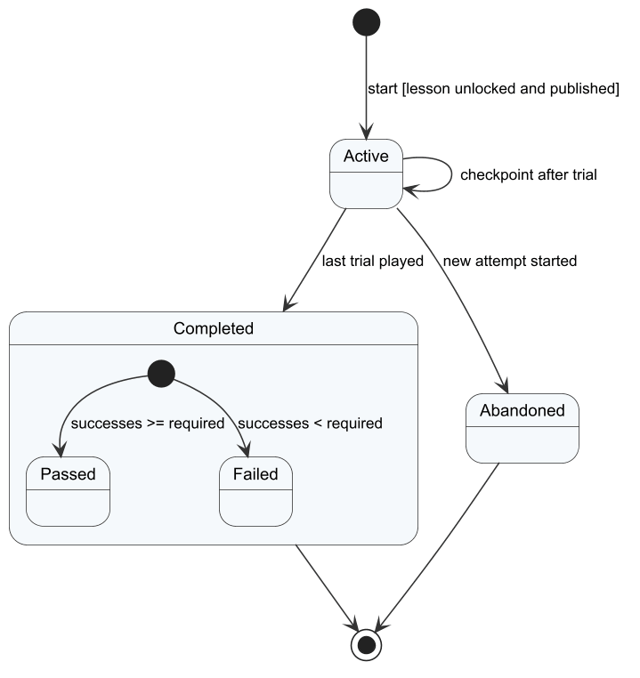
Figure 44. SM-03 Training attempt and receipt

SM-04 Offline queue item
Queued, sending, applied, duplicate or rejected; network failure returns the item to the queue.
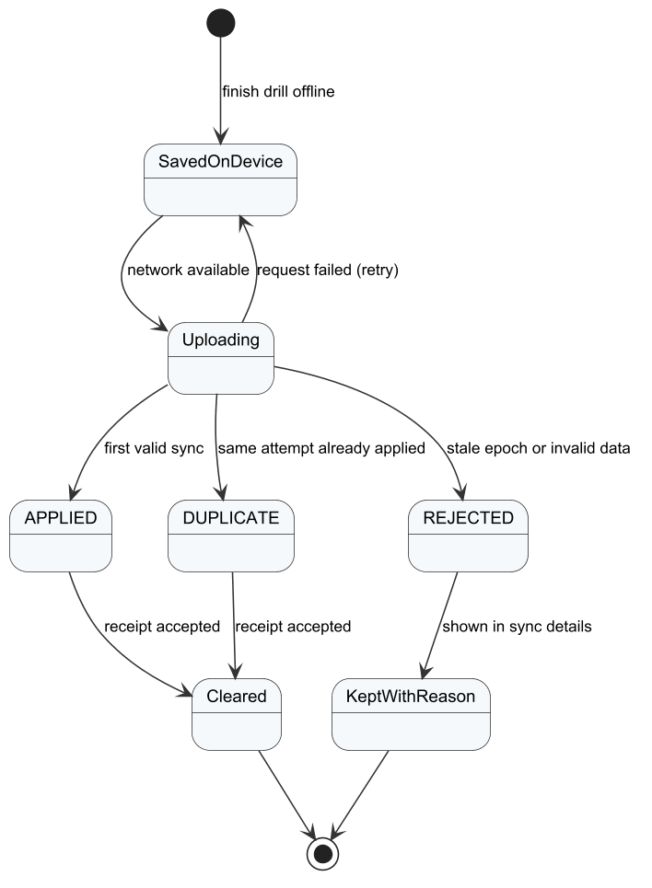
Figure 45. SM-04 Offline queue item

SM-05 Match phase (local match)
Intro, Cinematic, PreServe, Rally, Settling, BetweenPoints, BetweenGames and MatchOver. Time-outs were removed from play, so the Timeout value of the enum is never entered.
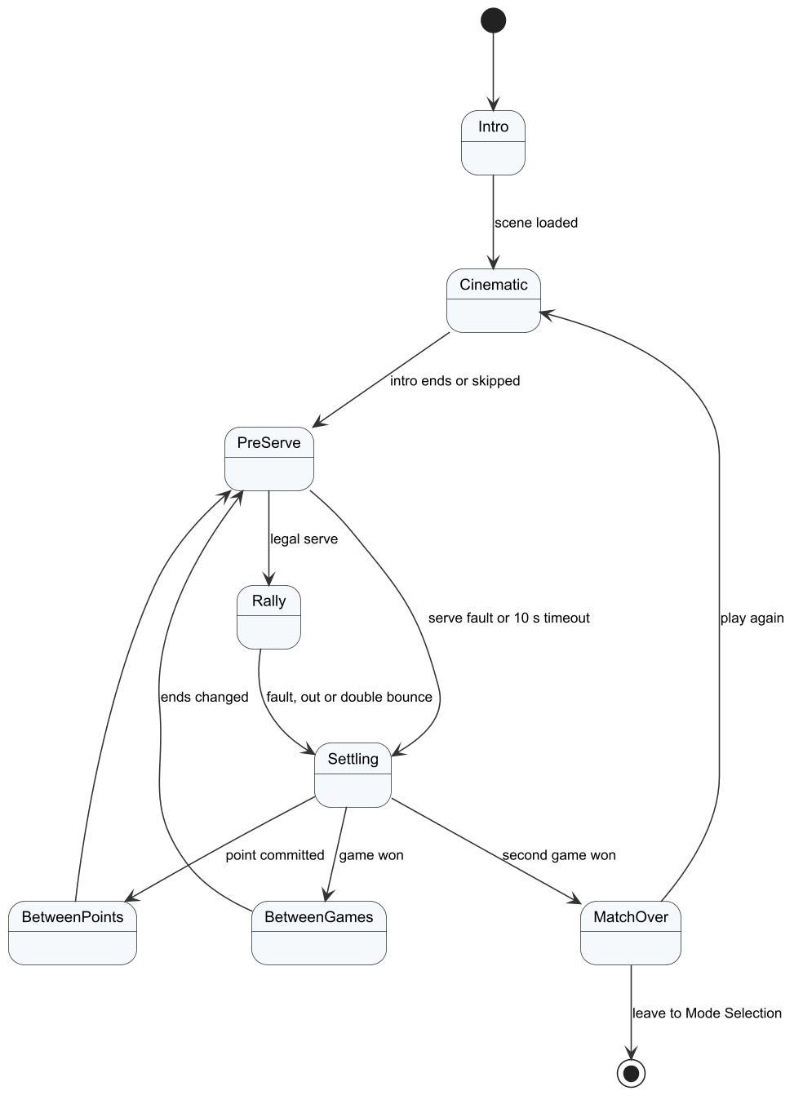
Figure 46. SM-05 Match phase (local match)

SM-06 Matchmaking search
SEARCHING ends in MATCHED, BOT (ranked singles fallback only), CANCELLED or TIMEOUT; a declined offer returns the other player to SEARCHING.
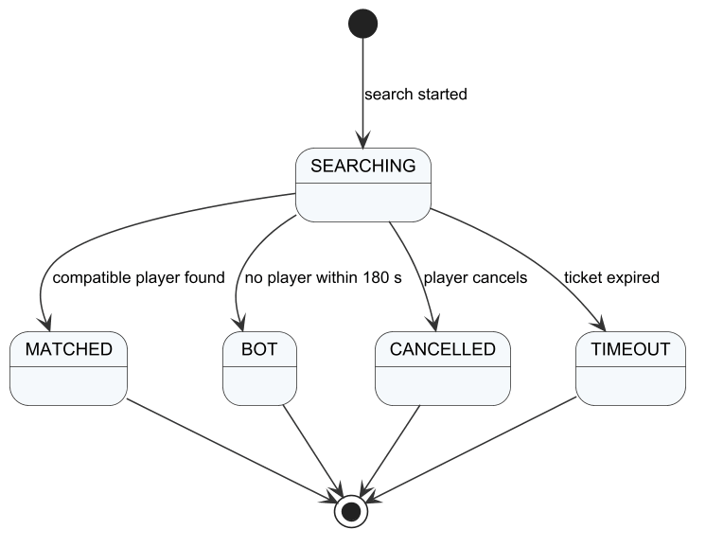
Figure 47. SM-06 Matchmaking search

SM-07 Online room phase
idle, searching, assigning-bot, ready, loading, playing, interrupted, closed and rejected.
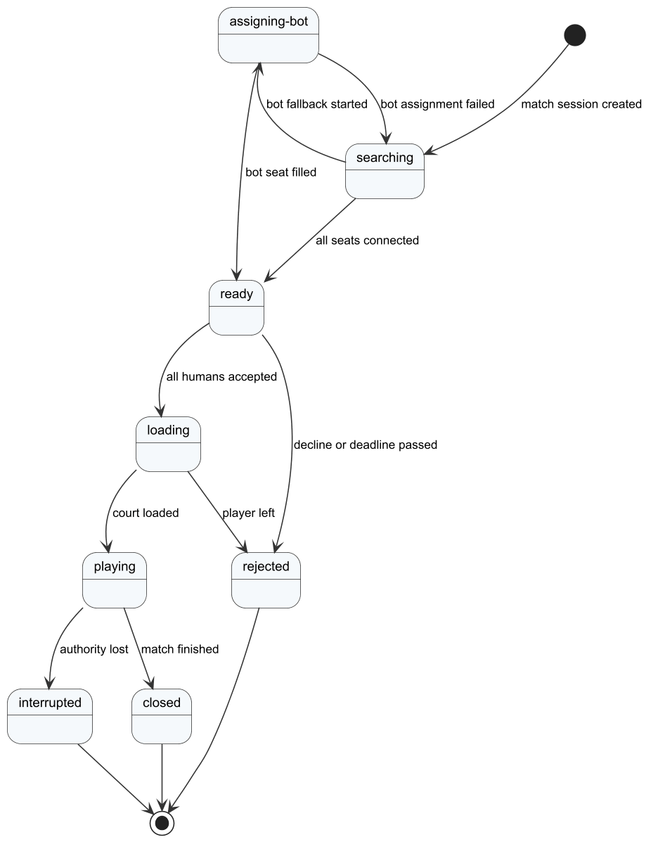
Figure 48. SM-07 Online room phase

SM-08 Game match
PREPARING, PLAYING, FINISHED and CANCELLED; interruption and administrator stop end the match without Elo.
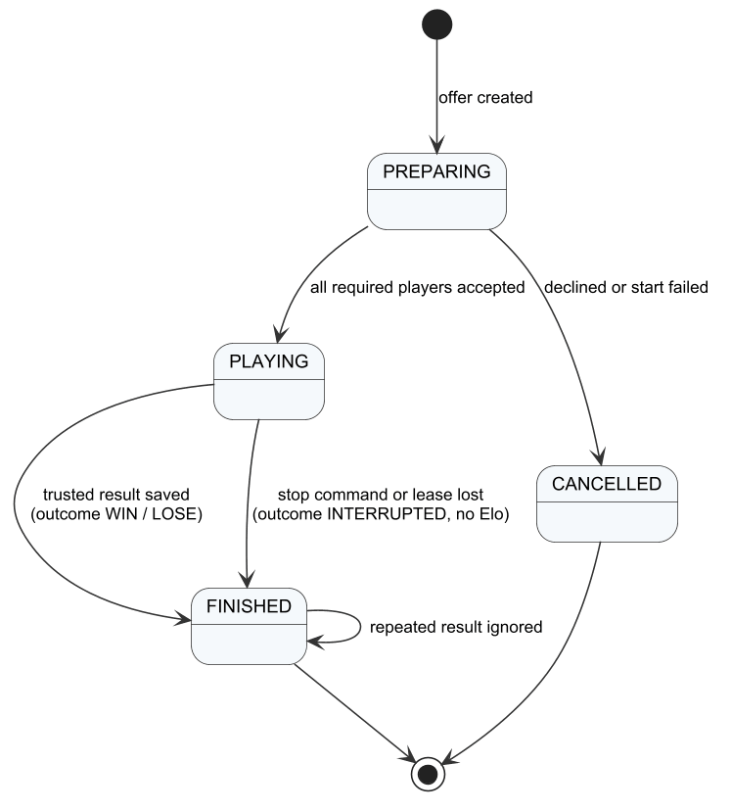
Figure 49. SM-08 Game match

SM-09 Dedicated server lease
queued, starting, ready, finishing, pending and busy; an expired lease releases the slot.
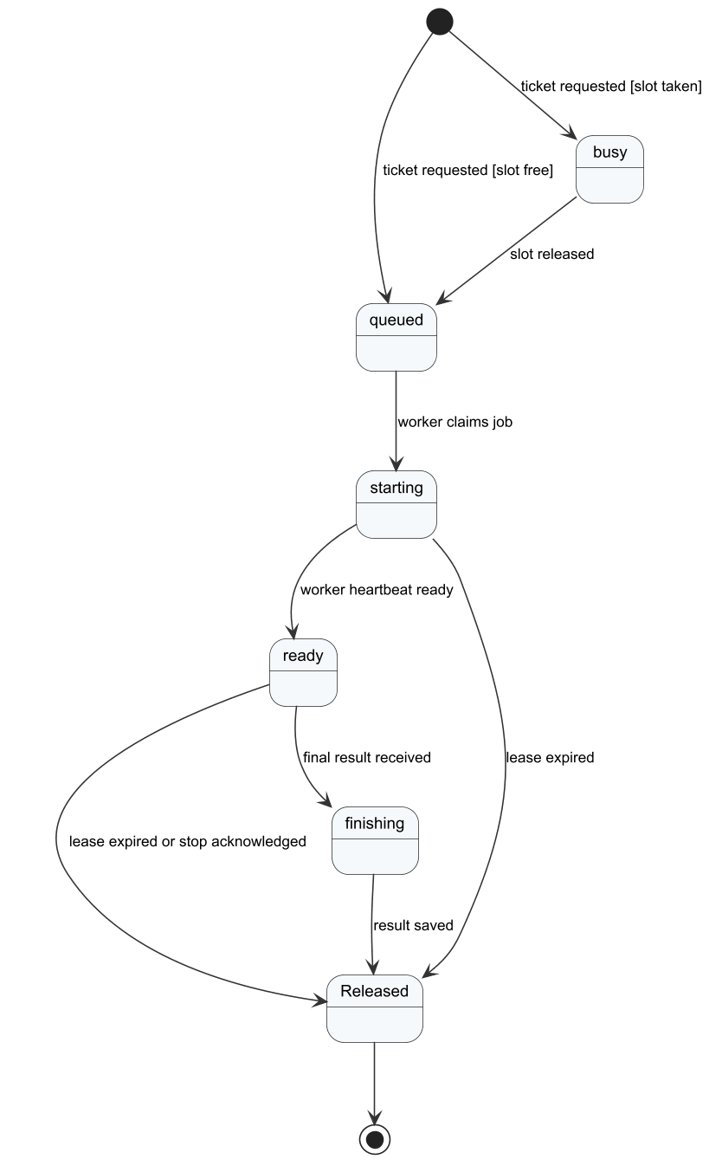
Figure 50. SM-09 Dedicated server lease

SM-10 Lesson publication
DRAFT, PUBLISHED and UNPUBLISHED.
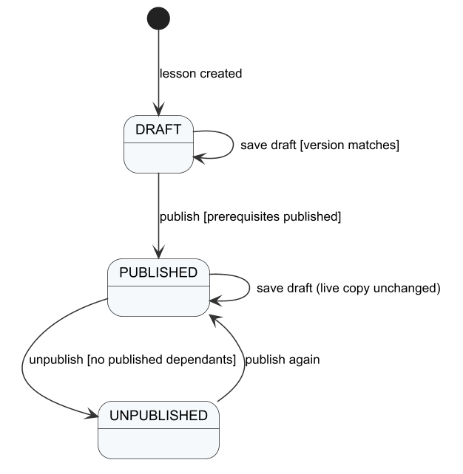
Figure 51. SM-10 Lesson publication

SM-11 Player report
PENDING, CHECKING, ACCEPTED and DECLINED.
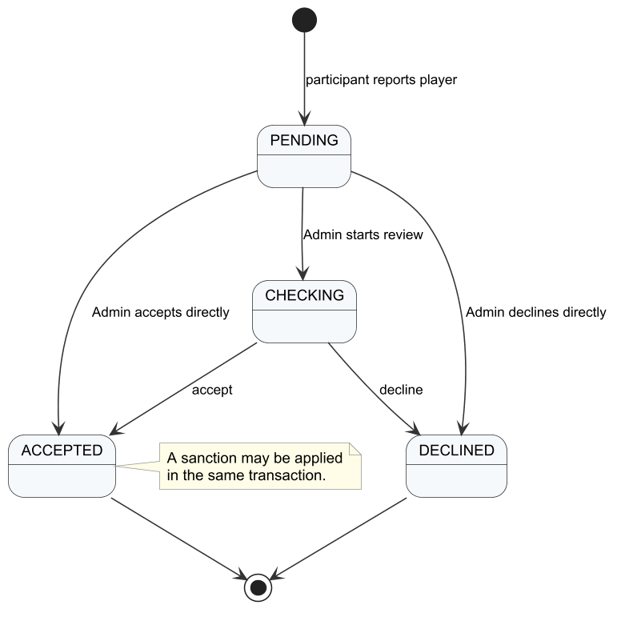
Figure 52. SM-11 Player report

SM-12 Sanction appeal
PENDING, CHECKING, ACCEPTED (sanction revoked) and DECLINED.
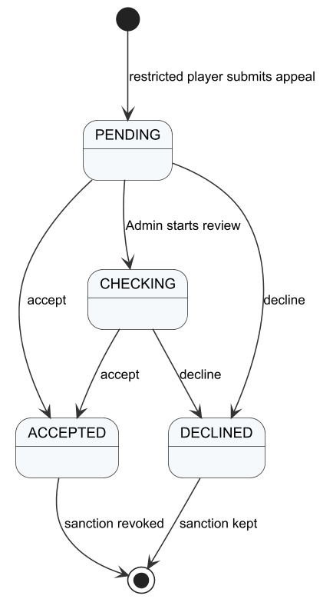
Figure 53. SM-12 Sanction appeal

SM-13 AI analysis job
pending, processing, completed and failed with retries.
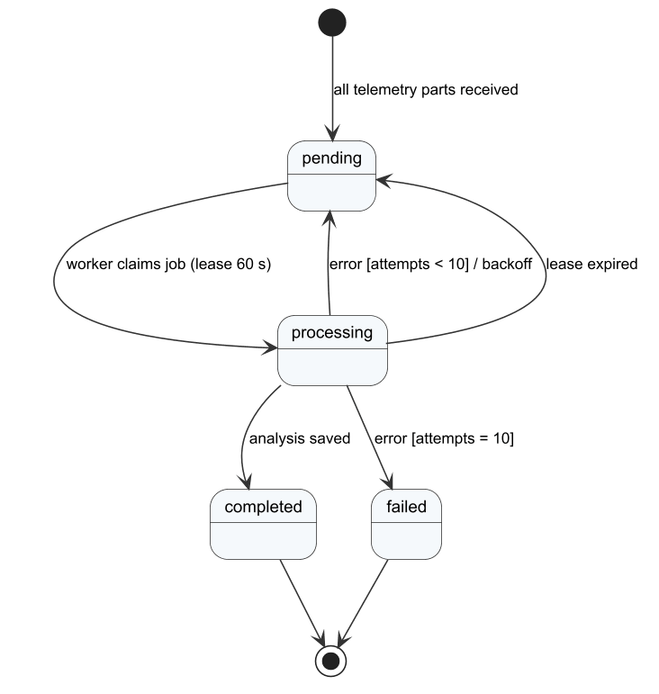
Figure 54. SM-13 AI analysis job

SM-14 Friend request
PENDING, ACCEPTED and DECLINED; blocking removes the friendship.
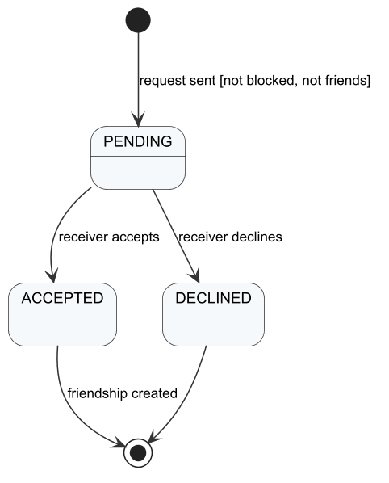
Figure 55. SM-14 Friend request

